Chapter 1
Thinking Like an Astronomer
Learning Objectives
1.1 Earth Occupies a Small Place in the Universe
1.1a State our “cosmic address.”
1.1b Express astronomical distances and distance scales.
1.1c Explain basic astronomical terms and concepts.
1.2 Science Is a Way of Viewing the Universe
1.2a Explain the scientific usage of the terms fact, idea, hypothesis, theory, and law.
1.2b Distinguish between the common meanings of the terms fact, idea, hypothesis, theory, and law, and their scientific meanings.
1.2c Describe the steps of the scientific method.
1.2d Assess whether a given statement is scientific.
1.2e Demonstrate that scientific knowledge is provisional.
1.2f Explain the significance of the cosmological principle.
1.2g Evaluate competing hypotheses using Occam’s razor.
1.3 Astronomers Use Mathematics to Find Patterns
1.3a Identify patterns in nature.
1.3b Explain how natural patterns imply underlying physical laws.
Working it Out 1.1 Mathematical Tools
Working It Out 1.1a Express numbers in scientific and standard notation.
Working It Out 1.1b Describe the physical properties of objects using ratios.
Working It Out 1.1c Predict the change in proportional quantities with respect to each other.
Working it Out 1.2 Reading a Graph
Working It Out 1.2a Identify the major features of a graph: x-axis, y-axis, x scale, y scale, data points, slope.
Working It Out 1.2b Assess different curves on a graph.
Working It Out 1.2c Demonstrate the ability to read data from a graph.
Origins 1 An Introduction
Origins 1a Explain the goals and scope of the field of astrobiology.
MULTIPLE CHOICE

1. The Sun is a
a. | supercluster. | d. | star.
b. | moon. | e. | planet.
c. | galaxy.

ANS: D DIF: Easy REF: 1.1
OBJ: 1.1a State our “cosmic address.” MSC: Remembering

2. The number of planets in our Solar System is
a. | six. | d. | twelve.
b. | eight. | e. | twenty.
c. | nine.

ANS: B DIF: Easy REF: 1.1
OBJ: 1.1a State our “cosmic address.” MSC: Remembering

3. Milky Way is the name of
a. | our Solar System. | d. | the supercluster of galaxies we are in.
b. | the galaxy in which we live. | e. | the entire universe.
c. | the local group of galaxies we are in.

ANS: B DIF: Easy REF: 1.1
OBJ: 1.1a State our “cosmic address.” MSC: Understanding

4. Our galaxy and the few dozen nearest galaxies are known as the
a. | Solar System. | d. | Virgo Supercluster.
b. | Milky Way. | e. | Laniakea Supercluster.
c. | Local Group.

ANS: C DIF: Moderate REF: 1.1
OBJ: 1.1a State our “cosmic address.” MSC: Remembering

5. According to the figure below, if you were to specify your address in the universe, listing your membership from the smallest to largest physical structures, it would be
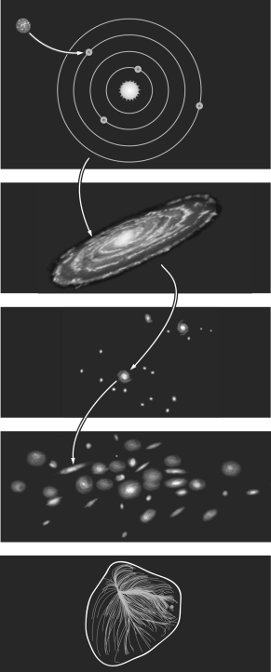
a. | Earth, Local Group, Solar System, Andromeda, the universe.
b. | Earth, Solar System, Local Group, Milky Way, the universe.
c. | Earth, Solar System, Milky Way, Local Group, Laniakea Supercluster, the universe.
d. | Earth, Solar System, Milky Way, Laniakea Supercluster, the universe.
e. | Earth, Laniakea Supercluster, Milky Way, Solar System, the universe.

ANS: C DIF: Difficult REF: 1.1
OBJ: 1.1a State our “cosmic address.” MSC: Understanding

6. The Andromeda Galaxy is also part of the Local Group, so it is also part of
a. | the Solar System. | d. | the Virgo Supercluster.
b. | the Milky Way. | e. | dark energy.
c. | the Moon.

ANS: D DIF: Difficult REF: 1.1
OBJ: 1.1a State our “cosmic address.” MSC: Understanding

7. According to the figure below, Earth is located approximately
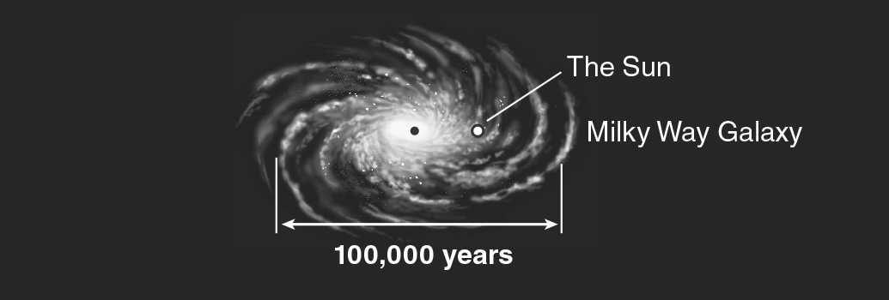
a. | at the center of the Milky Way.
b. | near the center of the Milky Way.
c. | about halfway out from the center of the Milky Way.
d. | at the farthest outskirts of the Milky Way.
e. | outside the Milky Way, which is why we can see it as a band across the night sky.

ANS: C DIF: Easy REF: 1.1
OBJ: 1.1b Express astronomical distances and distance scales. MSC: Analyzing

8. When a change occurs on the surface of the Sun, how long does it take before astronomers on Earth can see the change?
a. | 8 minutes | d. | 1 day
b. | 11 hours | e. | It reaches us instantaneously.
c. | 1 second

ANS: A DIF: Easy REF: 1.1
OBJ: 1.1b Express astronomical distances and distance scales. MSC: Applying

9. The average distance between Earth and the Sun is 1.5 × 10¹¹ m, and light from the Sun takes approximately ________ to reach Earth.
a. | 8 seconds | d. | 8 days
b. | 8 minutes | e. | 8 years
c. | 8 hours

ANS: B DIF: Easy REF: 1.1
OBJ: 1.1b Express astronomical distances and distance scales. MSC: Applying

10. One of the nearest stars, Alpha Centauri, is 4.4 light-years from Earth. The time it takes light to travel from Alpha Centauri to us is
a. | 1.25 seconds. | d. | 600 years.
b. | 8.3 minutes. | e. | 2.2 million years.
c. | 4.4 years.

ANS: C DIF: Easy REF: 1.1
OBJ: 1.1b Express astronomical distances and distance scales. MSC: Applying

11. The time it takes light to cross Neptune’s orbit is closest to which of the following?
a. | instantaneous
b. | a second
c. | a quick meal
d. | a night’s sleep
e. | the time between presidential elections

ANS: D DIF: Easy REF: 1.1
OBJ: 1.1b Express astronomical distances and distance scales. MSC: Analyzing

