Package Title: Test Bank

Course Title: Jenkins 3e
Chapter Number: 1

Question type: Multiple Choice

1) When the examiner uses a stethoscope to amplify the sound of breathing into the lungs, this is called ___.

a) inspection.
b) percussion.
c) auscultation.
d) palpation.
e) ultrasonography.

Answer: c

Difficulty: Easy
Learning Objective 1: LO 1.1 Describe the six levels of structural organization and the eleven systems of the human body.
Section Reference 1: Section 1.1 The human body is composed of six levels of structural organization and contains eleven body systems.

2) When an examiner feels the body surfaces with hands, for example to detect enlarged or tender organs, this is called ___.

a) inspection.
b) percussion.
c) auscultation.
d) palpation.
e) ultrasonography.

Answer: d

Difficulty: Easy
Learning Objective 1: LO 1.1 Describe the six levels of structural organization and the eleven systems of the human body.
Section Reference 1: Section 1.1 The human body is composed of six levels of structural organization and contains eleven body systems.

3) The spleen, thymus, and tonsils are all organs that function within the ___.

a) urinary system
b) digestive system
c) endocrine system
d) lymphatic system
e) cardiovascular system

Answer: d

Difficulty Easy
Learning Objective 1: LO 1.1 Describe the six levels of organization and the eleven systems of the human body.
Section Reference 1: Section 1.1 The human body is composed of six levels of structural organization and contains eleven body systems.

4) Which of the following statements best describes the location of the radius bone anatomically?

a) It is proximal to the carpal region and inferior to the manual region.
b) It is the lateral bone of the antebrachium.
c) It is located in the crural region.
d) It is inferior to the femoral region and superior to the tarsal region.
e) It is distal to the antecubital region, and is the medial bone of the crural region.

Answer: b

Difficulty: Medium
Learning Objective 1: LO 1.4 Describe the human body using the anatomical position and specific terms.
Section Reference 1: Directional Terms.

5) Two organs on the same side of the body, such as the spleen and the descending colon, are ___.

a) distal
b) ipsilateral
c) proximal
d) contralateral
e) intermediate

Answer: b

Difficulty: Easy
Learning Objective 1: LO 1.4 Describe the human body using the anatomical position and specific terms.
Section Reference 1: Directional Terms.

6) Two organs on the opposite side of the body, such as the spleen and the gallbladder, are ___.

a) distal
b) ipsilateral
c) proximal
d) contralateral
e) intermediate

Answer: d

Difficulty: Easy
Learning Objective 1: LO 1.4 Describe the human body using the anatomical position and specific terms.
Section Reference 1: Directional Terms.

7) The heart is ___ to the lungs.

a) distal
b) proximal
c) ipsilateral
d) medial
e) contralateral

Answer: d

Difficulty: Easy
Learning Objective 1: LO 1.4 Describe the human body using the anatomical position and specific terms.
Section Reference 1: Directional Terms.

8) A good example of a positive feedback mechanism would be:

a) enhancement of labor contraction by oxytocin
b) blood calcium regulation
c) blood pressure regulation
d) blood glucose regulation
e) body temperature regulation

Answer: a

Difficulty: Medium
Learning Objective 1: LO 1.3 Explain how homeostasis is maintained through negative and positive feedback systems, and how it can be disrupted by diseases and disorders.
Section Reference 1: Positive Feedback Systems.

9) Along which of the following body planes has this section been made?
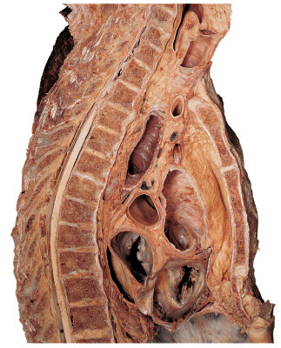

a) oblique
b) frontal
c) sagittal
d) coronal
e) transverse

Answer: c

Difficulty: Medium
Learning Objective 1: LO 1.4 Describe the human body using the anatomical position and specific terms.
Section Reference 1: Planes and Sections.

10) Which of the following anatomical terms best describes the indicated region?

