Representing Motion | 1
Q1.1. Reason: (a) The basic idea of the particle model is that we will treat an object as if all its mass is concentrated into a single point. The size and shape of the object will not be considered. This is a reasonable approximation of reality if: (i) the distance traveled by the object is large in comparison to the size of the object, and (ii) rotations and internal motions are not significant features of the object’s motion. The particle model is important in that it allows us to simplify a problem. Complete reality—which would have to include the motion of every single atom in the object—is too complicated to analyze. By treating an object as a particle, we can focus on the most important aspects of its motion while neglecting minor and unobservable details.
(b) The particle model is valid for understanding the motion of a satellite or a car traveling a large distance.
(c) The particle model is not valid for understanding how a car engine operates, how a person walks, how a bird flies, or how water flows through a pipe.
Assess: Models are representations of reality—not reality itself. As such they almost all make some simplifying assumptions. The test of a good model is the results it produces. The particle model allows us to model the motion of many objects simply and see common features of the movement of different objects. When used appropriately it is very useful. When used outside the range of its validity, it isn’t very helpful.
Q1.2. Reason: The softball player starts with an initial velocity but as he slides he moves slower and slower until coming to rest at the base. The distance he travels in successive times will become smaller and smaller until he comes to a stop. See the figure below.

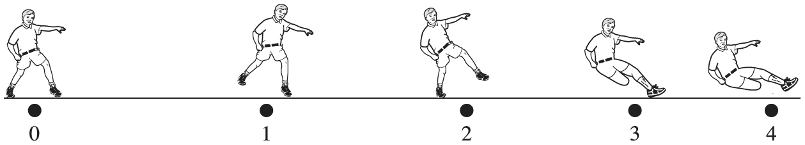

Assess: Compare to Figure 1.10 in the text.
Q1.3. Reason:

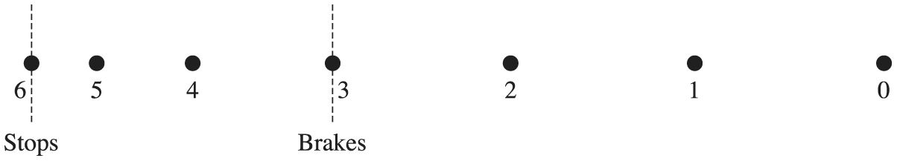

Assess: The dots are equally spaced until the brakes are applied to the car. Equidistant dots indicate constant average speed. On braking, the dots get closer as the average speed decreases.
Q1.4. Reason: As the ball drops from the tall building the ball will go faster and faster the farther it falls under the pull of gravity. The motion diagram should show the displacements for later times to be getting larger and larger. The successive displacements in the diagram given in the text get smaller and smaller. So the diagram given in the problem is incorrect. The correct diagram is below.

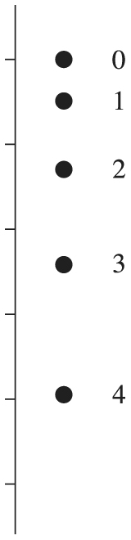

Assess: Compare to Figure 1.5 in the text, which shows a motion diagram for two objects falling under the influence of gravity. The displacements increase during the fall of the object as we reasoned.
Q1.5. Reason: Position refers to the location of an object at a given time relative to a coordinate system. Displacement, on the other hand, is the difference between the object’s final position at time and the initial position at time Displacement is a vector, whose direction is from the initial position toward the final position. An airplane at rest relative to a runway lamp, serving as the origin of our coordinate system, will have a position, called the initial position. The location of the airplane as it takes off may be labeled as the final position. The difference between the two positions, final minus initial, is displacement.
Assess: Some physics texts are not as explicit or clear about this terminology, but it pays off to have clear definitions for terms and to use them consistently.
Q1.6. Reason: The distance you travel will be recorded on the odometer. As you travel, the distance you travel accumulates, is recorded by the odometer, and is independent of the direction of travel. Your displacement is the difference between your final position and your initial position. If you travel around a 440 m track and end up where you started, you have traveled 440 m; however, since you ended up where you started, your change in position and hence displacement is zero.
Assess: If you watch a track meet, you will observe the 440-m race. As you watch the race, it is obvious that the runners travel a distance of 440 m (assuming they complete the race). Yet since they end up where they started, their final position is the same as their initial position and hence their displacement is zero.
Q1.7. Reason: Both speed and velocity are ratios with a time interval in the denominator, but speed is a scalar because it is the ratio of the scalar distance over the time interval while velocity is a vector because it is the ratio of the vector displacement over the time interval. Speed and velocity have the same SI units, but one must specify the direction when giving a velocity.
An example of speed would be that your hair grows (the end of a strand of hair moves relative to your scalp) at a speed of about 0.75 in/month.
An example of velocity (where direction matters) would be when you spring off a diving board. Your velocity could initially be 2.0 m/s up, while later it could be 2.0 m/s down.
Assess: Saying that a velocity has both magnitude and direction does not mean that velocity is somehow “better” and that speeds are never useful. Sometimes the direction is unimportant and the concept of speed is useful. In other cases, the direction is important to the physics, and velocity should be cited. Each shows up in various physics equations.
Q1.8. Reason: Since the velocity of the skateboard is negative during the whole time of its motion, it is moving in the negative direction the entire 5 seconds. In order to move closer to the origin, which is in the positive direction relative to the starting point of the skateboard, the skateboard must have had a velocity in the positive direction for some time. Since the velocity is always negative, the skateboard must be farther from the origin than initially.
Assess: Velocity gives direction of motion since it refers to displacements and not only distance traveled. If velocity is always negative, displacement will be negative also.
Q1.9. Reason: If the position of the bicycle is negative it is to your left. The bicycle’s velocity is positive, or to the right, so the bicycle is getting closer to you.
Assess: If the initial position had been positive and the velocity positive, the bicycle would be getting farther away from you.
Q1.10. Reason: Since the jogger is running around a track, she returns to her starting point at the end of the lap. Since her final position is the same as her initial position, her displacement is 0 m. Velocity is defined as
So her average velocity is 0 m/s!
However, though her displacement is 0 m, the actual distance she traveled is 400 m. Her average speed is not zero, since speed is defined in terms of distance, not displacement.
Her average speed is then
The second friend is correct.
Since the motion of a runner is not uniform we can only calculate average velocity and average speed.
Assess: This problem illustrates a very important difference between speed and velocity. Speed depends on total distance traveled. Velocity depends on displacement, which only takes into account the starting and ending points of a motion.
Q1.11. Reason:

Assess: The dots get farther apart and the velocity arrows get longer as she speeds up.
Q1.12. Reason: The child will be traveling with a constant velocity until hitting the rocky patch. During the constant velocity part of the motion the motion diagram should show equal displacements during each time interval. After hitting the rocky patch, the sled will start slowing. After this point the motion diagram should show ever-decreasing displacements and ever-decreasing velocity vectors. The motion diagram is below.

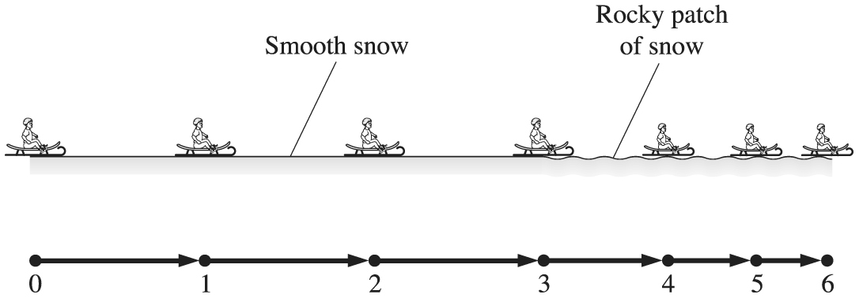

Assess: Compare to Figure 1.11 in the text where a similar motion is illustrated.
Q1.13. Reason: The initial velocity is zero. The velocity increases and the space between position markers increases until the chute is deployed. Once the chute is deployed, the velocity decreases and the spacing between the position markers decreases until a constant velocity is obtained. Once a constant velocity is obtained, the position markers are evenly spaced. See the following figure.

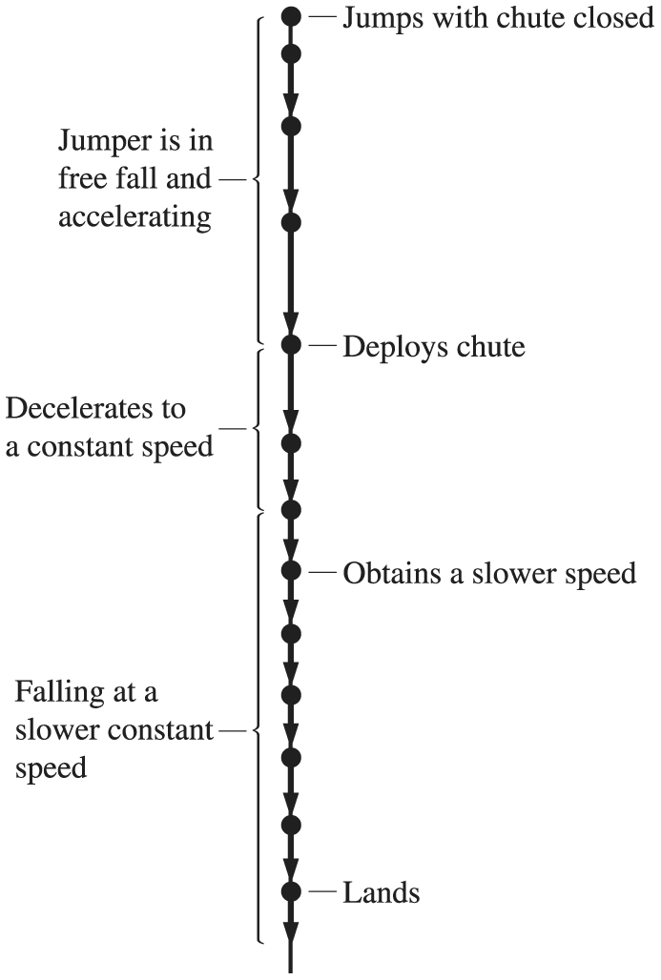

Assess: Knowing the velocity of the jumper will increase until the chute is deployed and then rapidly decrease until a constant descent velocity is obtained allows one to conclude that the figure is correct.
Q1.14. Reason: The tennis ball falls freely for the three stories under the pull of gravity. Since gravity is pulling it downward, its speed increases with time. It strikes the ground and very quickly slows down to a stop (while compressing the ball) then bounces back upward (while the ball decompresses). After the bounce, it travels upward while still under the pull of gravity. As it is traveling upward the pull of gravity decreases its velocity to zero at a height of two stories. The downward and upward motions of the ball are shown in the figure below. The increasing length of the arrows during the downward motion indicates increasing velocity. The decreasing length of the arrows during the upward motion indicates the particle slowing down.

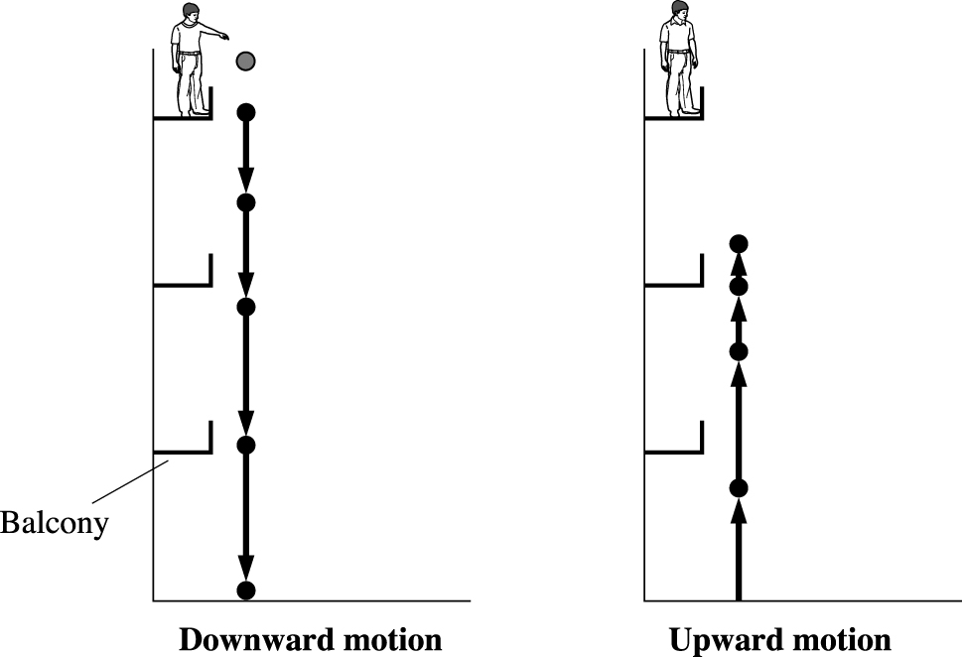

Assess: Compare Figure 1.5 in the text for the downward motion. Note that gravity always pulls downward, no matter what the direction of motion of something under its influence. So the ball will constantly be slowing down during its upward motion.
Q1.15. Reason:
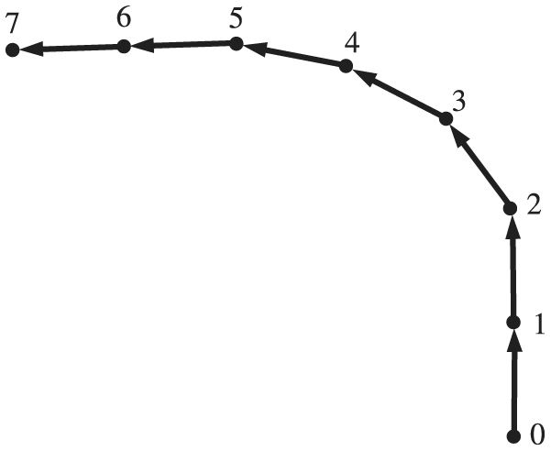
Assess: The car (particle) moves at a constant speed v so the distance between the dots is constant. While turning v remains constant, but the direction ofchanges.
Q1.16. Reason: As the toy car rolls down the ramp, its speed increases because of the pull of gravity. In a motion diagram this is indicated by increasing length of velocity arrows. At the bottom of the ramp, the floor is horizontal. Since the floor is horizontal, gravity is no longer pulling the car to increase its velocity. At this point in the motion diagram the velocity is constant, which is indicated by arrows of constant length. The toy car continues with the speed obtained with no change in velocity. See the following diagram.

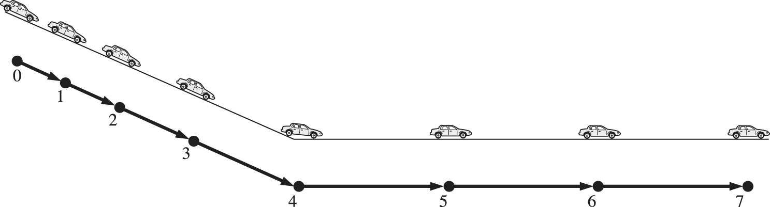
Assess: Compare to Question 1.12, which also has a motion diagram for a motion involving a part that is constant velocity and another where velocity is not constant.
Q1.17. Reason: Because density is defined to be the ratio of two scalars (mass and volume), it too must be a scalar.
Assess: This is always true. The ratio of scalars is a scalar. On the other hand, a vector divided by a scalar (as in the definition of velocity) is a vector.
Q1.18. Reason: The student changes direction during the walk. Her first displacement vector is 1.0 m west, and her second is in a different direction, 1.0 mi north. We need to use the rules for addition of vectors to find the distance she is from her starting point. The distance is the length of her net displacement vector. See the diagram below.
