CHAPTER 2

**ATOMIC STRUCTURE AND INTERATOMIC BONDING**

PROBLEM SOLUTIONS

**Fundamental Concepts**

**Electrons in Atoms**

2.1 *Cite the difference between atomic mass and atomic weight.*

Solution

Atomic mass is the mass of an individual atom, whereas atomic weight is the average (weighted) of the atomic masses of an atom's naturally occurring isotopes.

2.2 *Chromium has four naturally-occurring isotopes: 4.34% of 50Cr, with an atomic weight of 49.9460 amu, 83.79% of 52Cr, with an atomic weight of 51.9405 amu, 9.50% of 53Cr, with an atomic weight of 52.9407 amu, and 2.37% of 54Cr, with an atomic weight of 53.9389 amu. On the basis of these data, confirm that the average atomic weight of Cr is 51.9963 amu.*

Solution

The average atomic weight of chromium  is computed by adding fraction-of-occurrence/atomic weight products for the three isotopes. Thus



 2.3 *Hafnium has six naturally occurring isotopes: 0.16% of 174Hf, with an atomic weight of 173.940 amu; 5.26% of 176Hf, with an atomic weight of 175.941 amu; 18.60% of 177Hf, with an atomic weight of 176.943 amu; 27.28% of 178Hf, with an atomic weight of 177.944 amu; 13.62% of 179Hf, with an atomic weight of 178.946 amu;. and 35.08% of 180Hf, with an atomic weight of 179.947 amu. Calculate the average atomic weight of Hf.*

Solution

The average atomic weight of halfnium  is computed by adding fraction-of-occurrence—atomic weight products for the six isotopes—i.e., using Equation 2.2. (Remember: fraction of occurrence is equal to the percent of occurrence divided by 100.) Thus



Including data provided in the problem statement we solve for  as



= 178.485 amu

2.4 *Bromium has two naturally occurring isotopes: 79Br, with an atomic weight of 78.918 amu, and 81Br, with an atomic weight of 80.916 amu. If the average atomic weight for Br is 79.903 amu, calculate the fraction-of-occurrences of these two isotopes.*

Solution

The average atomic weight of indium  is computed by adding fraction-of-occurrence—atomic weight products for the two isotopes—i.e., using Equation 2.2, or



Because there are just two isotopes, the sum of the fracture-of-occurrences will be 1.000; or



which means that



Substituting into this expression the one noted above for , and incorporating the atomic weight values provided in the problem statement yields









Solving this expression for  yields . Furthermore, because



then



2.5 *(a) How many grams are there in one amu of a material?*

*(b) Mole, in the context of this book, is taken in units of gram-mole. On this basis, how many atoms are there in a pound-mole of a substance?*

Solution

(a) In order to determine the number of grams in one amu of material, appropriate manipulation of the amu/atom, g/mol, and atom/mol relationships is all that is necessary, as



= 1.66 × 10-24 g/amu

(b) Since there are 453.6 g/lbm,



= 2.73 × 1026 atoms/lb-mol

2.6 *(a)* *Cite two important quantum-mechanical concepts associated with the Bohr model of the atom.*

*(b) Cite two important additional refinements that resulted from the wave-mechanical atomic model.*

Solution

(a) Two important quantum-mechanical concepts associated with the Bohr model of the atom are (1) that electrons are particles moving in discrete orbitals, and (2) electron energy is quantized into shells.

(b) Two important refinements resulting from the wave-mechanical atomic model are (1) that electron position is described in terms of a probability distribution, and (2) electron energy is quantized into both shells and subshells--each electron is characterized by four quantum numbers.

2.7 *Relative to electrons and electron states, what does each of the four quantum numbers specify?*

Solution

The *n* quantum number designates the electron shell.

The *l* quantum number designates the electron subshell.

The *ml* quantum number designates the number of electron states in each electron subshell.

The *ms* quantum number designates the spin moment on each electron.

2.8 *Allowed values for the quantum numbers of electrons are as follows:*

*n = 1, 2, 3, . . .*

*l = 0, 1, 2, 3, . . . , n –1*

*ml = 0, ±1, ±2, ±3, . . . , ±l*



*The relationships between n and the shell designations are noted in Table 2.1. Relative to the subshells,*

*l = 0 corresponds to an s subshell*

*l = 1 corresponds to a p subshell*

*l = 2 corresponds to a d subshell*

*l = 3 corresponds to an f subshell*

*For the K shell, the four quantum numbers for each of the two electrons in the 1s state, in the order of nlmlms, are 100() and 100(). Write the four quantum numbers for all of the electrons in the L and M shells, and note which correspond to the s, p, and d subshells.*

Solution

For the *L* state, *n* = 2, and eight electron states are possible. Possible *l* values are 0 and 1, while possible *ml* values are 0 and ±1; and possible *ms* values are  Therefore, for the *s* states, the quantum numbers are  and . For the *p* states, the quantum numbers are , , , , , and .

For the *M* state, *n* = 3, and 18 states are possible. Possible *l* values are 0, 1, and 2; possible *ml* values are 0, ±1, and ±2; and possible *ms* values are  Therefore, for the *s* states, the quantum numbers are , , for the *p* states they are , , , , , and ; for the *d* states they are , , , , , , , , , and .

2.9 *Give the electron configurations for the following ions: Fe2+, Al3+, Cu+, Ba2+, Br-, and O2-.*

Solution

The electron configurations for the ions are determined using Table 2.2 (and Figure 2.8).

Fe2+: From Table 2.2, the electron configuration for an atom of iron is 1*s*22*s*22*p*63*s*23*p*63*d*64*s*2. In order to become an ion with a plus two charge, it must lose two electrons—in this case the two 4*s*. Thus, the electron configuration for an Fe2+ ion is 1*s*22*s*22*p*63*s*23*p*63*d*6.

Al3+: From Table 2.2, the electron configuration for an atom of aluminum is 1*s*22*s*22*p*63*s*23*p*1. In order to become an ion with a plus three charge, it must lose three electrons—in this case two 3*s* and the one 3*p*. Thus, the electron configuration for an Al3+ ion is 1*s*22*s*22*p*6.

Cu+: From Table 2.2, the electron configuration for an atom of copper is 1*s*22*s*22*p*63*s*23*p*63*d*104*s*1. In order to become an ion with a plus one charge, it must lose one electron—in this case the 4*s*. Thus, the electron configuration for a Cu+ ion is 1*s*22*s*22*p*63*s*23*p*63*d*10.

Ba2+: The atomic number for barium is 56 (Figure 2.8), and inasmuch as it is not a transition element the electron configuration for one of its atoms is 1*s*22*s*22*p*63*s*23*p*63*d*104*s*24*p*64*d*105*s*25*p*66*s*2. In order to become an ion with a plus two charge, it must lose two electrons—in this case two the 6*s*. Thus, the electron configuration for a Ba2+ ion is 1*s*22*s*22*p*63*s*23*p*63*d*104*s*24*p*64*d*105*s*25*p*6.

Br-: From Table 2.2, the electron configuration for an atom of bromine is 1*s*22*s*22*p*63*s*23*p*63*d*104*s*24*p*5. In order to become an ion with a minus one charge, it must acquire one electron—in this case another 4*p*. Thus, the electron configuration for a Br- ion is 1*s*22*s*22*p*63*s*23*p*63*d*104*s*24*p*6.

O2-: From Table 2.2, the electron configuration for an atom of oxygen is 1*s*22*s*22*p*4. In order to become an ion with a minus two charge, it must acquire two electrons—in this case another two 2*p*. Thus, the electron configuration for an O2- ion is 1*s*22*s*22*p*6.

2.10 *Sodium chloride (NaCl) exhibits predominantly ionic bonding. The Na+ and Cl- ions have electron structures that are identical to which two inert gases?*

Solution

The Na+ ion is just a sodium atom that has lost one electron; therefore, it has an electron configuration the same as neon (Figure 2.8).

The Cl- ion is a chlorine atom that has acquired one extra electron; therefore, it has an electron configuration the same as argon.

**The Periodic Table**

2.11 *With regard to electron configuration, what do all the elements in Group VIIA of the periodic table have in common?*

Solution

Each of the elements in Group VIIA has five *p* electrons.

2.12 *To what group in the periodic table would an element with atomic number 119 belong?*

Solution

From the periodic table (Figure 2.8) the element having atomic number 119 would belong to group IA. According to Figure 2.8, Uuo, having an atomic number of 118 belongs to Group 0 (or 18) of the periodic table. The next column to the right is actually the left-most column, Group IA (or 1).

2.13 *Without consulting Figure 2.8 or Table 2.2, determine whether each of the electron configurations given below is an inert gas, a halogen, an alkali metal, an alkaline earth metal, or a transition metal. Justify your choices.*

*(a****)*** *1s22s22p63s23p63d74s2*

*(b****)*** *1s22s22p63s23p6*

*(c)**1s22s22p5*

*(d****)*** *1s22s22p63s2*

*(e)**1s22s22p63s23p63d24s2*

*(f)**1s22s22p63s23p64s1*

Solution

(a) The 1*s*22*s*22*p*63*s*23*p*63*d*74*s*2 electron configuration is that of a transition metal because of an incomplete *d* subshell.

(b) The 1*s*22*s*22*p*63*s*23*p*6 electron configuration is that of an inert gas because of filled 3*s* and 3*p* subshells.

(c) The 1*s*22*s*22*p*5 electron configuration is that of a halogen because it is one electron deficient from having a filled *L* shell.

(d) The 1*s*22*s*22*p*63*s*2 electron configuration is that of an alkaline earth metal because of two *s* electrons.

(e) The 1*s*22*s*22*p*63*s*23*p*63*d*24*s*2 electron configuration is that of a transition metal because of an incomplete *d* subshell.

(f) The 1*s*22*s*22*p*63*s*23*p*64*s*1 electron configuration is that of an alkali metal because of a single *s* electron.

2.14 *(a)**What electron subshell is being filled for the rare earth series of elements on the periodic table?*

*(b)**What electron subshell is being filled for the actinide series?*

Solution

(a) The 4*f* subshell is being filled for the rare earth series of elements.

(b) The 5*f* subshell is being filled for the actinide series of elements.

**Bonding Forces and Energies**

2.15 *Calculate the force of attraction between a K+ and an O2- ion the centers of which are separated by a distance of 1.5 nm.*

Solution

The attractive force between two ions *FA* is just the derivative with respect to the interatomic separation of the attractive energy expression, Equation 2.9, which is just



The constant *A* in this expression is defined in Equation 2.10. Since the valences of the K+ and O2- ions (*Z*1 and *Z*2) are +1 and -2, respectively, *Z*1 = 1 and *Z*2 = 2, then





= 2.05 × 10-10 N

2.16 *The atomic radii of Li+ and O2− ions are 0.068 and 0.140 nm, respectively.*

*(a) Calculate the force of attraction between these two ions at their equilibrium interionic separation (i.e., when the ions just touch one another).*

*(b)**What is the force of repulsion at this same separation distance?*

Solution

This problem is solved in the same manner as Example Problem 2.2.

(a) The force of attraction *FA* is calculated using Equation 2.14 taking the interionic separation *r* to be *r*0 the equilibrium separation distance. This value of *r*0 is the sum of the atomic radii of the Li+ and O2− ions (per Equation 2.15)—that is





We may now compute *FA* using Equation 2.14. If was assume that ion 1 is Li+ and ion 2 is O2− then the respective charges on these ions are *Z*1 = , whereas *Z*2 = . Therefore, we determine *FA* as follows:







(b) At the equilibrium separation distance the sum of attractive and repulsive forces is zero according to Equation 2.4. Therefore

*FR* = − *FA*

= − (1.07 × 10−8 N) = − 1.07 × 10−8 N

2.17 *The force of attraction between a divalent cation and a monovalent anion is 8.02 × 10-9 N. If the ionic radius of the cation is 0.060 nm, what is the anion radius?*

Solution

To begin, let us rewrite Equation 2.15 to read as follows:



in which and represent, respectively, the radii of the cation and anion. Thus, this problem calls for us to determine the value of . However, before this is possible, it is necessary to compute the value of using Equation 2.14, and replacing the parameter *r* with . Solving this expression for  leads to the following:



Here and represent charges on the cation and anion, respectively. Furthermore, inasmuch as the cation is divalent means that  and since the anion is monovalent . The value of is determined as follows:





Using the version of Equation 2.15 given above, and incorporating this value of and also the value of given in the problem statement (0.060 nm) it is possible to solve for :





2.18 *The net potential energy between two adjacent ions, EN, may be represented by the sum of Equations 2.9 and 2.11; that is,*

 *(2.17)*

*Calculate the bonding energy E0 in terms of the parameters A, B, and n using the following procedure:*

*1. Differentiate EN with respect to r, and then set the resulting expression equal to zero, since the curve of EN versus r is a minimum at E0.*

*2. Solve for r in terms of A, B, and n, which yields r0, the equilibrium interionic spacing.*

*3. Determine the expression for E0 by substitution of r0 into Equation 2.17.*

Solution

(a) Differentiation of Equation 2.17 yields





(b) Now, solving for *r* (= *r*0)





or



(c) Substitution for *r*0 into Equation 2.17 and solving for *E* (= *E*0)







2.19 *For a K+–Cl– ion pair, attractive and repulsive energies EA and ER, respectively, depend on the distance between the ions r, according to*





*For these expressions, energies are expressed in electron volts per K+–Cl– pair, and r is the distance in nanometers. The net energy EN is just the sum of the two expressions above.*

*(a) Superimpose on a single plot EN, ER, and EA versus r up to 1.0 nm.*

*(b) On the basis of this plot, determine (i) the equilibrium spacing r0 between the K+ and Cl– ions, and (ii) the magnitude of the bonding energy E0 between the two ions.*

*(c) Mathematically determine the r0 and E0 values using the solutions to Problem 2.18 and compare these with the graphical results from part (b).*

Solution

(a) Curves of *EA*, *ER*, and *EN* are shown on the plot below.

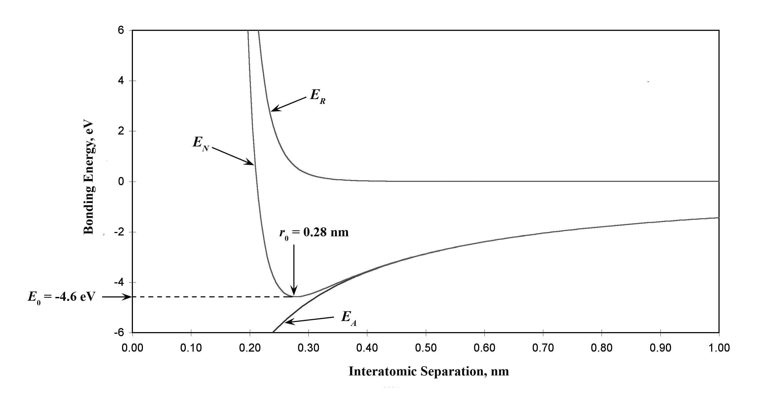

(b) From this plot

*r*0 = 0.28 nm

*E*0 = – 4.6 eV

(c) From Equation 2.17 for *EN*

*A* = 1.436

*B* = 5.86 × 10-6

*n* = 9

Thus,







and





= – 4.57 eV

2.20 *Consider a hypothetical X+-Y- ion pair for which the equilibrium interionic spacing and bonding energy values are 0.35 nm and -6.13 eV, respectively. If it is known that n in Equation 2.11 has a value of 10, using the results of Problem 2.18, determine explicit expressions for attractive and repulsive energies EA and ER of Equations 2.9 and 2.11.*

Solution

This problem gives us, for a hypothetical X+-Y- ion pair, values for *r*0 (0.35 nm), *E*0 (– 6.13 eV), and *n* (10), and asks that we determine explicit expressions for attractive and repulsive energies of Equations 2.9 and 2.11. In essence, it is necessary to compute the values of *A* and *B* in these equations. Expressions for *r*0 and *E*0 in terms of *n*, *A*, and *B* were determined in Problem 2.18, which are as follows:





Thus, we have two simultaneous equations with two unknowns (viz. *A* and *B*). Upon substitution of values for *r*0 and *E*0 in terms of *n*, these equations take the forms



and





We now want to solve these two equations simultaneously for values of *A* and *B*. From the first of these two equations, solving for *A*/10*B* leads to



Furthermore, from the above equation the *A* is equal to



When the above two expressions for *A*/10*B* and *A* are substituted into the above expression for *E*0 (−6.13 eV), the following results







Or



Solving for *B* from this equation yields



Furthermore, the value of *A* is determined from one of the previous equations, as follows:





Thus, Equations 2.9 and 2.11 become





Of course, these expressions are valid for *r* and *E* in units of nanometers and electron volts, respectively.

2.21 *The net potential energy EN between two adjacent ions is sometimes represented by the expression*

 *(2.18)*

*in which r is the interionic separation and C, D, and ρ are constants whose values depend on the specific material.*

*(a) Derive an expression for the bonding energy E0 in terms of the equilibrium interionic separation r0 and the constants D and ρ using the following procedure:*

*1. Differentiate EN with respect to r and set the resulting expression equal to zero.*

*2. Solve for C in terms of D, ρ, and r0.*

*3. Determine the expression for E0 by substitution for C in Equation 2.18.*

*(b) Derive another expression for E0 in terms of r0, C, and ρ using a procedure analogous to the one outlined in part (a).*

Solution

(a) Differentiating Equation 2.18 with respect to *r* yields





At *r* = *r*0, *dE/dr* = 0, and

 (2.18b)

Solving for *C* and substitution into Equation 2.18 yields an expression for *E*0 as



(b) Now solving for *D* from Equation 2.18b above yields



Substitution of this expression for *D* into Equation 2.18 yields an expression for *E*0 as



**Primary Interatomic Bonds**

2.22 *(a) Briefly cite the main differences between ionic, covalent, and metallic bonding.*

*(b) State the Pauli exclusion principle.*

Answer

(a) The main differences between the various forms of primary bonding are:

*Ionic*--there is electrostatic attraction between oppositely charged ions.

*Covalent*--there is electron sharing between two adjacent atoms such that each atom assumes a stable electron configuration.

*Metallic*--the positively charged ion cores are shielded from one another, and also "glued" together by the sea of valence electrons.

(b) The Pauli exclusion principle states that each electron state can hold no more than two electrons, which must have opposite spins.

2.23 *Make a plot of bonding energy versus melting temperature for the metals listed in Table 2.3. Using this plot, approximate the bonding energy for copper, which has a melting temperature of 1085°C.*

Solution

Below is plotted the bonding energy versus melting temperature for these four metals. From this plot, the bonding energy for copper (melting temperature of 1085°C) should be approximately 3.6 eV. The experimental value is 3.5 eV.

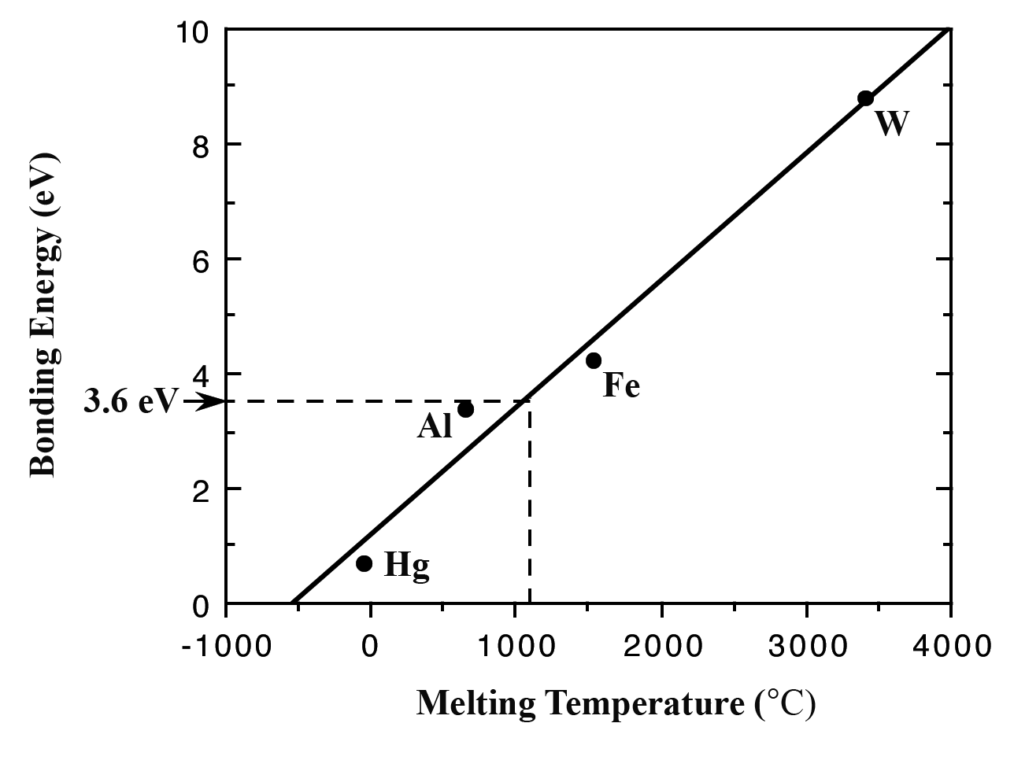

**Secondary Bonding or van der Waals Bonding**

2.24 *Explain why hydrogen fluoride (HF) has a higher boiling temperature than hydrogen chloride (HCl) (19.4 vs. –85°C), even though HF has a lower molecular weight.*

Answer

The intermolecular bonding for HF is hydrogen, whereas for HCl, the intermolecular bonding is van der Waals. Since the hydrogen bond is stronger than van der Waals, HF will have a higher melting temperature.

**Mixed Bonding**

2.25 *Compute the percents ionic character of the interatomic bonds for each of the following compounds: TiO2, ZnTe, CsCl, InSb, and MgCl2.*

Solution

The percent ionic character is a function of the electron negativities of the ions *X*A and *X*B according to Equation 2.16. The electronegativities of the elements are found in Figure 2.9.

For TiO2, *X*Ti = 1.5 and *X*O = 3.5, and therefore,



For ZnTe, *X*Zn = 1.6 and *X*Te = 2.1, and therefore,



For CsCl, *X*Cs = 0.7 and *X*Cl= 3.0, and therefore,



For InSb, *X*In = 1.7 and *X*Sb = 1.9, and therefore,



For MgCl2, *X*Mg = 1.2 and *X*Cl = 3.0, and therefore,



2.26 *(a) Calculate %IC of the interatomic bonds for the intermetallic compound TiAl3.*

*(b) On the basis of this result what type of interatomic bonding would you expect to be found in TiAl3?*

Solution

(a) The percent ionic character is a function of the electron negativities of the ions *X*A and *X*B according to Equation 2.16. The electronegativities for Al and Ti (Figure 2.9) are both 1.5 and. Therefore the percent ionic character is determined using Equation 2.16 as follows:



(b) Because the percent ionic character is zero and this intermetallic compound is composed of two metals, the bonding is completely metallic.

**Bonding Type-Material Classification Correlations**

2.27 *What type(s) of bonding would be expected for each of the following materials: brass (a copper-zinc alloy), epoxy, barium sulfide (BaS), solid xenon, bronze, nylon, and aluminum phosphide (AlP)?*

Solution

For brass, the bonding is metallic since it is a metal alloy.

For epoxy, which is a polymer composed primarily of carbon and hydrogen atoms, the bonding is predominantly covalent.

For BaS, the bonding is predominantly ionic (but with some covalent character) on the basis of the relative positions of Ba and S in the periodic table.

For solid xenon, the bonding is van der Waals since xenon is an inert gas.

For bronze, the bonding is metallic since it is a metal alloy (composed of copper and tin).

For nylon, the bonding is covalent with perhaps some van der Waals. (Nylon is composed primarily of carbon and hydrogen.)

For AlP the bonding is predominantly covalent (but with some ionic character) on the basis of the relative positions of Al and P in the periodic table.

**Fundamentals of Engineering Questions and Problems**

2.1FEWhich of the following electron configurations is for an inert gas?

(A) 1s22s22p63s23p6

(B) 1s22s22p63s2

(C) 1s22s22p63s23p64s1

(D)1s22s22p63s23p63d24s2

Solution

The correct answer is A. The 1*s*22*s*22*p*63*s*23*p*6 electron configuration is that of an inert gas because of filled 3*s* and 3*p* subshells.

2.2FE What type(s) of bonding would be expected for steel (an alloy composed of iron with a very small amount of carbon)?

(A) Ionic bonding

(B) Metallic bonding

(C) Covalent bonding with some van der Waals bonding

(D) van der Waals bonding

Solution

The correct answer is B. For steel, the bonding is metallic because it is a metal alloy.

2.3FE What type(s) of bonding would be expected for rubber?

(A) Ionic bonding

(B) Metallic bonding

(C) Covalent bonding with some van der Waals bonding

(D) van der Waals bonding

Solution

The correct answer is C. For rubber, the bonding is covalent with some van der Waals bonding. (Rubber is composed primarily of carbon and hydrogen atoms.)