Chapter 1. Introduction to Hematology and Basic Laboratory Practice

Multiple Choice

1. Tube length when referring to the microscope is the:
A. Resolution power of the objective
B. Distance from the eyepiece to the objective
C. Numerical aperture
D. Magnitude of the image on the stage

ANS: B
OBJ: 1.3

2. What is the most useful corrective action for the microscope when fine details cannot be visualized in immature cells?
A. Open up the diaphragm for maximum light.
B. Wipe off lenses with lens cleaner.
C. Get a new slide.
D. Move to a lower power.

ANS: A
OBJ: 1.4

3. Which of the following behaviors is a violation of standard precautions?
A. Hand washing after glove removal
B. Use of impermeable laboratory gowns
C. Use of goggles and face shields
D. Placing laboratory notebooks on laboratory work area

ANS: D
OBJ: 1.5

4. Standards and calibrators differ from control materials because:
A. An exact amount of analyte is present in a standard or calibrator
B. A variable amount of analyte is present depending on patient samples
C. Standards only need to be within a target range
D. Standards are run to the best estimate of the known value

ANS: A
OBJ: 1.7

5. Which of the following is involved in the study of hematology and used to determine sickness and health?
A. Quantity of cells
B. Cellular structure
C. Cellular function
D. All of the above

ANS: D
OBJ: 1.1

6. Proper mixing of samples and timely delivery of samples to the laboratory are both examples of:
A. Delta checks
B. Postanalytic variables
C. Preanalytic variables
D. Reflex testing

ANS: C
OBJ: 1.8

7. A delta check is a historical reference on samples run in the laboratories. Once a sample fails a delta check, the most obvious corrective action is to:
A. Verify the identification of the patient sample
B. Reestablish the parameters of the delta check
C. Perform reflex testing
D. Perform a manual method

ANS: A

8. Which of the following is the definition of a reference interval?
A. A solution of a known amount of analyte
B. Materials analyzed concurrently with unknown samples
C. Values established for a particular analyte, given a method, instrument, or patient population
D. Validation techniques on flagged samples

ANS: C
OBJ: 1.8

9. Which of the following is not considered a postanalytic variable?
A. Delta checks
B. Proper anticoagulant used
C. Specimen checked for clots
D. Calling critical results

ANS: B
OBJ: 1.8

10. Error analysis, standard protocols, and turnaround time are all part of the:
A. Quality assurance system
B. Quality control program
C. Reference standards
D. Delta check protocol

ANS: A
OBJ: 1.7

11. The average of a group of data points is defined as the:
A. Mean
B. Mode
C. Median
D. Modicum

ANS: A
OBJ: 1.7

12. Safety training is part of new employee training in health care and includes:
A. Biological hazards
B. Chemical hazards
C. Environmental hazards
D. All of the above

ANS: D
OBJ: 1.6

13. When viewing a slide with the 50× objective lens, the total magnification being used is:
A. 50×
B. 100×
C. 500×
D. 5000×

ANS: C
OBJ: 1.3

14. Delta checks are used in the hematology laboratory to:
A. Compare past patient results with the current result
B. Verify control accuracy
C. Establish a target range
D. Establish reference ranges for a particular analyte

ANS: A
OBJ: 1.8

15. When hand washing after a patient contact, the soap application process should last at least:
A. 5 seconds
B. 15 seconds
C. 20 seconds
D. 30 seconds

ANS: B
OBJ: 1.6

16. Which of the following represents an example of a safety violation in the laboratory?
A. Application of cosmetics
B. Mouth pipetting
C. Consuming bottled water
D. All the above

ANS: D
OBJ: 1.6

True/False

17. Standard deviation is a measurement of precision.

ANS: True
OBJ: 1.7

18. Accuracy is a measurement of the true value of an analyte.

ANS: True
OBJ: 1.8

19. A normal distribution curve will have 99.7% of the measured values fall within 2 SDs.

ANS: False
OBJ: 1.7

Completion (Ordered Response)

NARRBEGIN:

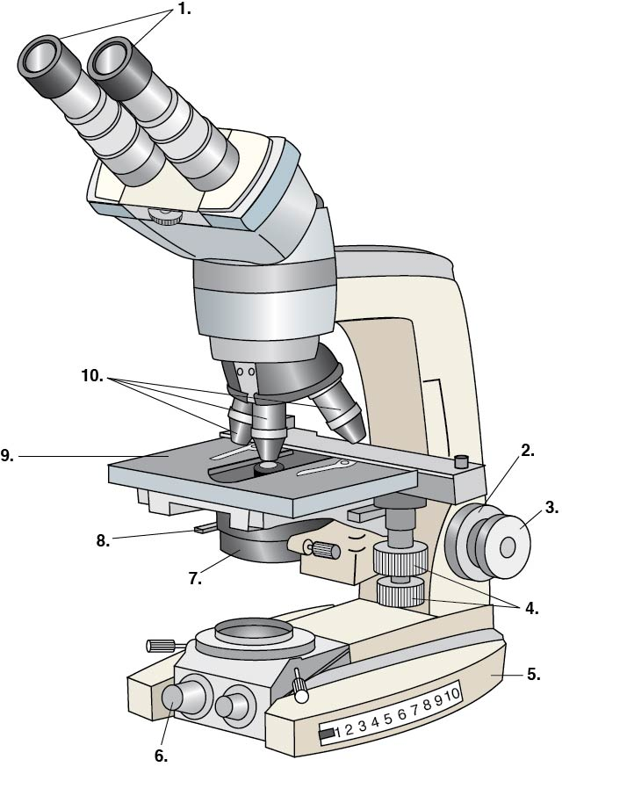
NARREND

20. Label the parts of the microscope.

_______________________1
_______________________2
_______________________3
_______________________4
_______________________5
_______________________6
_______________________7
_______________________8
_______________________9
_______________________10

ANS:

NAR: Figure 1-1
OBJ: 1.2

