Chapter 2
Student: ___________________________________________________________________________
1. | A stem-and-leaf display is a graphical portrayal of a data set that shows the data set's overall pattern of variation.  True False

2. | The median is the measure of central tendency that divides a population or sample into four equal parts.  True False

3. | The population mean is the average of the population measurements.  True False

4. | The mode is the measurement in a sample or population that occurs most frequently.  True False

5. | The population mean is a point estimate of the sample mean.  True False

6. | The median is said to be resistant to extreme values.  True False

7. | The range of set of measurements is the largest measurement plus the small measurement.  True False

8. | The population variance is the average of the squared deviations of the individual population measurements from the population mean.  True False

9. | In a symmetric population, the median equals the mean.  True False

10. | It is appropriate to use the Empirical Rule to describe a population that is extremely skewed.  True False

11. | The median is the value below which approximately 50 percent of the measurements lie.  True False

12. | An independent variable is a variable that can be used to describe, predict, or control a dependent variable.  True False

13. | The relative frequency is the frequency of a class divided by the total number of measurements.  True False

14. | The box-and-whiskers display is a graphical portrayal of data sets that depict both the central tendency and variability of the data.  True False

15. | When establishing the classes for a frequency table it is generally agreed that the more classes you use the better your frequency table will be.  True False

16. | If there are 7 classes in a frequency distribution, then the fourth class will always contain the median.  True False

17. | A Pareto chart is a type of histogram.  True False

18. | Range is a better measure of variation than standard deviation.  True False

19. | A normal population has 99.73 percent of the population measurements within _____ standard deviations of the mean.  A. one  B. two  C. three  D. four  E. five

20. | A number calculated using the sample measurements that describes some aspect of the sample is a sample ____________.  A. mean  B. variance  C. statistic  D. parameter  E. scale

21. | All of the following can be used to describe quantitative data with the exception of a _____.  A. histogram  B. stem-and-leaf display  C. dot plot  D. pie chart  E. scatter plot

22. | All of the following are measures of central tendency except the _____.  A. range  B. mode  C. mean  D. median

23. | A measurement that is separated from most of the other measurements is a(n) _____.  A. absolute extreme  B. outlier  C. mode  D. quartile  E. median

24. | Which of the following graphs is used to summarize qualitative data?  A. Histogram  B. Bar Chart  C. Time series plot  D. Stem-and-leaf display  E. Scatter plot

25. | Which percentile describes the first quartile, Q1?  A. 25th  B. 50th  C. 75th  D. 100th  E. 125th

26. | Which percentile describes the third quartile, Q3?  A. 25th  B. 50th  C. 75th  D. 100th  E. 125th

27. | A plot of the values of a dependent variable y versus the values of an independent variable x is a _____ plot.  A. runs  B. scatter  C. dot  D. time series  E. box

28. | A stem-and-leaf display is best used to _____  A. provide a point estimate of the variability in the population.  B. provide a point estimate of the central tendency in the population.  C. display the shape of the distribution of measurements.  D. reduce sampling bias.  E. represent the distribution of qualitative data.

29. | When grouping a large sample of items into classes, the _____ is a better tool than the ____.  A. histogram, stem-and-leaf display  B. box-and-whiskers display, histogram  C. stem-and-leaf display, histogram  D. scatter plot, box-and-whiskers display  E. box-and-whiskers display, scatter plot

30. | A ______________ displays the frequency of each group with qualitative data and a __________ displays the frequency of each group with quantitative data.  A. histogram, stem-and-leaf display  B. bar chart, histogram  C. scatter plot, bar chart  D. stem-and-leaf display, pie chart  E. scatter plot, pie chart

31. | A ______________ shows the relationship between two quantitative variables.  A. box-and-whiskers display  B. bar chart  C. histogram  D. scatter plot  E. pie chart

32. | In a given data set, the 25th percentile is _______________ equal to the lower hinge.  A. always  B. sometimes  C. never

33. | An airline company is, on average, late 10 minutes for arrivals. If the variance for the lateness statistic is 9, then the coefficient of variation is _____.  A. 3  B. 300  C. 10  D. 90  E. 30

34. | _____________ and ____________ are used to describe qualitative (categorical) data.  A. Stem-and- leaf displays; scatter plots.  B. Scatter plots; and box-and-whiskers displays  C. Box-and-whiskers displays; bar charts  D. Bar charts; pie charts  E. Pie charts; histograms

35. | Which of the following is influenced the least by the occurrence of extreme values in a sample?  A. Mean  B. Median  C. Mode  D. Range  E. Variance

36. | If a population distribution is positively skewed (i.e. skewed to the right), then, given a random sample from that population, one would expect that the ______________.  A. median would be greater than the mean  B. mode would be equal to the mean  C. median would never equal the mode  D. median would be equal to the mean  E. median would be less than the mean

37. | If a statistics course is determined by three exams. Exam 1 is worth 25% of the course grade. Exam 2 is worth 35% of the course grade. Exam 3 is worth 40% of the course grade. Calculate the term grade for a student with a 52% for the first exam, 63% for the second exam, and 75% for the third exam.  A. 45.75%  B. 65.05%  C. 55.25%  D. 36.35%  E. 63.00%

38. | If the mean, median, and mode for a given population are all equal, then we know that its distribution is _____.  A. bimodal  B. skewed to the right  C. symmetric  D. skewed to the left

39. | If one intends to compare the relative variation between two samples involving two different quantitative variables with different measurement scales, then the most appropriate way is to compare the __________ from the two samples.  A. standard deviations  B. variances  C. coefficients of variation  D. ranges  E. interquartile ranges

40. | A disadvantage of using grouping (a frequency table) with sample data is that  A. calculations involving central tendency and variation are more complicated than central tendency and variation calculations based on ungrouped data.  B. the descriptive statistics are less precise than the descriptive statistics obtained using ungrouped data.  C. the interpretation of the grouped data descriptive statistics is meaningless.  D. it is much more difficult to summarize the information than it is with the ungrouped data.  E. it is more difficult to interpret a pie chart.

41. | When developing a frequency distribution, the class intervals should be ___________.  A. large.  B. small.  C. different lengths.  D. mutually exclusive.  E. of equal length.

42. | Which of the following graphical tools is not used to study the shapes of distributions?  A. Stem-and-leaf display  B. Scatter plot  C. Histogram  D. Dot plot  E. Cumulative frequency distribution

43. | For a bell-shaped distribution, score x would be considered an outlier if:  A. x = 15, mean = 20, standard deviation = 3  B. x = 15, mean = 50, standard deviation = 30  C. x = 15, mean = 25, standard deviation = 5  D. x = 15, mean = 10, standard deviation = 100  E. x = 15, mean = 50, standard deviation = 10

44. | A quantity that measures the variation of a population or a sample relative to its mean is called the ____.  A. range  B. standard deviation  C. coefficient of variation  D. variance  E. interquartile range

45. | Which of the following sample statistics is a measure of variation that is based only on the minimum and maximum values in a sample?  A. Range  B. Standard deviation  C. Variance  D. Interquartile range  E. Coefficient of variation

46. | If there are 130 values in a data set, how many classes should be created for a frequency histogram?  A. 4  B. 5  C. 6  D. 7  E. 8

47. | If there are 120 values in a data set, how many classes should be created for a frequency histogram?  A. 4  B. 5  C. 6  D. 7  E. 8

48. | If there are 62 values in a data set, how many classes should be created for a frequency histogram?  A. 4  B. 5  C. 6  D. 7  E. 8

49. | If there are 30 values in a data set, how many classes should be created for a frequency histogram?  A. 4  B. 5  C. 6  D. 7  E. 8

A CFO is looking at what percentage of a company's resources are spent on computing. The CFO samples companies in the pharmaceutical industry and developed the following stem-and-leaf display. The leaf unit is 0.1.
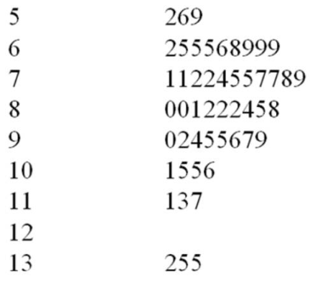

50. | What is the approximate shape of the distribution of the data?  A. Normal  B. Skewed to the right  C. Skewed to the left  D. Bimodal  E. Uniform

51. | What is the smallest percent spent on computing?  A. 5.9  B. 5.6  C. 5.2  D. 5.02  E. 50.2

52. | If a frequency histogram were to be created using these data, how many classes would you create?  A. 4  B. 5  C. 6  D. 7  E. 8

53. | What would be the class length that would be used in creating a frequency histogram?  A. 1.4  B. 8.3  C. 1.2  D. 1.7  E. 0.9

54. | What would be the first class interval for the frequency histogram?  A. 5.2 - 6.5  B. 5.2 - 6.0  C. 5.0 - 6.0  D. 5.2 - 6.6  E. 5.2 - 6.4

A local airport keeps track of the percentage of flights arriving within 15 minutes of their scheduled arrivals. The stem-and-leaf plot of the data for one year is below. The leaf unit is 0.1.
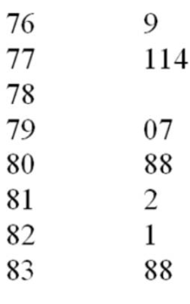

55. | What is the sample size?  A. 7  B. 9  C. 10  D. 11  E. 12

56. | In developing a histogram of these data, how many classes would be used?  A. 4  B. 5  C. 6  D. 7  E. 8

57. | What would be the class length for creating the frequency histogram?  A. 1.4  B. 0.8  C. 2.7  D. 1.7  E. 2.3

A company collected the ages from a random sample of its middle managers with the resulting frequency distribution shown below:
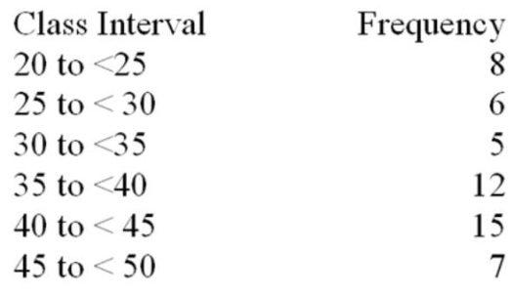

58. | What would be the approximate shape of the relative frequency histogram?  A. Uniform  B. Normal  C. Bimodal  D. Skewed to the left  E. Skewed to the right

59. | What is the relative frequency for the largest interval?  A. 0.132  B. 0.226  C. 0.231  D. 0.283  E. 0.288

60. | What is the midpoint of the third class interval?  A. 22.5  B. 27.5  C. 32.5  D. 37.5  E. 42.5

In a statistic class, 10 scores were randomly selected with the following results were obtained:
74, 73, 77, 77, 71, 68, 65, 77, 67, 66

61. | What is the mean?  A. 71.5  B. 72.0  C. 77.0  D. 71.0  E. 73.0

62. | What is the median?  A. 71.5  B. 72.0  C. 77.0  D. 71.0  E. 73.0

63. | What is the mode?  A. 71.5  B. 72.0  C. 77.0  D. 71.0  E. 73.0

The numbers of rooms for 15 homes recently sold were:
8, 8, 8, 5, 9, 8, 7, 6, 6, 7, 7, 7, 7, 9, 9

64. | What is the mean?  A. 8.0  B. 7.0  C. 6.0  D. 9.0  E. 7.4

65. | What is the median?  A. 8.0  B. 7.0  C. 6.0  D. 9.0  E. 7.4

66. | What is the mode?  A. 8.0  B. 7.0  C. 6.0  D. 9.0  E. 7.4

The values given below are snow depths measured as part of a study of satellite observations and water resources.
19, 18, 12, 25, 22, 8, 8, 16

67. | What is the mean?  A. 8  B. 23.5  C. 16  D. 17  E. 18

68. | What is the median?  A. 8  B. 23.5  C. 16  D. 17  E. 18

69. | What is the mode?  A. 8  B. 23.5  C. 16  D. 17  E. 18

In a hearing test, subjects estimate the loudness (in decibels) of sound, and the results are:
68, 67, 70, 71, 68, 75, 68, 62, 80, 73, 68

70. | What is the mean?  A. 70  B. 75  C. 68  D. 71  E. 80

71. | What is the median?  A. 70  B. 75  C. 68  D. 71  E. 80

72. | What is the mode?  A. 70  B. 75  C. 68  D. 71  E. 80

The reaction time in seconds to a stop light of a group of adult men were found to be
0.74, 0.71, 0.41, 0.82, 0.74, 0.85, 0.99, 0.71, 0.57, 0.85, 0.57, 0.55

73. | What is the mean?  A. 0.709  B. 0.710  C. 0.920  D. 0.725  E. 0.550

74. | What is the median?  A. 0.709  B. 0.710  C. 0.920  D. 0.725  E. 0.550

75. | What is the mode?  A. 0.709  B. 0.710  C. 0.920  D. 0.725  E. 0.550

In a rating of the satisfaction with their instructor, 13 students gave the following scores from a scale of 1 to 5:
3, 2, 1, 1, 5, 5, 4, 3, 3, 2, 4, 3, 3

76. | What is the mean?  A. 3  B. 5  C. 2  D. 4  E. 3.25

77. | What is the median?  A. 3  B. 5  C. 2  D. 4  E. 3.25

78. | What is the mode?  A. 3  B. 5  C. 2  D. 4  E. 3.25

The company financial officer was interested in the average cost of PCs that had been purchased in the past six months. A random sample of the price of 10 computers was taken with the following results:
$3,250, $1,127, $2,995, $3,250, $3,445, $3,449, $1,482, $6,120, $3,009, $4,000

79. | What is the mean?  A. 3447  B. 3213  C. 3250  D. 6120  E. 3445

80. | What is the median?  A. 3447  B. 3213  C. 3250  D. 6120  E. 3445

81. | What is the mode?  A. 3447  B. 3213  C. 3250  D. 6120  E. 3445

The local amusement park was interested in the average wait time at their most popular roller coaster at the peak park time (2 p.m.). They selected 13 patrons and had them get in line between 2 and 3 p.m. Each was given a stop watch to record the time they spent in line. The times recorded were as follows (in minutes):
118, 124, 108, 116, 99, 120, 148, 118, 119, 121, 45, 130, 118

82. | What is the mean?  A. 114.15  B. 118  C. 148  D. 45  E. 115.5

83. | What is the median?  A. 114.15  B. 118  C. 148  D. 45  E. 115.5

84. | What is the mode?  A. 114.15  B. 118  C. 148  D. 45  E. 115.5

Quality control is an important issue at ACME Company which manufacturers light bulbs. In order to conduct testing of the life hours of their light bulbs, they randomly sampled nine light bulbs and measured how many hours they lasted.
378, 361, 350, 375, 200, 391, 375, 368, 321

85. | What is the mean?  A. 375  B. 368  C. 389.9  D. 200  E. 346.6

86. | What is the median?  A. 375  B. 368  C. 389.9  D. 200  E. 346.6

87. | What is the mode?  A. 375  B. 368  C. 389.9  D. 200  E. 346.6

Twenty students were randomly selected from a business statistics course and were asked to report the number of times that they had eaten a meal at the university's cafeteria within the past month. Below are the values reported:
7, 8, 10, 11, 8, 6, 10, 9, 9, 8, 13, 12, 8, 11, 11, 14, 8, 7, 10, 12

88. | What is the mean?  A. 8  B. 9.6  C. 9.5  D. 10.5  E. 9

89. | What is the median?  A. 8  B. 9.6  C. 9.5  D. 10.5  E. 9

90. | What is the mode?  A. 8  B. 9.6  C. 9.5  D. 10.5  E. 9

91. | Find the coefficient of variation for an IQ test with a mean of 100 and a standard deviation of 15.  A. 15.0  B. 6.7  C. 0.15  D. 1.5  E. 0.67

92. | Find the z-score for an IQ test score of 142 when the mean is 100 and the standard deviation is 15.  A. 42  B. 2.8  C. 18.78  D. 1.27  E. -2.8

93. | Find the z-score for an IQ test score of 92.2 when the mean is 100 and the standard deviation is 15.  A. 0.53  B. 0.77  C. -0.77  D. -0.52  E. -8.00

94. | Find the z-score for an IQ test score of 118 when the mean is 100 and the standard deviation is 15.  A. 1.2  B. 1.0  C. 18.0  D. -1.03  E. -1.2

95. | Find the z-score for an IQ test score of 125 when the mean is 100 and the standard deviation is 15.  A. 25  B. 1.1  C. 1.67  D. -1.1  E. -1.67

96. | Using Chebyshev's Rule, find the interval that contains at least 93.75% of all measurements when mean = 2.549 and s = 1.828.  A. [-2.935, 8.033]  B. [-1.107, 6.205]  C. [-26.699, 31.797]  D. [2.435, 2.663]  E. [-4.763, 9.861]

According to a survey of the top 10 employers in a major city, a worker spends an average of 413 minutes a day on the job. Suppose the standard deviation is 26.8 minutes and the time spent is approximately a normal distribution.

97. | Within which interval will the times of approximately 68.26% of all workers fall?  A. [394.8, 431.2]  B. [386.2, 439.8]  C. [372.8, 453.2]  D. [359.4, 466.6]  E. [332.6, 493.4]

98. | Within which interval will the times of approximately 95.44% of all workers fall?  A. [387.5, 438.5]  B. [386.2, 439.8]  C. [372.8, 453.2]  D. [359.4, 466.6]  E. [332.6, 493.4]

99. | Within which interval will the times of approximately 99.73% of all workers fall?  A. [305.8, 520.2]  B. [386.2, 439.8]  C. [372.8, 453.2]  D. [359.4, 466.6]  E. [332.6, 493.4]

100. | According to Chebyshev's Theorem, at least what percentage of measurements in a data set will be within two standard deviations of the mean?  A. 68%  B. 50%  C. 25%  D. 75%  E. 34%

101. | According to Chebyshev's Theorem, at least what percentage of measurements in a data set will be within 2.5 standard deviations of the mean?  A. 16%  B. 40%  C. 68%  D. 60%  E. 84%

102. | According to Chebyshev's Theorem, at least what percentage of measurements in a data set will be within 1.6 standard deviations of the mean?  A. 39%  B. 58%  C. 68%  D. 61%  E. 92%

103. | According to Chebyshev's Theorem, at least what percentage of measurements in a data set will be within 3.2 standard deviations of the mean?  A. 90%  B. 95%  C. 84%  D. 97%  E. 10%

104. | Consider the interval 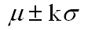 for some population. According to Chebyshev's theorem, what value of k would guarantee this interval would include at least 80% of the measurements in the population?  A. 5.0  B. 2.2  C. 2.5  D. 1.6  E. 2.0

In a statistic class, 10 scores were randomly selected with the following results were obtained (mean = 71.5):
74, 73, 77, 77, 71, 68, 65, 77, 67, 66

105. | What is the range?  A. 22.72  B. 12.00  C. 4.77  D. 516.20  E. 144.00

106. | What is the variance?  A. 22.72  B. 12.00  C. 4.77  D. 516.20  E. 144.00

107. | What is the standard deviation?  A. 22.72  B. 12.00  C. 4.77  D. 516.20  E. 144.00

The numbers of rooms for 15 homes recently sold were (mean = 7.4):
8, 8, 8, 5, 9, 8, 7, 6, 6, 7, 7, 7, 7, 9, 9

108. | What is the range?  A. 1.183  B. 1.400  C. 4.00  D. 16.00  E. 1.96

109. | What is the variance?  A. 1.183  B. 1.400  C. 4.00  D. 16.00  E. 1.96

110. | What is the standard deviation?  A. 1.183  B. 1.400  C. 4.00  D. 16.00  E. 1.96

The values given below are snow depths measured as part of a study of satellite observations and water resources (mean = 16).
19, 18, 12, 25, 22, 8, 8, 16

111. | What is the range?  A. 39.14  B. 6.26  C. 17  D. 289  E. 18

112. | What is the variance?  A. 39.14  B. 6.26  C. 17  D. 289  E. 18

113. | What is the standard deviation?  A. 39.14  B. 6.26  C. 17  D. 289  E. 18

In a hearing test, subjects estimate the loudness (in decibels) of sound, and the results are (mean = 70):
68, 67, 70, 71, 68, 75, 68, 62, 80, 73, 68

114. | What is the range?  A. 18  B. 4.73  C. 22.40  D. 324  E. 6.76

115. | What is the variance?  A. 18  B. 4.73  C. 22.40  D. 324  E. 6.76

116. | What is the standard deviation?  A. 18  B. 4.73  C. 22.40  D. 324  E. 6.76

The reaction time in seconds to a stop light for a group of adult men were found to be
0.74, 0.71, 0.41, 0.82, 0.74, 0.85, 0.99, 0.71, 0.57, 0.85, 0.57, 0.55 (mean = .709)

117. | What is the range?  A. 0.026  B. 0.052  C. 0.580  D. 0.1613  E. 0.0007

118. | What is the variance?  A. 0.026  B. 0.052  C. 0.580  D. 0.1613  E. 0.0007

119. | What is the standard deviation?  A. 0.026  B. 0.052  C. 0.580  D. 0.1613  E. 0.0007

In a rating of the satisfaction with their instructor, 13 students gave the following scores from a scale of 1 to 5 (mean = 3):
3, 2, 1, 1, 5, 5, 4, 3, 3, 2, 4, 3, 3

120. | What is the range?  A. 3  B. 4  C. 1.291  D. 1.667  E. 2.779

121. | What is the variance?  A. 3  B. 4  C. 1.291  D. 1.667  E. 2.779

122. | What is the standard deviation?  A. 3  B. 4  C. 1.291  D. 1.667  E. 2.779

The company financial officer was interested in the average cost of PCs that had been purchased in the past six months. A random sample of the price of 10 computers was taken with the following results (mean = $3,213):
$3,250, $1,127, $2,995, $3,250, $3,445, $3,449, $1,482, $6,120, $3,009, $4,000

123. | What is the range?  A. 1359  B. 4993  C. 1846575  D. 3587  E. 1976454

124. | What is the variance?  A. 1359  B. 4993  C. 1846575  D. 3587  E. 1976454

125. | What is the standard deviation?  A. 1359  B. 4993  C. 1846575  D. 3587  E. 1976454

The local amusement park was interested in the average wait time at their most popular roller coaster at the peak park time (2 p.m.). They selected 13 patrons and had them get in line between 2 and 3 p.m. Each was given a stop watch to record the time they spent in line. The times recorded were as follows (in minutes) (mean = 114.15):
118, 124, 108, 116, 99, 120, 148, 118, 119, 121, 45, 130, 118

126. | What is the range?  A. 103  B. 23.62  C. 557.97  D. 128.8  E. 115

127. | What is the variance?  A. 103  B. 23.62  C. 557.97  D. 128.8  E. 115

128. | What is the standard deviation?  A. 103  B. 23.62  C. 557.97  D. 128.8  E. 115

Quality control is an important issue at ACME Company which manufacturers light bulbs. In order to conduct testing of the life hours of their light bulbs, they randomly sampled nine light bulbs and measured how many hours they lasted (mean = 346.6).
378, 361, 350, 375, 200, 391, 375, 368, 321

129. | What is the range?  A. 342.43  B. 3424.3  C. 58.5  D. 191  E. 10609

130. | What is the variance?  A. 342.43  B. 3424.3  C. 58.5  D. 191  E. 10609

131. | What is the standard deviation?  A. 342.43  B. 3424.3  C. 58.5  D. 191  E. 10609

Twenty students were randomly selected from the most recent graduating class at a Canadian university. The number of semesters they were enrolled was calculated (mean = 9.6)
7, 8, 10, 11, 8, 6, 10, 9, 9, 8, 13, 12, 8, 11, 11, 14, 8, 7, 10, 12

132. | What is the range?  A. 8  B. 2.162  C. 9.5  D. 4.674  E. 21.846

133. | What is the variance?  A. 8  B. 2.162  C. 9.5  D. 4.674  E. 21.846

134. | What is the standard deviation?  A. 8  B. 2.162  C. 9.5  D. 4.674  E. 21.846

In a statistic class, 10 scores were randomly selected with the following results were obtained:
74, 73, 77, 77, 71, 68, 65, 77, 67, 66

135. | What is the 90th percentile?  A. 77  B. 73  C. 74  D. 67  E. 65.9

136. | What is the third quartile?  A. 65.9  B. 67.3  C. 66.75  D. 73.85  E. 77.0

137. | What is the first quartile?  A. 65.9  B. 67.3  C. 67.0  D. 73.85  E. 77.0

138. | What is the 10th percentile?  A. 65.5  B. 67.3  C. 66.75  D. 73.85  E. 77.0

139. | What is the 65th percentile?  A. 65.9  B. 67.3  C. 66.75  D. 74.0  E. 77.0

140. | What is the IQR?  A. 12.00  B. 5.25  C. 10.00  D. 5.00  E. 11.00

141. | What are the inner fences?  A. 15.375, 30.75  B. 82.125, 92.375  C. 97.50, 107.75  D. 52.00, 92.00  E. 35.95, 107.75

142. | What are the outer fences?  A. 15.375, 30.75  B. 51.375, 92.375  C. 37.00, 107.00  D. 82.125, 92.375  E. 97.50, 107.75

The numbers of rooms for 15 home recently sold were;
8, 8, 8, 5, 9, 8, 7, 6, 6, 7, 7, 7, 7, 9, 9

143. | What is the 90th percentile?  A. 9  B. 8  C. 7  D. 6  E. 5

144. | What is the third quartile?  A. 9  B. 8  C. 7  D. 6  E. 5

145. | What is the first quartile?  A. 9  B. 8  C. 7  D. 6  E. 5

146. | What is the 10th percentile?  A. 9  B. 8  C. 7  D. 6  E. 5

147. | What is the 65th percentile?  A. 9  B. 8  C. 7  D. 6  E. 5

148. | What is the IQR?  A. 15  B. 1.5  C. 3  D. 4  E. 1

149. | What are the inner fences?  A. 4, 11  B. 8.5, 9.5  C. 5.5, 9.5  D. 10, 9.5  E. 5.5, 10

150. | What are the outer fences?  A. 5.5, 9.5  B. 4, 11  C. 8.5, 9.5  D. 10, 9.5  E. 5.5, 10

The values given below are snow depths measured as part of a study of satellite observations and water resources.
19, 18, 12, 25, 22, 8, 8, 16

151. | What is the 90th percentile?  A. 8  B. 25  C. 18.55  D. 9  E. 21.25

152. | What is the third quartile?  A. 8  B. 22.9  C. 18.55  D. 9  E. 20.5

153. | What is the first quartile?  A. 8  B. 22.9  C. 18.55  D. 10  E. 21.25

154. | What is the 10th percentile?  A. 8  B. 22.9  C. 18.55  D. 9  E. 21.25

155. | What is the 65th percentile?  A. 8  B. 22.9  C. 19  D. 9  E. 21.25

156. | What is the IQR?  A. 10.5  B. 18.375  C. 36.75  D. 21.25  E. 30.25

157. | What are the inner fences?  A. 27.375, 39.625  B. -5.75, 36.25  C. -27.75, 58.00  D. 45.75, 58.00  E. 18.375, 36.75

158. | What are the outer fences?  A. -9.375, 39.625  B. -21.5, 52.00  C. 27.375, 39.625  D. 45.75, 58.00  E. 18.375, 36.75

In a hearing test, subjects estimate the loudness (in decibels) of sound, and the results are;
68, 67, 70, 71, 68, 75, 68, 62, 80, 73, 68

159. | What is the 90th percentile?  A. 73  B. 68  C. 70.5  D. 67  E. 75

160. | What is the third quartile?  A. 73  B. 68  C. 70.5  D. 67  E. 75

161. | What is the first quartile?  A. 73  B. 68  C. 70.5  D. 67  E. 75

162. | What is the 10th percentile?  A. 73  B. 68  C. 70.5  D. 67  E. 75

163. | What is the 65th percentile?  A. 73  B. 68  C. 71  D. 67  E. 75

164. | What is the IQR?  A. 18  B. 6  C. 5  D. 7.5  E. 15

165. | What are the inner fences?  A. 75.5, 80.5  B. 83, 88  C. 60.5, 80.5  D. 53, 88  E. 7.5, 15

166. | What are the outer fences?  A. 60.5, 80.5  B. 75.5, 80.5  C. 53, 88  D. 83, 88  E. 7.5, 15

The reaction time (in seconds) to a stop at a red light for a group of adult men was found to be
0.74, 0.71, 0.41, 0.82, 0.74, 0.85, 0.99, 0.71, 0.57, 0.85, 0.57, 0.55

167. | What is the 90th percentile?  A. 0.752  B. 0.552  C. 0.85  D. 0.8425  E. 0.57

168. | What is the third quartile?  A. 0.752  B. 0.552  C. 0.85  D. 0.835  E. 0.57

169. | What is the first quartile?  A. 0.752  B. 0.552  C. 0.85  D. 0.8425  E. 0.57

170. | What is the 10th percentile?  A. 0.752  B. 0.55  C. 0.85  D. 0.8425  E. 0.57

171. | What is the 65th percentile?  A. 0.74  B. 0.552  C. 0.85  D. 0.8425  E. 0.57

172. | What is the IQR?  A. 265  B. 8175  C. 40875  D. 57  E. 8425

173. | What are the inner fences?  A. 97875, 1.25125  B. 3875, 1.66  C. -.2475, 1.66  D. 40875, .8175  E. 1725, 1.2325

174. | What are the outer fences?  A. -.225, 1.63  B. 16125, 1.25125  C. 97875, 1.25125  D. 1.3875, 1.66  E. 40875, .8175

In a rating of the satisfaction with their instructor, 13 students gave the following scores from a scale of 1 to 5;
3, 2, 1, 1, 5, 5, 4, 3, 3, 2, 4, 3, 3

175. | What is the 90th percentile?  A. 1.2  B. 2  C. 3  D. 4  E. 5

176. | What is the third quartile?  A. 1.2  B. 2  C. 3  D. 4  E. 4.8

177. | What is the first quartile?  A. 1.2  B. 2  C. 3  D. 4  E. 4.8

178. | What is the 10th percentile?  A. 1  B. 2  C. 3  D. 4  E. 4.8

179. | What is the 65th percentile?  A. 1.2  B. 2  C. 3  D. 4  E. 4.8

180. | What is the IQR?  A. 2  B. 6  C. 3  D. 4  E. 1

181. | What are the inner fences?  A. -1, 7  B. -4, 10  C. 5, 7  D. 8, 10  E. 3, 6

182. | What are the outer fences?  A. -1, 7  B. -4, 10  C. 5, 7  D. 8, 10  E. 3, 6

The company financial officer was interested in the average cost of PCs that had been purchased in the past six months. A random sample of the price of 10 computers was taken with the following results;
$3,250, $1,127, $2,995, $3,250, $3,445, $3,449, $1,482, $6,120, $3,009, $4,000

183. | What is the 90th percentile?  A. $1,446.5  B. $2,617  C. $3,415.75  D. $3,587  E. $5,060

184. | What is the third quartile?  A. $1,446.5  B. $2,617  C. $3,415.75  D. $3,449  E. $4,212

185. | What is the first quartile?  A. $1,446.5  B. $2,995  C. $3,415.75  D. $3,587  E. $4,212

186. | What is the 10th percentile?  A. $1,304.50  B. $2,617  C. $3,415.75  D. $3,587  E. $4,212

187. | What is the 65th percentile?  A. $1,446.5  B. $2,617  C. $3,445  D. $3,587  E. $4,212

188. | What is the IQR?  A. 1455  B. 454  C. 2910  D. 4993  E. 6204

189. | What are the inner fences?  A. 1455, 2910  B. 4072, 5042  C. 5527, 6497  D. 2314, 4130  E. -293, 6497

190. | What are the outer fences?  A. 1455, 2910  B. 4072, 5042  C. 5527, 6497  D. 1162, 5042  E. 1633, 4811

The local amusement park was interested in the average wait time at their most popular roller coaster at the peak park time (2 p.m.). They selected 13 patrons and had them get in line between 2 and 3 p.m. Each was given a stop watch to record the time they spent in line. The times recorded were as follows (in minutes)
118, 124, 108, 116, 99, 120, 148, 118, 119, 121, 45, 130, 118

191. | What is the 90th percentile?  A. 100.8  B. 119.8  C. 130  D. 112  E. 122.5

192. | What is the third quartile?  A. 100.8  B. 119.8  C. 128.8  D. 112  E. 121

193. | What is the first quartile?  A. 100.8  B. 119.8  C. 128.8  D. 116  E. 122.5

194. | What is the 10th percentile?  A. 99  B. 119.8  C. 128.8  D. 112  E. 122.5

195. | What is the 65th percentile?  A. 100.8  B. 120  C. 128.8  D. 112  E. 122.5

196. | What is the IQR?  A. 21.00  B. 5  C. 15.75  D. 31.50  E. 11.50

197. | What are the inner fences?  A. 108.50, 128.50  B. 80.50, 154.00  C. 127.75, 138.25  D. 143.50, 154.00  E. 15.75, 31.50

198. | What are the outer fences?  A. 96.25, 138.25  B. 101.00, 136.00  C. 127.75, 138.25  D. 143.50, 154.00  E. 15.75, 31.50

Quality control is an important issue at ACME Company which manufacturers light bulbs. In order to conduct testing of the life hours of their light bulbs, they randomly sampled nine light bulbs and measured how many hours they lasted.
378, 361, 350, 375, 200, 391, 375, 368, 321

199. | What is the 90th percentile?  A. 335.5  B. 370.5  C. 391  D. 296.8  E. 375

200. | What is the third quartile?  A. 335.5  B. 370.5  C. 380.6  D. 296.8  E. 375

201. | What is the first quartile?  A. 350  B. 370.5  C. 380.6  D. 296.8  E. 375

202. | What is the 10th percentile?  A. 335.5  B. 370.5  C. 380.6  D. 200  E. 375

203. | What is the 65th percentile?  A. 335.5  B. 370.5  C. 380.6  D. 296.8  E. 375

204. | What is the IQR?  A. 25  B. 22  C. 61.50  D. 191  E. 82

205. | What are the inner fences?  A. 312.5, 412.5  B. 212.5, 499.5  C. 397.0, 438.0  D. 458.5, 499.5  E. 61.5, 123.0

206. | What are the outer fences?  A. 274.0, 438.0  B. 275.0, 450.0  C. 397.0, 438.0  D. 458.5, 499.5  E. 61.5, 123.0

Twenty students were randomly selected from a business statistics course and were asked to report the number of times that they had eaten a meal at the university's cafeteria within the past month. Below are the values reported:
7, 8, 10, 11, 8, 6, 10, 9, 9, 8, 13, 12, 8, 11, 11, 14, 8, 7, 10, 12

207. | What is the 90th percentile?  A. 7  B. 10.35  C. 12.5  D. 11  E. 8

208. | What is the third quartile?  A. 7  B. 10.35  C. 12.1  D. 11  E. 8

209. | What is the first quartile?  A. 7  B. 10.35  C. 12.1  D. 11  E. 8

210. | What is the 10th percentile?  A. 7  B. 10.35  C. 12.1  D. 11  E. 8

211. | What is the 65th percentile?  A. 7  B. 10.5  C. 12.1  D. 11  E. 8

212. | What is the IQR?  A. 3  B. 8  C. 3.5  D. 11  E. 4.5

213. | What are the inner fences?  A. 17, 20  B. 3.5, 15.5  C. 12.5, 15.5  D. -1, 20  E. 4.5, 9.0

214. | What are the outer fences?  A. 17, 20  B. -1, 20  C. 3.5, 15.5  D. 12.5, 15.5  E. 4.5, 9.0

In a survey of 550 randomly-selected business statistic students were surveyed on their impressions of their course, instructor, and textbook. The results are as follows:
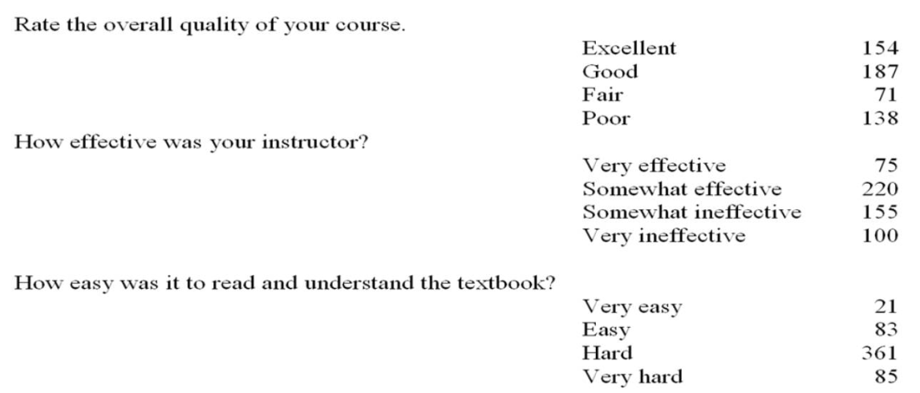
Use the above results to answer the following questions:
Compute a point estimate of the proportion of all college statistic students who:

215. | Think their instructor was "very effective"  A. 0.136  B. 0.536  C. 0.182  D. 0.280  E. 0.014

216. | Feel their textbook is not "easy" or "very easy"  A. 0.189  B. 0.811  C. 0.009  D. 0.656  E. 0.151

217. | Think the quality of the course was "fair"  A. 0.251  B. 0.620  C. 0.129  D. 0.871  E. 0.340

218. | Think that they had a "very ineffective" or "somewhat ineffective" instructor  A. 0.282  B. 0.136  C. 0.182  D. 0.280  E. 0.464

219. | Of the students who thought their textbook was very hard to read, 50 also thought that the quality of the course was "poor". What proportion of students who think that their textbook was "hard" also thought their course was "poor".  A. 0.588  B. 0.155  C. 0.091  D. 0.251  E. 0.616

The 550 students answered an additional question with the following results based on their rating of their instructor:
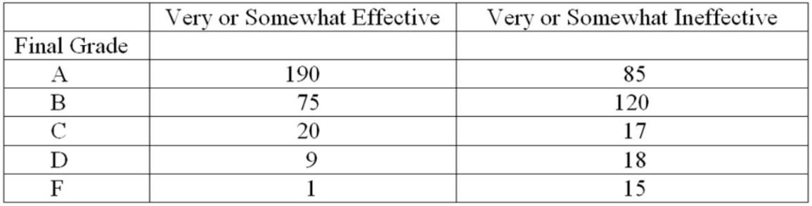

220. | What proportion of the students who rated their instructor as very or somewhat effective received a B or better in the class?  A. 0.345  B. 0.254  C. 0.482  D. 0.898  E. 0.644

221. | What proportion of all 550 students received less than a C?  A. 0.03  B. 0.06  C. 0.08  D. 0.13  E. 0.15

822 customers were randomly selected from those who had recently bought a book over the internet. The chart below shows the breakdown of the classification of the book type:
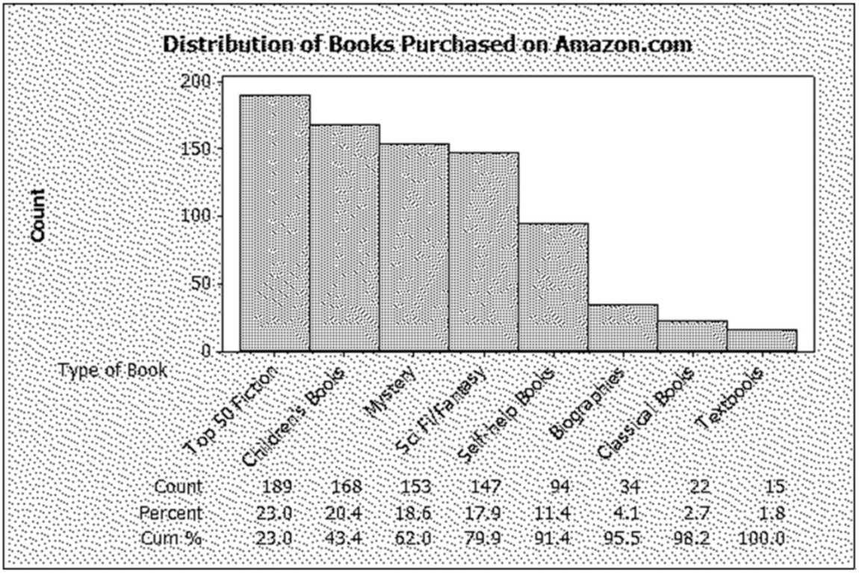

222. | What percentage of the books purchased were either mystery or science fiction/fantasy?  A. 18.61  B. 36.50  C. 17.88  D. 24.33  E. 22.99

223. | What proportion of the books purchased were self-help books?  A. 0.1144  B. 11.44  C. 1.82  D. 0.0182  E. 0.940

224. | What percentage of books were in the top two categories?  A. 22.99  B. 20.44  C. 4.50  D. 43.43  E. 4343

225. | A graphical display of categorical data made up of vertical or horizontal bars is called a _____.  ________________________________________

226. | A measurement located between the inner and outer fences of a box-and-whisker display is a(n) _____.  ________________________________________

227. | A measurement located outside the outer fences of a box-and-whisker display is a(n) _____.  ________________________________________

228. | A graphical portrayal of a data set that divides the data into classes and gives the frequency of each class is a(n) _____.  ________________________________________

229. | Another name for the 50th percentile is the _____.  ________________________________________

230. | The measurement in a sample or a population that occurs most frequently is the _____.  ________________________________________

231. | The average of the squared deviations of the individual population measurement from the population mean is the _____.  ________________________________________

232. | If a process is able to consistently produce output that meets customer requirements (specifications), we say that it is a _________ process.  ________________________________________

233. | Histograms and stem-and-leaf displays are used to visualize the distribution of _________ data.  ________________________________________

234. | The difference between the largest and smallest measurements in a population or sample is the _____.  ________________________________________

235. | A relative frequency curve having a long tail to the right is said to be _____ to the right.  ________________________________________

236. | If the mean is greater than the median, then the distribution is skewed _____.  ________________________________________

237. | The proportion of measurements in a class is called the _______ of that class.  ________________________________________

238. | A histogram that tails out towards larger values is skewed _____.  ________________________________________

239. | A histogram that tails out towards smaller values is skewed _____.  ________________________________________

240. | The point estimate of the population _______________ is the positive square root of the sample variance.  ________________________________________

241. | The ____________________ is a quantity that measures the variation of a population or sample relative to its mean.  ________________________________________

242. | A(n) ___________ is a graphical display of categorical data made up of vertical or horizontal bars.  ________________________________________

243. | What percent of a normal population is within 2 standard deviations of the mean?

244. | Twenty students were randomly selected from a business statistics course and were asked to report the number of times that they had eaten a meal at the university's cafeteria within the past month. Below are the values reported: 7, 8, 10, 11, 8, 6, 10, 9, 9, 8, 13, 12, 8, 11, 11, 14, 8, 7, 10, 12. What is the 90th percentile?

245. | Compute the mean of the data 32,33,22,28,24,23,27,24,27,21.

246. | Compute the median of the data 32,33,22,28,24,23,27,24,27,21.

247. | Compute the mode(s) of the data 32,33,22,28,24,23,27,24,27,21.

248. | Compute the range of the data: 16,18,23,21,17,16,24,23,9,17,11,16,13,10,15,14.

249. | Compute the population variance of the data: 16,18,23,21,17,16,24,23,9,17,11,16,22,10,15,14.

250. | Determine the sample mean of the data 5,4,8,6,1,0,2,6.

251. | Determine the median of the data 2,4,6,8,10,12,14.

252. | Determine the mode of the data 2,4,6,2,5,6,2,9,4,5,2,1.

253. | Compute the sample standard deviation of the data 5,4,8,6,1,0,2,6.

254. | What is the range of the following set of data: 3,7,2,1,8?

255. | Calculate a one standard deviation tolerance interval for the data that has a sample mean of 28,475 and a standard deviation of 9,369.

256. | Calculate a two standard deviation tolerance interval for the data that has a sample mean of 28,475 and a standard deviation of 9,369.

257. | Calculate a three standard deviation tolerance interval for the data that has a sample mean of 28,475 and a standard deviation of 9,369.

258. | If the median of a data set is 760 and the upper quartile is 950, and the lower quartile is 650, what is the interquartile range?

259. | If the median of the data set is 40 and the upper quartile is 42 and the lower quartile is 37, what is the interquartile range?

260. | Given a set of data with a mean of 150 and a standard deviation of 20. Using Chebyshev's Theorem, what is the minimum percentage of data between 110 and 190?

261. | Given a set of data with mean of 150 and a standard deviation of 25. Using Chebyshev's Theorem, what is the minimum percentage of data between 75 and 225?

262. | Determine the median of the data set 95,86,78,90,62,73,89,92,84,76.

263. | Compute the sample standard deviation of the data set 6,4,2,1,4,1

264. | If 50 of 500 sampled customers said they would make a purchase of a new TV set, what is the sample proportion?

265. | Describe the shape of a population distribution, if the median is greater than the mean.

266. | In a normally distributed population, what tolerance interval contains 68.26 percent of all measurements?

267. | In a normally distributed population, what tolerance interval contains 95.44 percent of all measurements?

268. | In a normally distributed population, what tolerance interval contains 99.73 percent of all measurements?

269. | What are three important properties of any data set?

270. | If specifications for a process are (1.6, 1.8), and a 99.73 percent tolerance interval is (1.62, 1.83), is the process capable?

271. | The average lateness for one of the top airline companies is 10 minutes. The variance of the lateness measure is calculated as 9. What is the coefficient of variation?

272. | The average lateness for one of the top airline companies is 10 minutes. The variance of the lateness measure is calculated as 9. An airplane arrived 13 minutes after the stated arrival time. Calculate the Z-score for this particular airplane's lateness.

The average life of Canadian women is 73.75 years and the standard deviation of the women's life expectancy in Canada is 6.5 years.

273. | Using the Chebychev's theorem, determine the minimum percentage of women in Canada whose life expectancy is between 64 and 83.5 years.

274. | Based on Chebychev's inequality determine the upper and lower bounds on the average life expectancy of the Canadian women such that at least 90% of all population is included.

275. | The average lateness for one of the top airline companies is 10 minutes. The variance of the lateness measure is calculated as 9. An airplane arrived 8.5 minutes after the stated arrival time. Calculate the Z-score for this particular airplane's lateness.

The following table shows the Price-to-Earnings ratio for a Stereo equipment manufacturing company between 1998 and 2002.
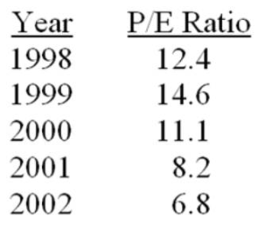

276. | Determine the percentage change in the P/E ratios from 1998 to 1999.

277. | Determine the percentage change in the P/E ratios from 1999 to 2000.

278. | The following table shows the annual percentage growth rate for a Stereo equipment manufacturing company between 1998 and 2002. The of the P/E ratios are also calculated and given below:  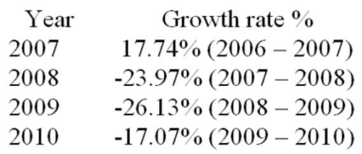  Calculate the mean growth rate.

The following frequency table summarizes the ages of 64 shoppers at the local grocery store.
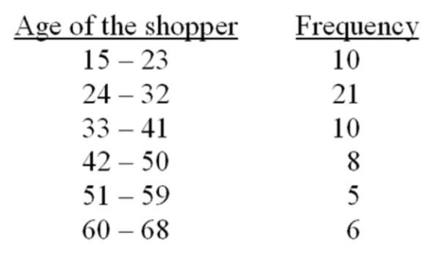

279. | Calculate the (approximate) sample mean for this data (mean for the grouped data).

280. | The sample mean for the above frequency table is calculated as 36.25. Calculate the (approximate) sample variance and standard deviation for this data set.

A CFO is looking at the percentage of a company's resources are spent on computing. The CFO samples companies in the pharmaceutical industry and developed the following stem-and-leaf display.
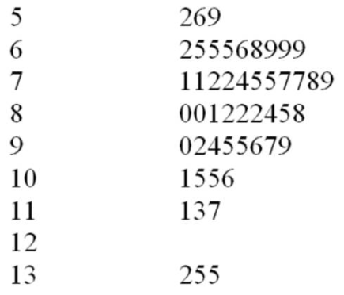

281. | What is the approximate shape of the distribution of the data?

282. | What is the smallest percent spent on computing?

283. | If a frequency histogram were to be created using these data, how many classes would you create?

284. | Personnel managers usually want to know where a job applicant ranked in an entrance test for their company. With a score of 3.83, Michelle Robinson ranked above the 93rd percentile of the other applicants. What is the percentile rank of an applicant whose score was the median value?

285. | The Rivertown city council is attempting to choose one of two sites (A or B) as the location for its new emergency facility. After the new emergency facility becomes available for service, the current emergency facility will be shut down. The project manager has estimated the following response times in minutes from each of the proposed sites to the four areas that must be served by the emergency facility.  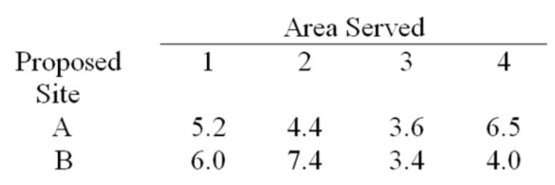  The number of emergency runs from the current emergency facility to each of the four areas over the past year is as follows:  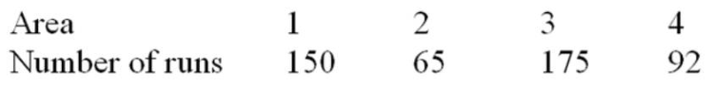  Compute the weighted mean response time from both proposed locations and determine which proposed site should be selected for the new emergency facility.

286. | Consider the following data:  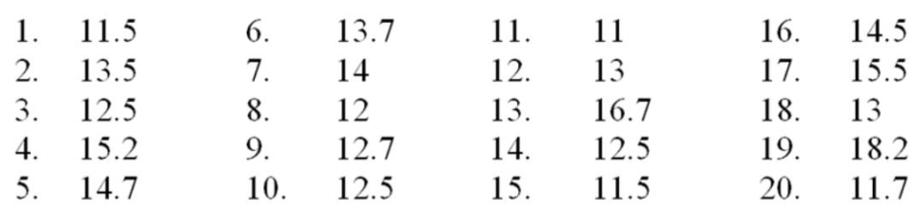  (a) Create a stem and leaf display for the sample.  (b) Describe the shape of the stem and leaf display.  (c) What is the mode?  (d) What is the media?

Chapter 2 Key
1. | A stem-and-leaf display is a graphical portrayal of a data set that shows the data set's overall pattern of variation.  TRUE

Accessibility: Keyboard Navigation
Bowerman - Chapter 02 #1
Difficulty: Medium
Learning Objective: 02-01 Explain what is demonstrated by a stem-and-leaf display that you have constructed

2. | The median is the measure of central tendency that divides a population or sample into four equal parts.  FALSE

Accessibility: Keyboard Navigation
Bowerman - Chapter 02 #2
Difficulty: Easy
Learning Objective: 02-06 Distinguish between a mean; a median; and a mode

3. | The population mean is the average of the population measurements.  TRUE

Accessibility: Keyboard Navigation
Bowerman - Chapter 02 #3
Difficulty: Easy
Learning Objective: 02-06 Distinguish between a mean; a median; and a mode

4. | The mode is the measurement in a sample or population that occurs most frequently.  TRUE

Accessibility: Keyboard Navigation
Bowerman - Chapter 02 #4
Difficulty: Easy
Learning Objective: 02-06 Distinguish between a mean; a median; and a mode

5. | The population mean is a point estimate of the sample mean.  FALSE

Accessibility: Keyboard Navigation
Bowerman - Chapter 02 #5
Difficulty: Medium
Learning Objective: 02-06 Distinguish between a mean; a median; and a mode

6. | The median is said to be resistant to extreme values.  TRUE

Accessibility: Keyboard Navigation
Bowerman - Chapter 02 #6
Difficulty: Medium
Learning Objective: 02-06 Distinguish between a mean; a median; and a mode

7. | The range of set of measurements is the largest measurement plus the small measurement.  FALSE

Accessibility: Keyboard Navigation
Bowerman - Chapter 02 #7
Difficulty: Easy
Learning Objective: 02-06 Distinguish between a mean; a median; and a mode

8. | The population variance is the average of the squared deviations of the individual population measurements from the population mean.  TRUE

Accessibility: Keyboard Navigation
Bowerman - Chapter 02 #8
Difficulty: Medium
Learning Objective: 02-07 Compute the variance and standard deviation from raw data

9. | In a symmetric population, the median equals the mean.  TRUE

Accessibility: Keyboard Navigation
Bowerman - Chapter 02 #9
Difficulty: Easy
Learning Objective: 02-04 Differentiate between a symmetrical distribution and a positively or negatively skewed distribution

10. | It is appropriate to use the Empirical Rule to describe a population that is extremely skewed.  FALSE

Accessibility: Keyboard Navigation
Bowerman - Chapter 02 #10
Difficulty: Medium
Learning Objective: 02-04 Differentiate between a symmetrical distribution and a positively or negatively skewed distribution

11. | The median is the value below which approximately 50 percent of the measurements lie.  TRUE

Accessibility: Keyboard Navigation
Bowerman - Chapter 02 #11
Difficulty: Easy
Learning Objective: 02-06 Distinguish between a mean; a median; and a mode

12. | An independent variable is a variable that can be used to describe, predict, or control a dependent variable.  TRUE

Accessibility: Keyboard Navigation
Bowerman - Chapter 02 #12
Difficulty: Medium
Learning Objective: N/A

13. | The relative frequency is the frequency of a class divided by the total number of measurements.  TRUE

Accessibility: Keyboard Navigation
Bowerman - Chapter 02 #13
Difficulty: Medium
Learning Objective: 02-02 Describe how a histogram is constructed

14. | The box-and-whiskers display is a graphical portrayal of data sets that depict both the central tendency and variability of the data.  TRUE

Accessibility: Keyboard Navigation
Bowerman - Chapter 02 #14
Difficulty: Medium
Learning Objective: N/A

15. | When establishing the classes for a frequency table it is generally agreed that the more classes you use the better your frequency table will be.  FALSE

Accessibility: Keyboard Navigation
Bowerman - Chapter 02 #15
Difficulty: Easy
Learning Objective: 02-02 Describe how a histogram is constructed

16. | If there are 7 classes in a frequency distribution, then the fourth class will always contain the median.  FALSE

Accessibility: Keyboard Navigation
Bowerman - Chapter 02 #16
Difficulty: Medium
Learning Objective: 02-02 Describe how a histogram is constructed

17. | A Pareto chart is a type of histogram.  FALSE

Accessibility: Keyboard Navigation
Bowerman - Chapter 02 #17
Difficulty: Medium
Learning Objective: 02-03 Identify when a histogram should be used

18. | Range is a better measure of variation than standard deviation.  FALSE

Accessibility: Keyboard Navigation
Bowerman - Chapter 02 #18
Difficulty: Medium
Learning Objective: 02-07 Compute the variance and standard deviation from raw data

19. | A normal population has 99.73 percent of the population measurements within _____ standard deviations of the mean.  A. one  B. two  C. three  D. four  E. five

Accessibility: Keyboard Navigation
Bowerman - Chapter 02 #19
Difficulty: Medium
Learning Objective: 02-07 Compute the variance and standard deviation from raw data

20. | A number calculated using the sample measurements that describes some aspect of the sample is a sample ____________.  A. mean  B. variance  C. statistic  D. parameter  E. scale

Accessibility: Keyboard Navigation
Bowerman - Chapter 02 #20
Difficulty: Medium
Learning Objective: 02-06 Distinguish between a mean; a median; and a mode
Learning Objective: 02-07 Compute the variance and standard deviation from raw data

21. | All of the following can be used to describe quantitative data with the exception of a _____.  A. histogram  B. stem-and-leaf display  C. dot plot  D. pie chart  E. scatter plot

Accessibility: Keyboard Navigation
Bowerman - Chapter 02 #21
Difficulty: Medium
Learning Objective: 02-01 Explain what is demonstrated by a stem-and-leaf display that you have constructed
Learning Objective: 02-03 Identify when a histogram should be used

22. | All of the following are measures of central tendency except the _____.  A. range  B. mode  C. mean  D. median

Accessibility: Keyboard Navigation
Bowerman - Chapter 02 #22
Difficulty: Easy
Learning Objective: 02-06 Distinguish between a mean; a median; and a mode

23. | A measurement that is separated from most of the other measurements is a(n) _____.  A. absolute extreme  B. outlier  C. mode  D. quartile  E. median

Accessibility: Keyboard Navigation
Bowerman - Chapter 02 #23
Difficulty: Easy
Learning Objective: 02-05 Define the term outlier

24. | Which of the following graphs is used to summarize qualitative data?  A. Histogram  B. Bar Chart  C. Time series plot  D. Stem-and-leaf display  E. Scatter plot

Accessibility: Keyboard Navigation
Bowerman - Chapter 02 #24
Difficulty: Medium
Learning Objective: N/A

25. | Which percentile describes the first quartile, Q1?  A. 25th  B. 50th  C. 75th  D. 100th  E. 125th

Accessibility: Keyboard Navigation
Bowerman - Chapter 02 #25
Difficulty: Easy
Learning Objective: N/A

26. | Which percentile describes the third quartile, Q3?  A. 25th  B. 50th  C. 75th  D. 100th  E. 125th

Accessibility: Keyboard Navigation
Bowerman - Chapter 02 #26
Difficulty: Easy
Learning Objective: N/A

27. | A plot of the values of a dependent variable y versus the values of an independent variable x is a _____ plot.  A. runs  B. scatter  C. dot  D. time series  E. box

Accessibility: Keyboard Navigation
Bowerman - Chapter 02 #27
Difficulty: Medium
Learning Objective: N/A

28. | A stem-and-leaf display is best used to _____  A. provide a point estimate of the variability in the population.  B. provide a point estimate of the central tendency in the population.  C. display the shape of the distribution of measurements.  D. reduce sampling bias.  E. represent the distribution of qualitative data.

Accessibility: Keyboard Navigation
Bowerman - Chapter 02 #28
Difficulty: Medium
Learning Objective: 02-01 Explain what is demonstrated by a stem-and-leaf display that you have constructed

29. | When grouping a large sample of items into classes, the _____ is a better tool than the ____.  A. histogram, stem-and-leaf display  B. box-and-whiskers display, histogram  C. stem-and-leaf display, histogram  D. scatter plot, box-and-whiskers display  E. box-and-whiskers display, scatter plot

Accessibility: Keyboard Navigation
Bowerman - Chapter 02 #29
Difficulty: Medium
Learning Objective: 02-01 Explain what is demonstrated by a stem-and-leaf display that you have constructed
Learning Objective: 02-03 Identify when a histogram should be used

30. | A ______________ displays the frequency of each group with qualitative data and a __________ displays the frequency of each group with quantitative data.  A. histogram, stem-and-leaf display  B. bar chart, histogram  C. scatter plot, bar chart  D. stem-and-leaf display, pie chart  E. scatter plot, pie chart

Accessibility: Keyboard Navigation
Bowerman - Chapter 02 #30
Difficulty: Medium
Learning Objective: 02-03 Identify when a histogram should be used

31. | A ______________ shows the relationship between two quantitative variables.  A. box-and-whiskers display  B. bar chart  C. histogram  D. scatter plot  E. pie chart

Accessibility: Keyboard Navigation
Bowerman - Chapter 02 #31
Difficulty: Medium
Learning Objective: N/A

32. | In a given data set, the 25th percentile is _______________ equal to the lower hinge.  A. always  B. sometimes  C. never

Accessibility: Keyboard Navigation
Bowerman - Chapter 02 #32
Difficulty: Hard
Learning Objective: N/A

33. | An airline company is, on average, late 10 minutes for arrivals. If the variance for the lateness statistic is 9, then the coefficient of variation is _____.  A. 3  B. 300  C. 10  D. 90  E. 30

Accessibility: Keyboard Navigation
Bowerman - Chapter 02 #33
Difficulty: Medium
Learning Objective: 02-07 Compute the variance and standard deviation from raw data

34. | _____________ and ____________ are used to describe qualitative (categorical) data.  A. Stem-and- leaf displays; scatter plots.  B. Scatter plots; and box-and-whiskers displays  C. Box-and-whiskers displays; bar charts  D. Bar charts; pie charts  E. Pie charts; histograms

Accessibility: Keyboard Navigation
Bowerman - Chapter 02 #34
Difficulty: Medium
Learning Objective: N/A

35. | Which of the following is influenced the least by the occurrence of extreme values in a sample?  A. Mean  B. Median  C. Mode  D. Range  E. Variance

Accessibility: Keyboard Navigation
Bowerman - Chapter 02 #35
Difficulty: Medium
Learning Objective: 02-06 Distinguish between a mean; a median; and a mode
Learning Objective: 02-07 Compute the variance and standard deviation from raw data

36. | If a population distribution is positively skewed (i.e. skewed to the right), then, given a random sample from that population, one would expect that the ______________.  A. median would be greater than the mean  B. mode would be equal to the mean  C. median would never equal the mode  D. median would be equal to the mean  E. median would be less than the mean

Accessibility: Keyboard Navigation
Bowerman - Chapter 02 #36
Difficulty: Medium
Learning Objective: 02-04 Differentiate between a symmetrical distribution and a positively or negatively skewed distribution

37. | If a statistics course is determined by three exams. Exam 1 is worth 25% of the course grade. Exam 2 is worth 35% of the course grade. Exam 3 is worth 40% of the course grade. Calculate the term grade for a student with a 52% for the first exam, 63% for the second exam, and 75% for the third exam.  A. 45.75%  B. 65.05%  C. 55.25%  D. 36.35%  E. 63.00%

Accessibility: Keyboard Navigation
Bowerman - Chapter 02 #37
Difficulty: Medium
Learning Objective: N/A

38. | If the mean, median, and mode for a given population are all equal, then we know that its distribution is _____.  A. bimodal  B. skewed to the right  C. symmetric  D. skewed to the left

Accessibility: Keyboard Navigation
Bowerman - Chapter 02 #38
Difficulty: Medium
Learning Objective: 02-04 Differentiate between a symmetrical distribution and a positively or negatively skewed distribution

39. | If one intends to compare the relative variation between two samples involving two different quantitative variables with different measurement scales, then the most appropriate way is to compare the __________ from the two samples.  A. standard deviations  B. variances  C. coefficients of variation  D. ranges  E. interquartile ranges

Accessibility: Keyboard Navigation
Bowerman - Chapter 02 #39
Difficulty: Medium
Learning Objective: 02-07 Compute the variance and standard deviation from raw data

40. | A disadvantage of using grouping (a frequency table) with sample data is that  A. calculations involving central tendency and variation are more complicated than central tendency and variation calculations based on ungrouped data.  B. the descriptive statistics are less precise than the descriptive statistics obtained using ungrouped data.  C. the interpretation of the grouped data descriptive statistics is meaningless.  D. it is much more difficult to summarize the information than it is with the ungrouped data.  E. it is more difficult to interpret a pie chart.

Accessibility: Keyboard Navigation
Bowerman - Chapter 02 #40
Difficulty: Medium
Learning Objective: N/A

41. | When developing a frequency distribution, the class intervals should be ___________.  A. large.  B. small.  C. different lengths.  D. mutually exclusive.  E. of equal length.

Accessibility: Keyboard Navigation
Bowerman - Chapter 02 #41
Difficulty: Hard
Learning Objective: 02-02 Describe how a histogram is constructed

42. | Which of the following graphical tools is not used to study the shapes of distributions?  A. Stem-and-leaf display  B. Scatter plot  C. Histogram  D. Dot plot  E. Cumulative frequency distribution

Accessibility: Keyboard Navigation
Bowerman - Chapter 02 #42
Difficulty: Medium
Learning Objective: 02-01 Explain what is demonstrated by a stem-and-leaf display that you have constructed
Learning Objective: 02-03 Identify when a histogram should be used

43. | For a bell-shaped distribution, score x would be considered an outlier if:  A. x = 15, mean = 20, standard deviation = 3  B. x = 15, mean = 50, standard deviation = 30  C. x = 15, mean = 25, standard deviation = 5  D. x = 15, mean = 10, standard deviation = 100  E. x = 15, mean = 50, standard deviation = 10

Accessibility: Keyboard Navigation
Bowerman - Chapter 02 #43
Difficulty: Hard
Learning Objective: 02-05 Define the term outlier

44. | A quantity that measures the variation of a population or a sample relative to its mean is called the ____.  A. range  B. standard deviation  C. coefficient of variation  D. variance  E. interquartile range

Accessibility: Keyboard Navigation
Bowerman - Chapter 02 #44
Difficulty: Easy
Learning Objective: 02-07 Compute the variance and standard deviation from raw data

45. | Which of the following sample statistics is a measure of variation that is based only on the minimum and maximum values in a sample?  A. Range  B. Standard deviation  C. Variance  D. Interquartile range  E. Coefficient of variation

Accessibility: Keyboard Navigation
Bowerman - Chapter 02 #45
Difficulty: Medium
Learning Objective: 02-07 Compute the variance and standard deviation from raw data

46. | If there are 130 values in a data set, how many classes should be created for a frequency histogram?  A. 4  B. 5  C. 6  D. 7  E. 8

Accessibility: Keyboard Navigation
Bowerman - Chapter 02 #46
Difficulty: Medium
Learning Objective: 02-02 Describe how a histogram is constructed

47. | If there are 120 values in a data set, how many classes should be created for a frequency histogram?  A. 4  B. 5  C. 6  D. 7  E. 8

Accessibility: Keyboard Navigation
Bowerman - Chapter 02 #47
Difficulty: Medium
Learning Objective: 02-02 Describe how a histogram is constructed

48. | If there are 62 values in a data set, how many classes should be created for a frequency histogram?  A. 4  B. 5  C. 6  D. 7  E. 8

Accessibility: Keyboard Navigation
Bowerman - Chapter 02 #48
Difficulty: Medium
Learning Objective: 02-02 Describe how a histogram is constructed

49. | If there are 30 values in a data set, how many classes should be created for a frequency histogram?  A. 4  B. 5  C. 6  D. 7  E. 8

Accessibility: Keyboard Navigation
Bowerman - Chapter 02 #49
Difficulty: Medium
Learning Objective: 02-02 Describe how a histogram is constructed

A CFO is looking at what percentage of a company's resources are spent on computing. The CFO samples companies in the pharmaceutical industry and developed the following stem-and-leaf display. The leaf unit is 0.1.

Bowerman - Chapter 02

50. | What is the approximate shape of the distribution of the data?  A. Normal  B. Skewed to the right  C. Skewed to the left  D. Bimodal  E. Uniform

Bowerman - Chapter 02 #50
Difficulty: Medium
Learning Objective: 02-01 Explain what is demonstrated by a stem-and-leaf display that you have constructed

51. | What is the smallest percent spent on computing?  A. 5.9  B. 5.6  C. 5.2  D. 5.02  E. 50.2

Bowerman - Chapter 02 #51
Difficulty: Medium
Learning Objective: 02-01 Explain what is demonstrated by a stem-and-leaf display that you have constructed

52. | If a frequency histogram were to be created using these data, how many classes would you create?  A. 4  B. 5  C. 6  D. 7  E. 8

Bowerman - Chapter 02 #52
Difficulty: Medium
Learning Objective: 02-02 Describe how a histogram is constructed

53. | What would be the class length that would be used in creating a frequency histogram?  A. 1.4  B. 8.3  C. 1.2  D. 1.7  E. 0.9

Bowerman - Chapter 02 #53
Difficulty: Medium
Learning Objective: 02-02 Describe how a histogram is constructed

54. | What would be the first class interval for the frequency histogram?  A. 5.2 - 6.5  B. 5.2 - 6.0  C. 5.0 - 6.0  D. 5.2 - 6.6  E. 5.2 - 6.4

Bowerman - Chapter 02 #54
Difficulty: Medium
Learning Objective: 02-02 Describe how a histogram is constructed

A local airport keeps track of the percentage of flights arriving within 15 minutes of their scheduled arrivals. The stem-and-leaf plot of the data for one year is below. The leaf unit is 0.1.

Bowerman - Chapter 02

55. | What is the sample size?  A. 7  B. 9  C. 10  D. 11  E. 12

Bowerman - Chapter 02 #55
Difficulty: Medium
Learning Objective: 02-01 Explain what is demonstrated by a stem-and-leaf display that you have constructed

56. | In developing a histogram of these data, how many classes would be used?  A. 4  B. 5  C. 6  D. 7  E. 8

Bowerman - Chapter 02 #56
Difficulty: Medium
Learning Objective: 02-02 Describe how a histogram is constructed

57. | What would be the class length for creating the frequency histogram?  A. 1.4  B. 0.8  C. 2.7  D. 1.7  E. 2.3

Bowerman - Chapter 02 #57
Difficulty: Medium
Learning Objective: 02-02 Describe how a histogram is constructed

A company collected the ages from a random sample of its middle managers with the resulting frequency distribution shown below:

Bowerman - Chapter 02

58. | What would be the approximate shape of the relative frequency histogram?  A. Uniform  B. Normal  C. Bimodal  D. Skewed to the left  E. Skewed to the right

Bowerman - Chapter 02 #58
Difficulty: Hard
Learning Objective: 02-02 Describe how a histogram is constructed

59. | What is the relative frequency for the largest interval?  A. 0.132  B. 0.226  C. 0.231  D. 0.283  E. 0.288

Bowerman - Chapter 02 #59
Difficulty: Hard
Learning Objective: 02-02 Describe how a histogram is constructed

60. | What is the midpoint of the third class interval?  A. 22.5  B. 27.5  C. 32.5  D. 37.5  E. 42.5

Bowerman - Chapter 02 #60
Difficulty: Hard
Learning Objective: 02-02 Describe how a histogram is constructed

In a statistic class, 10 scores were randomly selected with the following results were obtained:
74, 73, 77, 77, 71, 68, 65, 77, 67, 66

Bowerman - Chapter 02

61. | What is the mean?  A. 71.5  B. 72.0  C. 77.0  D. 71.0  E. 73.0

Accessibility: Keyboard Navigation
Bowerman - Chapter 02 #61
Difficulty: Easy
Learning Objective: 02-06 Distinguish between a mean; a median; and a mode

62. | What is the median?  A. 71.5  B. 72.0  C. 77.0  D. 71.0  E. 73.0

Accessibility: Keyboard Navigation
Bowerman - Chapter 02 #62
Difficulty: Easy
Learning Objective: 02-06 Distinguish between a mean; a median; and a mode

63. | What is the mode?  A. 71.5  B. 72.0  C. 77.0  D. 71.0  E. 73.0

Accessibility: Keyboard Navigation
Bowerman - Chapter 02 #63
Difficulty: Easy
Learning Objective: 02-06 Distinguish between a mean; a median; and a mode

The numbers of rooms for 15 homes recently sold were:
8, 8, 8, 5, 9, 8, 7, 6, 6, 7, 7, 7, 7, 9, 9

Bowerman - Chapter 02

64. | What is the mean?  A. 8.0  B. 7.0  C. 6.0  D. 9.0  E. 7.4

Accessibility: Keyboard Navigation
Bowerman - Chapter 02 #64
Difficulty: Easy
Learning Objective: 02-06 Distinguish between a mean; a median; and a mode

65. | What is the median?  A. 8.0  B. 7.0  C. 6.0  D. 9.0  E. 7.4

Accessibility: Keyboard Navigation
Bowerman - Chapter 02 #65
Difficulty: Easy
Learning Objective: 02-06 Distinguish between a mean; a median; and a mode

66. | What is the mode?  A. 8.0  B. 7.0  C. 6.0  D. 9.0  E. 7.4

Accessibility: Keyboard Navigation
Bowerman - Chapter 02 #66
Difficulty: Easy
Learning Objective: 02-06 Distinguish between a mean; a median; and a mode

The values given below are snow depths measured as part of a study of satellite observations and water resources.
19, 18, 12, 25, 22, 8, 8, 16

Bowerman - Chapter 02

67. | What is the mean?  A. 8  B. 23.5  C. 16  D. 17  E. 18

Accessibility: Keyboard Navigation
Bowerman - Chapter 02 #67
Difficulty: Easy
Learning Objective: 02-06 Distinguish between a mean; a median; and a mode

68. | What is the median?  A. 8  B. 23.5  C. 16  D. 17  E. 18

Accessibility: Keyboard Navigation
Bowerman - Chapter 02 #68
Difficulty: Easy
Learning Objective: 02-06 Distinguish between a mean; a median; and a mode

69. | What is the mode?  A. 8  B. 23.5  C. 16  D. 17  E. 18

Accessibility: Keyboard Navigation
Bowerman - Chapter 02 #69
Difficulty: Easy
Learning Objective: 02-06 Distinguish between a mean; a median; and a mode

In a hearing test, subjects estimate the loudness (in decibels) of sound, and the results are:
68, 67, 70, 71, 68, 75, 68, 62, 80, 73, 68

Bowerman - Chapter 02

70. | What is the mean?  A. 70  B. 75  C. 68  D. 71  E. 80

Accessibility: Keyboard Navigation
Bowerman - Chapter 02 #70
Difficulty: Easy
Learning Objective: 02-06 Distinguish between a mean; a median; and a mode

71. | What is the median?  A. 70  B. 75  C. 68  D. 71  E. 80

Accessibility: Keyboard Navigation
Bowerman - Chapter 02 #71
Difficulty: Easy
Learning Objective: 02-06 Distinguish between a mean; a median; and a mode

72. | What is the mode?  A. 70  B. 75  C. 68  D. 71  E. 80

Accessibility: Keyboard Navigation
Bowerman - Chapter 02 #72
Difficulty: Easy
Learning Objective: 02-06 Distinguish between a mean; a median; and a mode

The reaction time in seconds to a stop light of a group of adult men were found to be
0.74, 0.71, 0.41, 0.82, 0.74, 0.85, 0.99, 0.71, 0.57, 0.85, 0.57, 0.55

Bowerman - Chapter 02

73. | What is the mean?  A. 0.709  B. 0.710  C. 0.920  D. 0.725  E. 0.550

Accessibility: Keyboard Navigation
Bowerman - Chapter 02 #73
Difficulty: Easy
Learning Objective: 02-06 Distinguish between a mean; a median; and a mode

74. | What is the median?  A. 0.709  B. 0.710  C. 0.920  D. 0.725  E. 0.550

Accessibility: Keyboard Navigation
Bowerman - Chapter 02 #74
Difficulty: Easy
Learning Objective: 02-06 Distinguish between a mean; a median; and a mode

75. | What is the mode?  A. 0.709  B. 0.710  C. 0.920  D. 0.725  E. 0.550

Accessibility: Keyboard Navigation
Bowerman - Chapter 02 #75
Difficulty: Easy
Learning Objective: 02-06 Distinguish between a mean; a median; and a mode

In a rating of the satisfaction with their instructor, 13 students gave the following scores from a scale of 1 to 5:
3, 2, 1, 1, 5, 5, 4, 3, 3, 2, 4, 3, 3

Bowerman - Chapter 02

76. | What is the mean?  A. 3  B. 5  C. 2  D. 4  E. 3.25

Accessibility: Keyboard Navigation
Bowerman - Chapter 02 #76
Difficulty: Easy
Learning Objective: 02-06 Distinguish between a mean; a median; and a mode

77. | What is the median?  A. 3  B. 5  C. 2  D. 4  E. 3.25

Accessibility: Keyboard Navigation
Bowerman - Chapter 02 #77
Difficulty: Easy
Learning Objective: 02-06 Distinguish between a mean; a median; and a mode

78. | What is the mode?  A. 3  B. 5  C. 2  D. 4  E. 3.25

Accessibility: Keyboard Navigation
Bowerman - Chapter 02 #78
Difficulty: Easy
Learning Objective: 02-06 Distinguish between a mean; a median; and a mode

The company financial officer was interested in the average cost of PCs that had been purchased in the past six months. A random sample of the price of 10 computers was taken with the following results:
$3,250, $1,127, $2,995, $3,250, $3,445, $3,449, $1,482, $6,120, $3,009, $4,000

Bowerman - Chapter 02

79. | What is the mean?  A. 3447  B. 3213  C. 3250  D. 6120  E. 3445

Accessibility: Keyboard Navigation
Bowerman - Chapter 02 #79
Difficulty: Easy
Learning Objective: 02-06 Distinguish between a mean; a median; and a mode

80. | What is the median?  A. 3447  B. 3213  C. 3250  D. 6120  E. 3445

Accessibility: Keyboard Navigation
Bowerman - Chapter 02 #80
Difficulty: Easy
Learning Objective: 02-06 Distinguish between a mean; a median; and a mode

81. | What is the mode?  A. 3447  B. 3213  C. 3250  D. 6120  E. 3445

Accessibility: Keyboard Navigation
Bowerman - Chapter 02 #81
Difficulty: Easy
Learning Objective: 02-06 Distinguish between a mean; a median; and a mode

The local amusement park was interested in the average wait time at their most popular roller coaster at the peak park time (2 p.m.). They selected 13 patrons and had them get in line between 2 and 3 p.m. Each was given a stop watch to record the time they spent in line. The times recorded were as follows (in minutes):
118, 124, 108, 116, 99, 120, 148, 118, 119, 121, 45, 130, 118

Bowerman - Chapter 02

82. | What is the mean?  A. 114.15  B. 118  C. 148  D. 45  E. 115.5

Accessibility: Keyboard Navigation
Bowerman - Chapter 02 #82
Difficulty: Easy
Learning Objective: 02-06 Distinguish between a mean; a median; and a mode

83. | What is the median?  A. 114.15  B. 118  C. 148  D. 45  E. 115.5

Bowerman - Chapter 02 #83
Difficulty: Easy
Learning Objective: 02-06 Distinguish between a mean; a median; and a mode

84. | What is the mode?  A. 114.15  B. 118  C. 148  D. 45  E. 115.5

Accessibility: Keyboard Navigation
Bowerman - Chapter 02 #84
Difficulty: Easy
Learning Objective: 02-06 Distinguish between a mean; a median; and a mode

Quality control is an important issue at ACME Company which manufacturers light bulbs. In order to conduct testing of the life hours of their light bulbs, they randomly sampled nine light bulbs and measured how many hours they lasted.
378, 361, 350, 375, 200, 391, 375, 368, 321

Bowerman - Chapter 02

85. | What is the mean?  A. 375  B. 368  C. 389.9  D. 200  E. 346.6

Accessibility: Keyboard Navigation
Bowerman - Chapter 02 #85
Difficulty: Easy
Learning Objective: 02-06 Distinguish between a mean; a median; and a mode

86. | What is the median?  A. 375  B. 368  C. 389.9  D. 200  E. 346.6

Accessibility: Keyboard Navigation
Bowerman - Chapter 02 #86
Difficulty: Easy
Learning Objective: 02-06 Distinguish between a mean; a median; and a mode

87. | What is the mode?  A. 375  B. 368  C. 389.9  D. 200  E. 346.6

Accessibility: Keyboard Navigation
Bowerman - Chapter 02 #87
Difficulty: Easy
Learning Objective: 02-06 Distinguish between a mean; a median; and a mode

Twenty students were randomly selected from a business statistics course and were asked to report the number of times that they had eaten a meal at the university's cafeteria within the past month. Below are the values reported:
7, 8, 10, 11, 8, 6, 10, 9, 9, 8, 13, 12, 8, 11, 11, 14, 8, 7, 10, 12

Bowerman - Chapter 02

88. | What is the mean?  A. 8  B. 9.6  C. 9.5  D. 10.5  E. 9

Accessibility: Keyboard Navigation
Bowerman - Chapter 02 #88
Difficulty: Easy
Learning Objective: 02-06 Distinguish between a mean; a median; and a mode

89. | What is the median?  A. 8  B. 9.6  C. 9.5  D. 10.5  E. 9

Accessibility: Keyboard Navigation
Bowerman - Chapter 02 #89
Difficulty: Easy
Learning Objective: 02-06 Distinguish between a mean; a median; and a mode

90. | What is the mode?  A. 8  B. 9.6  C. 9.5  D. 10.5  E. 9

Accessibility: Keyboard Navigation
Bowerman - Chapter 02 #90
Difficulty: Easy
Learning Objective: 02-06 Distinguish between a mean; a median; and a mode

91. | Find the coefficient of variation for an IQ test with a mean of 100 and a standard deviation of 15.  A. 15.0  B. 6.7  C. 0.15  D. 1.5  E. 0.67

Accessibility: Keyboard Navigation
Bowerman - Chapter 02 #91
Difficulty: Medium
Learning Objective: 02-07 Compute the variance and standard deviation from raw data

92. | Find the z-score for an IQ test score of 142 when the mean is 100 and the standard deviation is 15.  A. 42  B. 2.8  C. 18.78  D. 1.27  E. -2.8

Accessibility: Keyboard Navigation
Bowerman - Chapter 02 #92
Difficulty: Medium
Learning Objective: 02-07 Compute the variance and standard deviation from raw data

93. | Find the z-score for an IQ test score of 92.2 when the mean is 100 and the standard deviation is 15.  A. 0.53  B. 0.77  C. -0.77  D. -0.52  E. -8.00

Accessibility: Keyboard Navigation
Bowerman - Chapter 02 #93
Difficulty: Medium
Learning Objective: 02-07 Compute the variance and standard deviation from raw data

94. | Find the z-score for an IQ test score of 118 when the mean is 100 and the standard deviation is 15.  A. 1.2  B. 1.0  C. 18.0  D. -1.03  E. -1.2

Accessibility: Keyboard Navigation
Bowerman - Chapter 02 #94
Difficulty: Medium
Learning Objective: 02-07 Compute the variance and standard deviation from raw data

95. | Find the z-score for an IQ test score of 125 when the mean is 100 and the standard deviation is 15.  A. 25  B. 1.1  C. 1.67  D. -1.1  E. -1.67

Accessibility: Keyboard Navigation
Bowerman - Chapter 02 #95
Difficulty: Medium
Learning Objective: 02-07 Compute the variance and standard deviation from raw data

96. | Using Chebyshev's Rule, find the interval that contains at least 93.75% of all measurements when mean = 2.549 and s = 1.828.  A. [-2.935, 8.033]  B. [-1.107, 6.205]  C. [-26.699, 31.797]  D. [2.435, 2.663]  E. [-4.763, 9.861]

Accessibility: Keyboard Navigation
Bowerman - Chapter 02 #96
Difficulty: Hard
Learning Objective: 02-07 Compute the variance and standard deviation from raw data

According to a survey of the top 10 employers in a major city, a worker spends an average of 413 minutes a day on the job. Suppose the standard deviation is 26.8 minutes and the time spent is approximately a normal distribution.

Bowerman - Chapter 02

97. | Within which interval will the times of approximately 68.26% of all workers fall?  A. [394.8, 431.2]  B. [386.2, 439.8]  C. [372.8, 453.2]  D. [359.4, 466.6]  E. [332.6, 493.4]

Accessibility: Keyboard Navigation
Bowerman - Chapter 02 #97
Difficulty: Medium
Learning Objective: 02-07 Compute the variance and standard deviation from raw data

98. | Within which interval will the times of approximately 95.44% of all workers fall?  A. [387.5, 438.5]  B. [386.2, 439.8]  C. [372.8, 453.2]  D. [359.4, 466.6]  E. [332.6, 493.4]

Accessibility: Keyboard Navigation
Bowerman - Chapter 02 #98
Difficulty: Medium
Learning Objective: 02-07 Compute the variance and standard deviation from raw data

99. | Within which interval will the times of approximately 99.73% of all workers fall?  A. [305.8, 520.2]  B. [386.2, 439.8]  C. [372.8, 453.2]  D. [359.4, 466.6]  E. [332.6, 493.4]

Accessibility: Keyboard Navigation
Bowerman - Chapter 02 #99
Difficulty: Medium
Learning Objective: 02-07 Compute the variance and standard deviation from raw data

100. | According to Chebyshev's Theorem, at least what percentage of measurements in a data set will be within two standard deviations of the mean?  A. 68%  B. 50%  C. 25%  D. 75%  E. 34%

Accessibility: Keyboard Navigation
Bowerman - Chapter 02 #100
Difficulty: Medium
Learning Objective: 02-07 Compute the variance and standard deviation from raw data

101. | According to Chebyshev's Theorem, at least what percentage of measurements in a data set will be within 2.5 standard deviations of the mean?  A. 16%  B. 40%  C. 68%  D. 60%  E. 84%

Accessibility: Keyboard Navigation
Bowerman - Chapter 02 #101
Difficulty: Medium
Learning Objective: 02-07 Compute the variance and standard deviation from raw data

102. | According to Chebyshev's Theorem, at least what percentage of measurements in a data set will be within 1.6 standard deviations of the mean?  A. 39%  B. 58%  C. 68%  D. 61%  E. 92%

Accessibility: Keyboard Navigation
Bowerman - Chapter 02 #102
Difficulty: Medium
Learning Objective: 02-07 Compute the variance and standard deviation from raw data

103. | According to Chebyshev's Theorem, at least what percentage of measurements in a data set will be within 3.2 standard deviations of the mean?  A. 90%  B. 95%  C. 84%  D. 97%  E. 10%

Accessibility: Keyboard Navigation
Bowerman - Chapter 02 #103
Difficulty: Medium
Learning Objective: 02-07 Compute the variance and standard deviation from raw data

104. | Consider the interval for some population. According to Chebyshev's theorem, what value of k would guarantee this interval would include at least 80% of the measurements in the population?  A. 5.0  B. 2.2  C. 2.5  D. 1.6  E. 2.0

Accessibility: Keyboard Navigation
Bowerman - Chapter 02 #104
Difficulty: Hard
Learning Objective: 02-07 Compute the variance and standard deviation from raw data

In a statistic class, 10 scores were randomly selected with the following results were obtained (mean = 71.5):
74, 73, 77, 77, 71, 68, 65, 77, 67, 66

Bowerman - Chapter 02

105. | What is the range?  A. 22.72  B. 12.00  C. 4.77  D. 516.20  E. 144.00

Accessibility: Keyboard Navigation
Bowerman - Chapter 02 #105
Difficulty: Easy
Learning Objective: 02-07 Compute the variance and standard deviation from raw data

106. | What is the variance?  A. 22.72  B. 12.00  C. 4.77  D. 516.20  E. 144.00

Accessibility: Keyboard Navigation
Bowerman - Chapter 02 #106
Difficulty: Medium
Learning Objective: 02-07 Compute the variance and standard deviation from raw data

107. | What is the standard deviation?  A. 22.72  B. 12.00  C. 4.77  D. 516.20  E. 144.00

Accessibility: Keyboard Navigation
Bowerman - Chapter 02 #107
Difficulty: Medium
Learning Objective: 02-07 Compute the variance and standard deviation from raw data

The numbers of rooms for 15 homes recently sold were (mean = 7.4):
8, 8, 8, 5, 9, 8, 7, 6, 6, 7, 7, 7, 7, 9, 9

Bowerman - Chapter 02

108. | What is the range?  A. 1.183  B. 1.400  C. 4.00  D. 16.00  E. 1.96

Accessibility: Keyboard Navigation
Bowerman - Chapter 02 #108
Difficulty: Easy
Learning Objective: 02-07 Compute the variance and standard deviation from raw data

109. | What is the variance?  A. 1.183  B. 1.400  C. 4.00  D. 16.00  E. 1.96

Accessibility: Keyboard Navigation
Bowerman - Chapter 02 #109
Difficulty: Medium
Learning Objective: 02-07 Compute the variance and standard deviation from raw data

110. | What is the standard deviation?  A. 1.183  B. 1.400  C. 4.00  D. 16.00  E. 1.96

Accessibility: Keyboard Navigation
Bowerman - Chapter 02 #110
Difficulty: Medium
Learning Objective: 02-07 Compute the variance and standard deviation from raw data

The values given below are snow depths measured as part of a study of satellite observations and water resources (mean = 16).
19, 18, 12, 25, 22, 8, 8, 16

Bowerman - Chapter 02

111. | What is the range?  A. 39.14  B. 6.26  C. 17  D. 289  E. 18

Accessibility: Keyboard Navigation
Bowerman - Chapter 02 #111
Difficulty: Easy
Learning Objective: 02-07 Compute the variance and standard deviation from raw data

112. | What is the variance?  A. 39.14  B. 6.26  C. 17  D. 289  E. 18

Accessibility: Keyboard Navigation
Bowerman - Chapter 02 #112
Difficulty: Medium
Learning Objective: 02-07 Compute the variance and standard deviation from raw data

113. | What is the standard deviation?  A. 39.14  B. 6.26  C. 17  D. 289  E. 18

Accessibility: Keyboard Navigation
Bowerman - Chapter 02 #113
Difficulty: Medium
Learning Objective: 02-07 Compute the variance and standard deviation from raw data

In a hearing test, subjects estimate the loudness (in decibels) of sound, and the results are (mean = 70):
68, 67, 70, 71, 68, 75, 68, 62, 80, 73, 68

Bowerman - Chapter 02

114. | What is the range?  A. 18  B. 4.73  C. 22.40  D. 324  E. 6.76

Accessibility: Keyboard Navigation
Bowerman - Chapter 02 #114
Difficulty: Easy
Learning Objective: 02-07 Compute the variance and standard deviation from raw data

115. | What is the variance?  A. 18  B. 4.73  C. 22.40  D. 324  E. 6.76

Accessibility: Keyboard Navigation
Bowerman - Chapter 02 #115
Difficulty: Medium
Learning Objective: 02-07 Compute the variance and standard deviation from raw data

116. | What is the standard deviation?  A. 18  B. 4.73  C. 22.40  D. 324  E. 6.76

Accessibility: Keyboard Navigation
Bowerman - Chapter 02 #116
Difficulty: Medium
Learning Objective: 02-07 Compute the variance and standard deviation from raw data

The reaction time in seconds to a stop light for a group of adult men were found to be
0.74, 0.71, 0.41, 0.82, 0.74, 0.85, 0.99, 0.71, 0.57, 0.85, 0.57, 0.55 (mean = .709)

Bowerman - Chapter 02

117. | What is the range?  A. 0.026  B. 0.052  C. 0.580  D. 0.1613  E. 0.0007

Accessibility: Keyboard Navigation
Bowerman - Chapter 02 #117
Difficulty: Easy
Learning Objective: 02-07 Compute the variance and standard deviation from raw data

118. | What is the variance?  A. 0.026  B. 0.052  C. 0.580  D. 0.1613  E. 0.0007

Accessibility: Keyboard Navigation
Bowerman - Chapter 02 #118
Difficulty: Medium
Learning Objective: 02-07 Compute the variance and standard deviation from raw data

119. | What is the standard deviation?  A. 0.026  B. 0.052  C. 0.580  D. 0.1613  E. 0.0007

Accessibility: Keyboard Navigation
Bowerman - Chapter 02 #119
Difficulty: Medium
Learning Objective: 02-07 Compute the variance and standard deviation from raw data

In a rating of the satisfaction with their instructor, 13 students gave the following scores from a scale of 1 to 5 (mean = 3):
3, 2, 1, 1, 5, 5, 4, 3, 3, 2, 4, 3, 3

Bowerman - Chapter 02

120. | What is the range?  A. 3  B. 4  C. 1.291  D. 1.667  E. 2.779

Accessibility: Keyboard Navigation
Bowerman - Chapter 02 #120
Difficulty: Easy
Learning Objective: 02-07 Compute the variance and standard deviation from raw data

121. | What is the variance?  A. 3  B. 4  C. 1.291  D. 1.667  E. 2.779

Accessibility: Keyboard Navigation
Bowerman - Chapter 02 #121
Difficulty: Medium
Learning Objective: 02-07 Compute the variance and standard deviation from raw data

122. | What is the standard deviation?  A. 3  B. 4  C. 1.291  D. 1.667  E. 2.779

Accessibility: Keyboard Navigation
Bowerman - Chapter 02 #122
Difficulty: Medium
Learning Objective: 02-07 Compute the variance and standard deviation from raw data

The company financial officer was interested in the average cost of PCs that had been purchased in the past six months. A random sample of the price of 10 computers was taken with the following results (mean = $3,213):
$3,250, $1,127, $2,995, $3,250, $3,445, $3,449, $1,482, $6,120, $3,009, $4,000

Bowerman - Chapter 02

123. | What is the range?  A. 1359  B. 4993  C. 1846575  D. 3587  E. 1976454

Accessibility: Keyboard Navigation
Bowerman - Chapter 02 #123
Difficulty: Easy
Learning Objective: 02-07 Compute the variance and standard deviation from raw data

124. | What is the variance?  A. 1359  B. 4993  C. 1846575  D. 3587  E. 1976454

Accessibility: Keyboard Navigation
Bowerman - Chapter 02 #124
Difficulty: Medium
Learning Objective: 02-07 Compute the variance and standard deviation from raw data

125. | What is the standard deviation?  A. 1359  B. 4993  C. 1846575  D. 3587  E. 1976454

Accessibility: Keyboard Navigation
Bowerman - Chapter 02 #125
Difficulty: Medium
Learning Objective: 02-07 Compute the variance and standard deviation from raw data

The local amusement park was interested in the average wait time at their most popular roller coaster at the peak park time (2 p.m.). They selected 13 patrons and had them get in line between 2 and 3 p.m. Each was given a stop watch to record the time they spent in line. The times recorded were as follows (in minutes) (mean = 114.15):
118, 124, 108, 116, 99, 120, 148, 118, 119, 121, 45, 130, 118

Bowerman - Chapter 02

126. | What is the range?  A. 103  B. 23.62  C. 557.97  D. 128.8  E. 115

Accessibility: Keyboard Navigation
Bowerman - Chapter 02 #126
Difficulty: Easy
Learning Objective: 02-07 Compute the variance and standard deviation from raw data

127. | What is the variance?  A. 103  B. 23.62  C. 557.97  D. 128.8  E. 115

Accessibility: Keyboard Navigation
Bowerman - Chapter 02 #127
Difficulty: Medium
Learning Objective: 02-07 Compute the variance and standard deviation from raw data

128. | What is the standard deviation?  A. 103  B. 23.62  C. 557.97  D. 128.8  E. 115

Accessibility: Keyboard Navigation
Bowerman - Chapter 02 #128
Difficulty: Medium
Learning Objective: 02-07 Compute the variance and standard deviation from raw data

Quality control is an important issue at ACME Company which manufacturers light bulbs. In order to conduct testing of the life hours of their light bulbs, they randomly sampled nine light bulbs and measured how many hours they lasted (mean = 346.6).
378, 361, 350, 375, 200, 391, 375, 368, 321

Bowerman - Chapter 02

129. | What is the range?  A. 342.43  B. 3424.3  C. 58.5  D. 191  E. 10609

Accessibility: Keyboard Navigation
Bowerman - Chapter 02 #129
Difficulty: Easy
Learning Objective: 02-07 Compute the variance and standard deviation from raw data

130. | What is the variance?  A. 342.43  B. 3424.3  C. 58.5  D. 191  E. 10609

Accessibility: Keyboard Navigation
Bowerman - Chapter 02 #130
Difficulty: Medium
Learning Objective: 02-07 Compute the variance and standard deviation from raw data

131. | What is the standard deviation?  A. 342.43  B. 3424.3  C. 58.5  D. 191  E. 10609

Accessibility: Keyboard Navigation
Bowerman - Chapter 02 #131
Difficulty: Medium
Learning Objective: 02-07 Compute the variance and standard deviation from raw data

Twenty students were randomly selected from the most recent graduating class at a Canadian university. The number of semesters they were enrolled was calculated (mean = 9.6)
7, 8, 10, 11, 8, 6, 10, 9, 9, 8, 13, 12, 8, 11, 11, 14, 8, 7, 10, 12

Bowerman - Chapter 02

132. | What is the range?  A. 8  B. 2.162  C. 9.5  D. 4.674  E. 21.846

Accessibility: Keyboard Navigation
Bowerman - Chapter 02 #132
Difficulty: Easy
Learning Objective: 02-07 Compute the variance and standard deviation from raw data

133. | What is the variance?  A. 8  B. 2.162  C. 9.5  D. 4.674  E. 21.846

Accessibility: Keyboard Navigation
Bowerman - Chapter 02 #133
Difficulty: Medium
Learning Objective: 02-07 Compute the variance and standard deviation from raw data

134. | What is the standard deviation?  A. 8  B. 2.162  C. 9.5  D. 4.674  E. 21.846

Accessibility: Keyboard Navigation
Bowerman - Chapter 02 #134
Difficulty: Medium
Learning Objective: 02-07 Compute the variance and standard deviation from raw data

In a statistic class, 10 scores were randomly selected with the following results were obtained:
74, 73, 77, 77, 71, 68, 65, 77, 67, 66

Bowerman - Chapter 02

135. | What is the 90th percentile?  A. 77  B. 73  C. 74  D. 67  E. 65.9

Accessibility: Keyboard Navigation
Bowerman - Chapter 02 #135
Difficulty: Medium
Learning Objective: N/A

136. | What is the third quartile?  A. 65.9  B. 67.3  C. 66.75  D. 73.85  E. 77.0

Accessibility: Keyboard Navigation
Bowerman - Chapter 02 #136
Difficulty: Medium
Learning Objective: N/A

137. | What is the first quartile?  A. 65.9  B. 67.3  C. 67.0  D. 73.85  E. 77.0

Accessibility: Keyboard Navigation
Bowerman - Chapter 02 #137
Difficulty: Medium
Learning Objective: N/A

138. | What is the 10th percentile?  A. 65.5  B. 67.3  C. 66.75  D. 73.85  E. 77.0

Accessibility: Keyboard Navigation
Bowerman - Chapter 02 #138
Difficulty: Medium
Learning Objective: N/A

139. | What is the 65th percentile?  A. 65.9  B. 67.3  C. 66.75  D. 74.0  E. 77.0

Accessibility: Keyboard Navigation
Bowerman - Chapter 02 #139
Difficulty: Medium
Learning Objective: N/A

140. | What is the IQR?  A. 12.00  B. 5.25  C. 10.00  D. 5.00  E. 11.00

Accessibility: Keyboard Navigation
Bowerman - Chapter 02 #140
Difficulty: Easy
Learning Objective: N/A

141. | What are the inner fences?  A. 15.375, 30.75  B. 82.125, 92.375  C. 97.50, 107.75  D. 52.00, 92.00  E. 35.95, 107.75

Accessibility: Keyboard Navigation
Bowerman - Chapter 02 #141
Difficulty: Hard
Learning Objective: 02-05 Define the term outlier

142. | What are the outer fences?  A. 15.375, 30.75  B. 51.375, 92.375  C. 37.00, 107.00  D. 82.125, 92.375  E. 97.50, 107.75

Accessibility: Keyboard Navigation
Bowerman - Chapter 02 #142
Difficulty: Hard
Learning Objective: 02-05 Define the term outlier

The numbers of rooms for 15 home recently sold were;
8, 8, 8, 5, 9, 8, 7, 6, 6, 7, 7, 7, 7, 9, 9

Bowerman - Chapter 02

143. | What is the 90th percentile?  A. 9  B. 8  C. 7  D. 6  E. 5

Accessibility: Keyboard Navigation
Bowerman - Chapter 02 #143
Difficulty: Medium
Learning Objective: N/A

144. | What is the third quartile?  A. 9  B. 8  C. 7  D. 6  E. 5

Accessibility: Keyboard Navigation
Bowerman - Chapter 02 #144
Difficulty: Medium
Learning Objective: N/A

145. | What is the first quartile?  A. 9  B. 8  C. 7  D. 6  E. 5

Accessibility: Keyboard Navigation
Bowerman - Chapter 02 #145
Difficulty: Medium
Learning Objective: N/A

146. | What is the 10th percentile?  A. 9  B. 8  C. 7  D. 6  E. 5

Accessibility: Keyboard Navigation
Bowerman - Chapter 02 #146
Difficulty: Medium
Learning Objective: N/A

147. | What is the 65th percentile?  A. 9  B. 8  C. 7  D. 6  E. 5

Accessibility: Keyboard Navigation
Bowerman - Chapter 02 #147
Difficulty: Medium
Learning Objective: N/A

148. | What is the IQR?  A. 15  B. 1.5  C. 3  D. 4  E. 1

Accessibility: Keyboard Navigation
Bowerman - Chapter 02 #148
Difficulty: Easy
Learning Objective: N/A

149. | What are the inner fences?  A. 4, 11  B. 8.5, 9.5  C. 5.5, 9.5  D. 10, 9.5  E. 5.5, 10

Accessibility: Keyboard Navigation
Bowerman - Chapter 02 #149
Difficulty: Hard
Learning Objective: 02-05 Define the term outlier

150. | What are the outer fences?  A. 5.5, 9.5  B. 4, 11  C. 8.5, 9.5  D. 10, 9.5  E. 5.5, 10

Accessibility: Keyboard Navigation
Bowerman - Chapter 02 #150
Difficulty: Hard
Learning Objective: 02-05 Define the term outlier

The values given below are snow depths measured as part of a study of satellite observations and water resources.
19, 18, 12, 25, 22, 8, 8, 16

Bowerman - Chapter 02

151. | What is the 90th percentile?  A. 8  B. 25  C. 18.55  D. 9  E. 21.25

Accessibility: Keyboard Navigation
Bowerman - Chapter 02 #151
Difficulty: Medium
Learning Objective: N/A

152. | What is the third quartile?  A. 8  B. 22.9  C. 18.55  D. 9  E. 20.5

Accessibility: Keyboard Navigation
Bowerman - Chapter 02 #152
Difficulty: Medium
Learning Objective: N/A

153. | What is the first quartile?  A. 8  B. 22.9  C. 18.55  D. 10  E. 21.25

Accessibility: Keyboard Navigation
Bowerman - Chapter 02 #153
Difficulty: Medium
Learning Objective: N/A

154. | What is the 10th percentile?  A. 8  B. 22.9  C. 18.55  D. 9  E. 21.25

Accessibility: Keyboard Navigation
Bowerman - Chapter 02 #154
Difficulty: Medium
Learning Objective: N/A

155. | What is the 65th percentile?  A. 8  B. 22.9  C. 19  D. 9  E. 21.25

Accessibility: Keyboard Navigation
Bowerman - Chapter 02 #155
Difficulty: Medium
Learning Objective: N/A

156. | What is the IQR?  A. 10.5  B. 18.375  C. 36.75  D. 21.25  E. 30.25

Accessibility: Keyboard Navigation
Bowerman - Chapter 02 #156
Difficulty: Easy
Learning Objective: N/A

157. | What are the inner fences?  A. 27.375, 39.625  B. -5.75, 36.25  C. -27.75, 58.00  D. 45.75, 58.00  E. 18.375, 36.75

Accessibility: Keyboard Navigation
Bowerman - Chapter 02 #157
Difficulty: Hard
Learning Objective: 02-05 Define the term outlier

158. | What are the outer fences?  A. -9.375, 39.625  B. -21.5, 52.00  C. 27.375, 39.625  D. 45.75, 58.00  E. 18.375, 36.75

Accessibility: Keyboard Navigation
Bowerman - Chapter 02 #158
Difficulty: Hard
Learning Objective: 02-05 Define the term outlier

In a hearing test, subjects estimate the loudness (in decibels) of sound, and the results are;
68, 67, 70, 71, 68, 75, 68, 62, 80, 73, 68

Bowerman - Chapter 02

159. | What is the 90th percentile?  A. 73  B. 68  C. 70.5  D. 67  E. 75

Accessibility: Keyboard Navigation
Bowerman - Chapter 02 #159
Difficulty: Medium
Learning Objective: N/A

160. | What is the third quartile?  A. 73  B. 68  C. 70.5  D. 67  E. 75

Accessibility: Keyboard Navigation
Bowerman - Chapter 02 #160
Difficulty: Medium
Learning Objective: N/A

161. | What is the first quartile?  A. 73  B. 68  C. 70.5  D. 67  E. 75

Accessibility: Keyboard Navigation
Bowerman - Chapter 02 #161
Difficulty: Medium
Learning Objective: N/A

162. | What is the 10th percentile?  A. 73  B. 68  C. 70.5  D. 67  E. 75

Accessibility: Keyboard Navigation
Bowerman - Chapter 02 #162
Difficulty: Medium
Learning Objective: N/A

163. | What is the 65th percentile?  A. 73  B. 68  C. 71  D. 67  E. 75

Accessibility: Keyboard Navigation
Bowerman - Chapter 02 #163
Difficulty: Medium
Learning Objective: N/A

164. | What is the IQR?  A. 18  B. 6  C. 5  D. 7.5  E. 15

Accessibility: Keyboard Navigation
Bowerman - Chapter 02 #164
Difficulty: Easy
Learning Objective: N/A

165. | What are the inner fences?  A. 75.5, 80.5  B. 83, 88  C. 60.5, 80.5  D. 53, 88  E. 7.5, 15

Accessibility: Keyboard Navigation
Bowerman - Chapter 02 #165
Difficulty: Hard
Learning Objective: 02-05 Define the term outlier

166. | What are the outer fences?  A. 60.5, 80.5  B. 75.5, 80.5  C. 53, 88  D. 83, 88  E. 7.5, 15

Accessibility: Keyboard Navigation
Bowerman - Chapter 02 #166
Difficulty: Hard
Learning Objective: 02-05 Define the term outlier

The reaction time (in seconds) to a stop at a red light for a group of adult men was found to be
0.74, 0.71, 0.41, 0.82, 0.74, 0.85, 0.99, 0.71, 0.57, 0.85, 0.57, 0.55

Bowerman - Chapter 02

167. | What is the 90th percentile?  A. 0.752  B. 0.552  C. 0.85  D. 0.8425  E. 0.57

Accessibility: Keyboard Navigation
Bowerman - Chapter 02 #167
Difficulty: Medium
Learning Objective: N/A

168. | What is the third quartile?  A. 0.752  B. 0.552  C. 0.85  D. 0.835  E. 0.57

Accessibility: Keyboard Navigation
Bowerman - Chapter 02 #168
Difficulty: Medium
Learning Objective: N/A

169. | What is the first quartile?  A. 0.752  B. 0.552  C. 0.85  D. 0.8425  E. 0.57

Accessibility: Keyboard Navigation
Bowerman - Chapter 02 #169
Difficulty: Medium
Learning Objective: N/A

170. | What is the 10th percentile?  A. 0.752  B. 0.55  C. 0.85  D. 0.8425  E. 0.57

Accessibility: Keyboard Navigation
Bowerman - Chapter 02 #170
Difficulty: Medium
Learning Objective: N/A

171. | What is the 65th percentile?  A. 0.74  B. 0.552  C. 0.85  D. 0.8425  E. 0.57

Accessibility: Keyboard Navigation
Bowerman - Chapter 02 #171
Difficulty: Medium
Learning Objective: N/A

172. | What is the IQR?  A. 265  B. 8175  C. 40875  D. 57  E. 8425

Accessibility: Keyboard Navigation
Bowerman - Chapter 02 #172
Difficulty: Easy
Learning Objective: N/A

173. | What are the inner fences?  A. 97875, 1.25125  B. 3875, 1.66  C. -.2475, 1.66  D. 40875, .8175  E. 1725, 1.2325

Accessibility: Keyboard Navigation
Bowerman - Chapter 02 #173
Difficulty: Hard
Learning Objective: 02-05 Define the term outlier

174. | What are the outer fences?  A. -.225, 1.63  B. 16125, 1.25125  C. 97875, 1.25125  D. 1.3875, 1.66  E. 40875, .8175

Accessibility: Keyboard Navigation
Bowerman - Chapter 02 #174
Difficulty: Hard
Learning Objective: 02-05 Define the term outlier

In a rating of the satisfaction with their instructor, 13 students gave the following scores from a scale of 1 to 5;
3, 2, 1, 1, 5, 5, 4, 3, 3, 2, 4, 3, 3

Bowerman - Chapter 02

175. | What is the 90th percentile?  A. 1.2  B. 2  C. 3  D. 4  E. 5

Accessibility: Keyboard Navigation
Bowerman - Chapter 02 #175
Difficulty: Medium
Learning Objective: N/A

176. | What is the third quartile?  A. 1.2  B. 2  C. 3  D. 4  E. 4.8

Accessibility: Keyboard Navigation
Bowerman - Chapter 02 #176
Difficulty: Medium
Learning Objective: N/A

177. | What is the first quartile?  A. 1.2  B. 2  C. 3  D. 4  E. 4.8

Accessibility: Keyboard Navigation
Bowerman - Chapter 02 #177
Difficulty: Medium
Learning Objective: N/A

178. | What is the 10th percentile?  A. 1  B. 2  C. 3  D. 4  E. 4.8

Accessibility: Keyboard Navigation
Bowerman - Chapter 02 #178
Difficulty: Medium
Learning Objective: N/A

179. | What is the 65th percentile?  A. 1.2  B. 2  C. 3  D. 4  E. 4.8

Accessibility: Keyboard Navigation
Bowerman - Chapter 02 #179
Difficulty: Medium
Learning Objective: N/A

180. | What is the IQR?  A. 2  B. 6  C. 3  D. 4  E. 1

Accessibility: Keyboard Navigation
Bowerman - Chapter 02 #180
Difficulty: Easy
Learning Objective: N/A

181. | What are the inner fences?  A. -1, 7  B. -4, 10  C. 5, 7  D. 8, 10  E. 3, 6

Accessibility: Keyboard Navigation
Bowerman - Chapter 02 #181
Difficulty: Hard
Learning Objective: 02-05 Define the term outlier

182. | What are the outer fences?  A. -1, 7  B. -4, 10  C. 5, 7  D. 8, 10  E. 3, 6

Accessibility: Keyboard Navigation
Bowerman - Chapter 02 #182
Difficulty: Hard
Learning Objective: 02-05 Define the term outlier

The company financial officer was interested in the average cost of PCs that had been purchased in the past six months. A random sample of the price of 10 computers was taken with the following results;
$3,250, $1,127, $2,995, $3,250, $3,445, $3,449, $1,482, $6,120, $3,009, $4,000

Bowerman - Chapter 02

183. | What is the 90th percentile?  A. $1,446.5  B. $2,617  C. $3,415.75  D. $3,587  E. $5,060

Accessibility: Keyboard Navigation
Bowerman - Chapter 02 #183
Difficulty: Medium
Learning Objective: N/A

184. | What is the third quartile?  A. $1,446.5  B. $2,617  C. $3,415.75  D. $3,449  E. $4,212

Accessibility: Keyboard Navigation
Bowerman - Chapter 02 #184
Difficulty: Medium
Learning Objective: N/A

185. | What is the first quartile?  A. $1,446.5  B. $2,995  C. $3,415.75  D. $3,587  E. $4,212

Accessibility: Keyboard Navigation
Bowerman - Chapter 02 #185
Difficulty: Medium
Learning Objective: N/A

186. | What is the 10th percentile?  A. $1,304.50  B. $2,617  C. $3,415.75  D. $3,587  E. $4,212

Accessibility: Keyboard Navigation
Bowerman - Chapter 02 #186
Difficulty: Medium
Learning Objective: N/A

187. | What is the 65th percentile?  A. $1,446.5  B. $2,617  C. $3,445  D. $3,587  E. $4,212

Accessibility: Keyboard Navigation
Bowerman - Chapter 02 #187
Difficulty: Medium
Learning Objective: N/A

188. | What is the IQR?  A. 1455  B. 454  C. 2910  D. 4993  E. 6204

Accessibility: Keyboard Navigation
Bowerman - Chapter 02 #188
Difficulty: Easy
Learning Objective: N/A

189. | What are the inner fences?  A. 1455, 2910  B. 4072, 5042  C. 5527, 6497  D. 2314, 4130  E. -293, 6497

Accessibility: Keyboard Navigation
Bowerman - Chapter 02 #189
Difficulty: Hard
Learning Objective: 02-05 Define the term outlier

190. | What are the outer fences?  A. 1455, 2910  B. 4072, 5042  C. 5527, 6497  D. 1162, 5042  E. 1633, 4811

Accessibility: Keyboard Navigation
Bowerman - Chapter 02 #190
Difficulty: Hard
Learning Objective: 02-05 Define the term outlier

The local amusement park was interested in the average wait time at their most popular roller coaster at the peak park time (2 p.m.). They selected 13 patrons and had them get in line between 2 and 3 p.m. Each was given a stop watch to record the time they spent in line. The times recorded were as follows (in minutes)
118, 124, 108, 116, 99, 120, 148, 118, 119, 121, 45, 130, 118

Bowerman - Chapter 02

191. | What is the 90th percentile?  A. 100.8  B. 119.8  C. 130  D. 112  E. 122.5

Accessibility: Keyboard Navigation
Bowerman - Chapter 02 #191
Difficulty: Medium
Learning Objective: N/A

192. | What is the third quartile?  A. 100.8  B. 119.8  C. 128.8  D. 112  E. 121

Accessibility: Keyboard Navigation
Bowerman - Chapter 02 #192
Difficulty: Medium
Learning Objective: N/A

193. | What is the first quartile?  A. 100.8  B. 119.8  C. 128.8  D. 116  E. 122.5

Accessibility: Keyboard Navigation
Bowerman - Chapter 02 #193
Difficulty: Medium
Learning Objective: N/A

194. | What is the 10th percentile?  A. 99  B. 119.8  C. 128.8  D. 112  E. 122.5

Accessibility: Keyboard Navigation
Bowerman - Chapter 02 #194
Difficulty: Medium
Learning Objective: N/A

195. | What is the 65th percentile?  A. 100.8  B. 120  C. 128.8  D. 112  E. 122.5

Accessibility: Keyboard Navigation
Bowerman - Chapter 02 #195
Difficulty: Medium
Learning Objective: N/A

196. | What is the IQR?  A. 21.00  B. 5  C. 15.75  D. 31.50  E. 11.50

Accessibility: Keyboard Navigation
Bowerman - Chapter 02 #196
Difficulty: Easy
Learning Objective: N/A

197. | What are the inner fences?  A. 108.50, 128.50  B. 80.50, 154.00  C. 127.75, 138.25  D. 143.50, 154.00  E. 15.75, 31.50

Accessibility: Keyboard Navigation
Bowerman - Chapter 02 #197
Difficulty: Hard
Learning Objective: 02-05 Define the term outlier

198. | What are the outer fences?  A. 96.25, 138.25  B. 101.00, 136.00  C. 127.75, 138.25  D. 143.50, 154.00  E. 15.75, 31.50

Accessibility: Keyboard Navigation
Bowerman - Chapter 02 #198
Difficulty: Hard
Learning Objective: 02-05 Define the term outlier

Quality control is an important issue at ACME Company which manufacturers light bulbs. In order to conduct testing of the life hours of their light bulbs, they randomly sampled nine light bulbs and measured how many hours they lasted.
378, 361, 350, 375, 200, 391, 375, 368, 321

Bowerman - Chapter 02

199. | What is the 90th percentile?  A. 335.5  B. 370.5  C. 391  D. 296.8  E. 375

Accessibility: Keyboard Navigation
Bowerman - Chapter 02 #199
Difficulty: Medium
Learning Objective: N/A

200. | What is the third quartile?  A. 335.5  B. 370.5  C. 380.6  D. 296.8  E. 375

Accessibility: Keyboard Navigation
Bowerman - Chapter 02 #200
Difficulty: Medium
Learning Objective: N/A

201. | What is the first quartile?  A. 350  B. 370.5  C. 380.6  D. 296.8  E. 375

Accessibility: Keyboard Navigation
Bowerman - Chapter 02 #201
Difficulty: Medium
Learning Objective: N/A

202. | What is the 10th percentile?  A. 335.5  B. 370.5  C. 380.6  D. 200  E. 375

Accessibility: Keyboard Navigation
Bowerman - Chapter 02 #202
Difficulty: Medium
Learning Objective: N/A

203. | What is the 65th percentile?  A. 335.5  B. 370.5  C. 380.6  D. 296.8  E. 375

Accessibility: Keyboard Navigation
Bowerman - Chapter 02 #203
Difficulty: Medium
Learning Objective: N/A

204. | What is the IQR?  A. 25  B. 22  C. 61.50  D. 191  E. 82

Accessibility: Keyboard Navigation
Bowerman - Chapter 02 #204
Difficulty: Easy
Learning Objective: N/A

205. | What are the inner fences?  A. 312.5, 412.5  B. 212.5, 499.5  C. 397.0, 438.0  D. 458.5, 499.5  E. 61.5, 123.0

Accessibility: Keyboard Navigation
Bowerman - Chapter 02 #205
Difficulty: Hard
Learning Objective: 02-05 Define the term outlier

206. | What are the outer fences?  A. 274.0, 438.0  B. 275.0, 450.0  C. 397.0, 438.0  D. 458.5, 499.5  E. 61.5, 123.0

Accessibility: Keyboard Navigation
Bowerman - Chapter 02 #206
Difficulty: Hard
Learning Objective: 02-05 Define the term outlier

Twenty students were randomly selected from a business statistics course and were asked to report the number of times that they had eaten a meal at the university's cafeteria within the past month. Below are the values reported:
7, 8, 10, 11, 8, 6, 10, 9, 9, 8, 13, 12, 8, 11, 11, 14, 8, 7, 10, 12

Bowerman - Chapter 02

207. | What is the 90th percentile?  A. 7  B. 10.35  C. 12.5  D. 11  E. 8

Accessibility: Keyboard Navigation
Bowerman - Chapter 02 #207
Difficulty: Medium
Learning Objective: N/A

208. | What is the third quartile?  A. 7  B. 10.35  C. 12.1  D. 11  E. 8

Accessibility: Keyboard Navigation
Bowerman - Chapter 02 #208
Difficulty: Medium
Learning Objective: N/A

209. | What is the first quartile?  A. 7  B. 10.35  C. 12.1  D. 11  E. 8

Accessibility: Keyboard Navigation
Bowerman - Chapter 02 #209
Difficulty: Medium
Learning Objective: N/A

210. | What is the 10th percentile?  A. 7  B. 10.35  C. 12.1  D. 11  E. 8

Accessibility: Keyboard Navigation
Bowerman - Chapter 02 #210
Difficulty: Medium
Learning Objective: N/A

211. | What is the 65th percentile?  A. 7  B. 10.5  C. 12.1  D. 11  E. 8

Accessibility: Keyboard Navigation
Bowerman - Chapter 02 #211
Difficulty: Medium
Learning Objective: N/A

212. | What is the IQR?  A. 3  B. 8  C. 3.5  D. 11  E. 4.5

Accessibility: Keyboard Navigation
Bowerman - Chapter 02 #212
Difficulty: Easy
Learning Objective: N/A

213. | What are the inner fences?  A. 17, 20  B. 3.5, 15.5  C. 12.5, 15.5  D. -1, 20  E. 4.5, 9.0

Accessibility: Keyboard Navigation
Bowerman - Chapter 02 #213
Difficulty: Hard
Learning Objective: 02-05 Define the term outlier

214. | What are the outer fences?  A. 17, 20  B. -1, 20  C. 3.5, 15.5  D. 12.5, 15.5  E. 4.5, 9.0

Accessibility: Keyboard Navigation
Bowerman - Chapter 02 #214
Difficulty: Hard
Learning Objective: 02-05 Define the term outlier

In a survey of 550 randomly-selected business statistic students were surveyed on their impressions of their course, instructor, and textbook. The results are as follows:
Use the above results to answer the following questions:
Compute a point estimate of the proportion of all college statistic students who:

Bowerman - Chapter 02

215. | Think their instructor was "very effective"  A. 0.136  B. 0.536  C. 0.182  D. 0.280  E. 0.014

Bowerman - Chapter 02 #215
Difficulty: Easy
Learning Objective: N/A

216. | Feel their textbook is not "easy" or "very easy"  A. 0.189  B. 0.811  C. 0.009  D. 0.656  E. 0.151

Bowerman - Chapter 02 #216
Difficulty: Medium
Learning Objective: N/A

217. | Think the quality of the course was "fair"  A. 0.251  B. 0.620  C. 0.129  D. 0.871  E. 0.340

Bowerman - Chapter 02 #217
Difficulty: Easy
Learning Objective: N/A

218. | Think that they had a "very ineffective" or "somewhat ineffective" instructor  A. 0.282  B. 0.136  C. 0.182  D. 0.280  E. 0.464

Bowerman - Chapter 02 #218
Difficulty: Medium
Learning Objective: N/A

219. | Of the students who thought their textbook was very hard to read, 50 also thought that the quality of the course was "poor". What proportion of students who think that their textbook was "hard" also thought their course was "poor".  A. 0.588  B. 0.155  C. 0.091  D. 0.251  E. 0.616

Bowerman - Chapter 02 #219
Difficulty: Hard
Learning Objective: N/A

The 550 students answered an additional question with the following results based on their rating of their instructor:

Bowerman - Chapter 02

220. | What proportion of the students who rated their instructor as very or somewhat effective received a B or better in the class?  A. 0.345  B. 0.254  C. 0.482  D. 0.898  E. 0.644

Bowerman - Chapter 02 #220
Difficulty: Hard
Learning Objective: N/A

221. | What proportion of all 550 students received less than a C?  A. 0.03  B. 0.06  C. 0.08  D. 0.13  E. 0.15

Bowerman - Chapter 02 #221
Difficulty: Hard
Learning Objective: N/A

822 customers were randomly selected from those who had recently bought a book over the internet. The chart below shows the breakdown of the classification of the book type:

Bowerman - Chapter 02

222. | What percentage of the books purchased were either mystery or science fiction/fantasy?  A. 18.61  B. 36.50  C. 17.88  D. 24.33  E. 22.99

Bowerman - Chapter 02 #222
Difficulty: Easy
Learning Objective: N/A

223. | What proportion of the books purchased were self-help books?  A. 0.1144  B. 11.44  C. 1.82  D. 0.0182  E. 0.940

Bowerman - Chapter 02 #223
Difficulty: Easy
Learning Objective: N/A

224. | What percentage of books were in the top two categories?  A. 22.99  B. 20.44  C. 4.50  D. 43.43  E. 4343

Bowerman - Chapter 02 #224
Difficulty: Medium
Learning Objective: N/A

225. | A graphical display of categorical data made up of vertical or horizontal bars is called a _____.  Bar Chart

Bowerman - Chapter 02 #225
Difficulty: Medium
Learning Objective: N/A

226. | A measurement located between the inner and outer fences of a box-and-whisker display is a(n) _____.  mild outlier

Bowerman - Chapter 02 #226
Difficulty: Medium
Learning Objective: 02-05 Define the term outlier

227. | A measurement located outside the outer fences of a box-and-whisker display is a(n) _____.  extreme outlier

Bowerman - Chapter 02 #227
Difficulty: Medium
Learning Objective: 02-05 Define the term outlier

228. | A graphical portrayal of a data set that divides the data into classes and gives the frequency of each class is a(n) _____.  Histogram

Bowerman - Chapter 02 #228
Difficulty: Medium
Learning Objective: 02-02 Describe how a histogram is constructed

229. | Another name for the 50th percentile is the _____.  Median

Bowerman - Chapter 02 #229
Difficulty: Medium
Learning Objective: 02-06 Distinguish between a mean; a median; and a mode

230. | The measurement in a sample or a population that occurs most frequently is the _____.  Mode

Bowerman - Chapter 02 #230
Difficulty: Medium
Learning Objective: 02-06 Distinguish between a mean; a median; and a mode

231. | The average of the squared deviations of the individual population measurement from the population mean is the _____.  Variance

Bowerman - Chapter 02 #231
Difficulty: Medium
Learning Objective: 02-07 Compute the variance and standard deviation from raw data

232. | If a process is able to consistently produce output that meets customer requirements (specifications), we say that it is a _________ process.  capable

Bowerman - Chapter 02 #232
Difficulty: Medium
Learning Objective: N/A

233. | Histograms and stem-and-leaf displays are used to visualize the distribution of _________ data.  quantitative

Bowerman - Chapter 02 #233
Difficulty: Medium
Learning Objective: 02-01 Explain what is demonstrated by a stem-and-leaf display that you have constructed
Learning Objective: 02-03 Identify when a histogram should be used

234. | The difference between the largest and smallest measurements in a population or sample is the _____.  Range

Bowerman - Chapter 02 #234
Difficulty: Medium
Learning Objective: 02-07 Compute the variance and standard deviation from raw data

235. | A relative frequency curve having a long tail to the right is said to be _____ to the right.  Skewed

Bowerman - Chapter 02 #235
Difficulty: Medium
Learning Objective: 02-04 Differentiate between a symmetrical distribution and a positively or negatively skewed distribution

236. | If the mean is greater than the median, then the distribution is skewed _____.  Right or positively

Bowerman - Chapter 02 #236
Difficulty: Medium
Learning Objective: 02-04 Differentiate between a symmetrical distribution and a positively or negatively skewed distribution

237. | The proportion of measurements in a class is called the _______ of that class.  Relative frequency

Bowerman - Chapter 02 #237
Difficulty: Medium
Learning Objective: 02-02 Describe how a histogram is constructed

238. | A histogram that tails out towards larger values is skewed _____.  positively or to the right

Bowerman - Chapter 02 #238
Difficulty: Medium
Learning Objective: 02-04 Differentiate between a symmetrical distribution and a positively or negatively skewed distribution

239. | A histogram that tails out towards smaller values is skewed _____.  negatively or to the left

Bowerman - Chapter 02 #239
Difficulty: Medium
Learning Objective: 02-04 Differentiate between a symmetrical distribution and a positively or negatively skewed distribution

240. | The point estimate of the population _______________ is the positive square root of the sample variance.  Standard deviation

Bowerman - Chapter 02 #240
Difficulty: Medium
Learning Objective: 02-07 Compute the variance and standard deviation from raw data

241. | The ____________________ is a quantity that measures the variation of a population or sample relative to its mean.  coefficient of variation

Bowerman - Chapter 02 #241
Difficulty: Medium
Learning Objective: 02-07 Compute the variance and standard deviation from raw data

242. | A(n) ___________ is a graphical display of categorical data made up of vertical or horizontal bars.  Bar chart

Bowerman - Chapter 02 #242
Difficulty: Easy
Learning Objective: N/A

243. | What percent of a normal population is within 2 standard deviations of the mean?  95.44

Bowerman - Chapter 02 #243
Difficulty: Medium
Learning Objective: 02-07 Compute the variance and standard deviation from raw data

244. | Twenty students were randomly selected from a business statistics course and were asked to report the number of times that they had eaten a meal at the university's cafeteria within the past month. Below are the values reported: 7, 8, 10, 11, 8, 6, 10, 9, 9, 8, 13, 12, 8, 11, 11, 14, 8, 7, 10, 12. What is the 90th percentile?  12.5

Bowerman - Chapter 02 #244
Difficulty: Medium
Learning Objective: N/A

245. | Compute the mean of the data 32,33,22,28,24,23,27,24,27,21.  26.1

Bowerman - Chapter 02 #245
Difficulty: Easy
Learning Objective: 02-06 Distinguish between a mean; a median; and a mode

246. | Compute the median of the data 32,33,22,28,24,23,27,24,27,21.  25.5

Bowerman - Chapter 02 #246
Difficulty: Easy
Learning Objective: 02-06 Distinguish between a mean; a median; and a mode

247. | Compute the mode(s) of the data 32,33,22,28,24,23,27,24,27,21.  24 and 27

Bowerman - Chapter 02 #247
Difficulty: Medium
Learning Objective: 02-06 Distinguish between a mean; a median; and a mode

248. | Compute the range of the data: 16,18,23,21,17,16,24,23,9,17,11,16,13,10,15,14.  15  Range = 24 - 9 = 15

Bowerman - Chapter 02 #248
Difficulty: Medium
Learning Objective: 02-07 Compute the variance and standard deviation from raw data

249. | Compute the population variance of the data: 16,18,23,21,17,16,24,23,9,17,11,16,22,10,15,14.  20.5  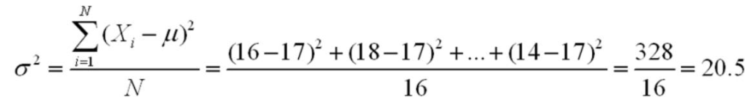

Bowerman - Chapter 02 #249
Difficulty: Medium
Learning Objective: 02-07 Compute the variance and standard deviation from raw data

250. | Determine the sample mean of the data 5,4,8,6,1,0,2,6.  4

Bowerman - Chapter 02 #250
Difficulty: Medium
Learning Objective: 02-06 Distinguish between a mean; a median; and a mode

251. | Determine the median of the data 2,4,6,8,10,12,14.  8

Bowerman - Chapter 02 #251
Difficulty: Medium
Learning Objective: 02-06 Distinguish between a mean; a median; and a mode

252. | Determine the mode of the data 2,4,6,2,5,6,2,9,4,5,2,1.  2

Bowerman - Chapter 02 #252
Difficulty: Medium
Learning Objective: 02-06 Distinguish between a mean; a median; and a mode

253. | Compute the sample standard deviation of the data 5,4,8,6,1,0,2,6.  2.77

Bowerman - Chapter 02 #253
Difficulty: Medium
Learning Objective: 02-07 Compute the variance and standard deviation from raw data

254. | What is the range of the following set of data: 3,7,2,1,8?  7

Bowerman - Chapter 02 #254
Difficulty: Easy
Learning Objective: 02-07 Compute the variance and standard deviation from raw data

255. | Calculate a one standard deviation tolerance interval for the data that has a sample mean of 28,475 and a standard deviation of 9,369.  19,106 to 37,844  28,475 - 9,369 = 19,106  28,475 + 9,369 = 37,844

Bowerman - Chapter 02 #255
Difficulty: Easy
Learning Objective: 02-07 Compute the variance and standard deviation from raw data

256. | Calculate a two standard deviation tolerance interval for the data that has a sample mean of 28,475 and a standard deviation of 9,369.  9,737 to 47,213  28,475 - 2(9,369) = 9,737  28,475 + 2(9,369) = 47,213

Bowerman - Chapter 02 #256
Difficulty: Easy
Learning Objective: 02-07 Compute the variance and standard deviation from raw data

257. | Calculate a three standard deviation tolerance interval for the data that has a sample mean of 28,475 and a standard deviation of 9,369.  368 to 56,582  28,475 - 3(9,369) = 368  28,475 + 3(9,369) = 56,582

Bowerman - Chapter 02 #257
Difficulty: Easy
Learning Objective: 02-07 Compute the variance and standard deviation from raw data

258. | If the median of a data set is 760 and the upper quartile is 950, and the lower quartile is 650, what is the interquartile range?  300 Interquartile range = 950 - 650 = 300

Bowerman - Chapter 02 #258
Difficulty: Medium
Learning Objective: N/A

259. | If the median of the data set is 40 and the upper quartile is 42 and the lower quartile is 37, what is the interquartile range?  5 Interquartile range = 42 - 37 = 5

Bowerman - Chapter 02 #259
Difficulty: Medium
Learning Objective: N/A

260. | Given a set of data with a mean of 150 and a standard deviation of 20. Using Chebyshev's Theorem, what is the minimum percentage of data between 110 and 190?  75%  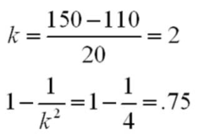

Bowerman - Chapter 02 #260
Difficulty: Hard
Learning Objective: 02-07 Compute the variance and standard deviation from raw data

261. | Given a set of data with mean of 150 and a standard deviation of 25. Using Chebyshev's Theorem, what is the minimum percentage of data between 75 and 225?  88.89%  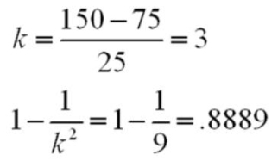

Bowerman - Chapter 02 #261
Difficulty: Hard
Learning Objective: 02-07 Compute the variance and standard deviation from raw data

262. | Determine the median of the data set 95,86,78,90,62,73,89,92,84,76.  85

Bowerman - Chapter 02 #262
Difficulty: Medium
Learning Objective: 02-06 Distinguish between a mean; a median; and a mode

263. | Compute the sample standard deviation of the data set 6,4,2,1,4,1  2  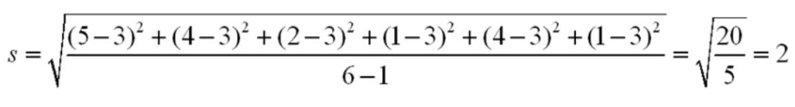

Bowerman - Chapter 02 #263
Difficulty: Medium
Learning Objective: 02-07 Compute the variance and standard deviation from raw data

264. | If 50 of 500 sampled customers said they would make a purchase of a new TV set, what is the sample proportion?  10

Bowerman - Chapter 02 #264
Difficulty: Easy
Learning Objective: N/A

265. | Describe the shape of a population distribution, if the median is greater than the mean.  Skewed to the left, or negatively skewed.

Bowerman - Chapter 02 #265
Difficulty: Medium
Learning Objective: 02-04 Differentiate between a symmetrical distribution and a positively or negatively skewed distribution

266. | In a normally distributed population, what tolerance interval contains 68.26 percent of all measurements?  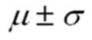

Bowerman - Chapter 02 #266
Difficulty: Medium
Learning Objective: 02-07 Compute the variance and standard deviation from raw data

267. | In a normally distributed population, what tolerance interval contains 95.44 percent of all measurements?  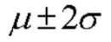

Bowerman - Chapter 02 #267
Difficulty: Medium
Learning Objective: 02-07 Compute the variance and standard deviation from raw data

268. | In a normally distributed population, what tolerance interval contains 99.73 percent of all measurements?  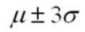

Bowerman - Chapter 02 #268
Difficulty: Medium
Learning Objective: 02-07 Compute the variance and standard deviation from raw data

269. | What are three important properties of any data set?  central tendency, variation, and shape

Bowerman - Chapter 02 #269
Difficulty: Hard
Learning Objective: 02-01 Explain what is demonstrated by a stem-and-leaf display that you have constructed
Learning Objective: 02-03 Identify when a histogram should be used

270. | If specifications for a process are (1.6, 1.8), and a 99.73 percent tolerance interval is (1.62, 1.83), is the process capable?  No

Bowerman - Chapter 02 #270
Difficulty: Medium
Learning Objective: N/A

271. | The average lateness for one of the top airline companies is 10 minutes. The variance of the lateness measure is calculated as 9. What is the coefficient of variation?  30  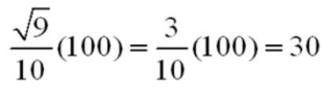

Bowerman - Chapter 02 #271
Difficulty: Medium
Learning Objective: N/A

272. | The average lateness for one of the top airline companies is 10 minutes. The variance of the lateness measure is calculated as 9. An airplane arrived 13 minutes after the stated arrival time. Calculate the Z-score for this particular airplane's lateness.  1  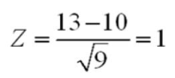

Bowerman - Chapter 02 #272
Difficulty: Medium
Learning Objective: 02-07 Compute the variance and standard deviation from raw data

The average life of Canadian women is 73.75 years and the standard deviation of the women's life expectancy in Canada is 6.5 years.

Bowerman - Chapter 02

273. | Using the Chebychev's theorem, determine the minimum percentage of women in Canada whose life expectancy is between 64 and 83.5 years.  55.56%  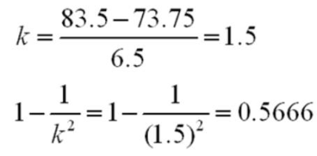

Bowerman - Chapter 02 #273
Difficulty: Hard
Learning Objective: 02-07 Compute the variance and standard deviation from raw data

274. | Based on Chebychev's inequality determine the upper and lower bounds on the average life expectancy of the Canadian women such that at least 90% of all population is included.  53.2 to 94.3  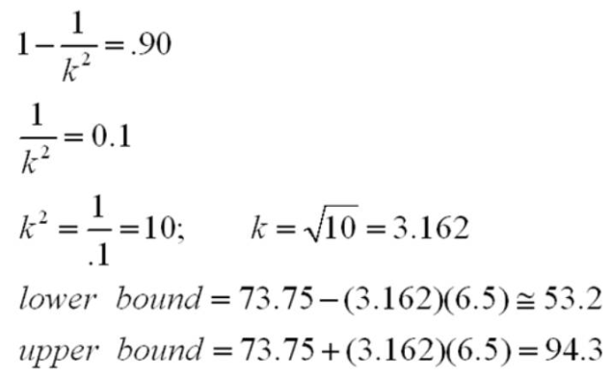

Bowerman - Chapter 02 #274
Difficulty: Hard
Learning Objective: 02-07 Compute the variance and standard deviation from raw data

275. | The average lateness for one of the top airline companies is 10 minutes. The variance of the lateness measure is calculated as 9. An airplane arrived 8.5 minutes after the stated arrival time. Calculate the Z-score for this particular airplane's lateness.  -0.5  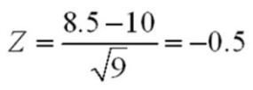

Bowerman - Chapter 02 #275
Difficulty: Medium
Learning Objective: 02-07 Compute the variance and standard deviation from raw data

The following table shows the Price-to-Earnings ratio for a Stereo equipment manufacturing company between 1998 and 2002.

Bowerman - Chapter 02

276. | Determine the percentage change in the P/E ratios from 1998 to 1999.  17.74%  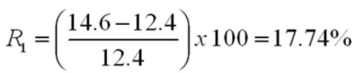

Bowerman - Chapter 02 #276
Difficulty: Medium
Learning Objective: N/A

277. | Determine the percentage change in the P/E ratios from 1999 to 2000.  -23.97%  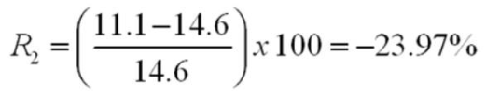

Bowerman - Chapter 02 #277
Difficulty: Medium
Learning Objective: N/A

278. | The following table shows the annual percentage growth rate for a Stereo equipment manufacturing company between 1998 and 2002. The of the P/E ratios are also calculated and given below:  Calculate the mean growth rate.  -12.36%

Bowerman - Chapter 02 #278
Difficulty: Easy
Learning Objective: N/A

The following frequency table summarizes the ages of 64 shoppers at the local grocery store.

Bowerman - Chapter 02

279. | Calculate the (approximate) sample mean for this data (mean for the grouped data).  36.25 years  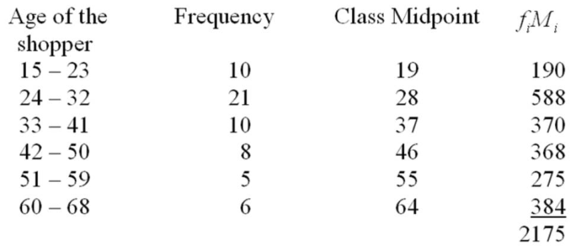  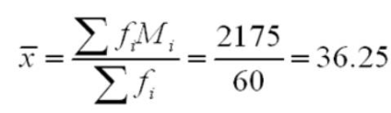

Bowerman - Chapter 02 #279
Difficulty: Medium
Learning Objective: N/A

280. | The sample mean for the above frequency table is calculated as 36.25. Calculate the (approximate) sample variance and standard deviation for this data set.  184.1493 and 13.57  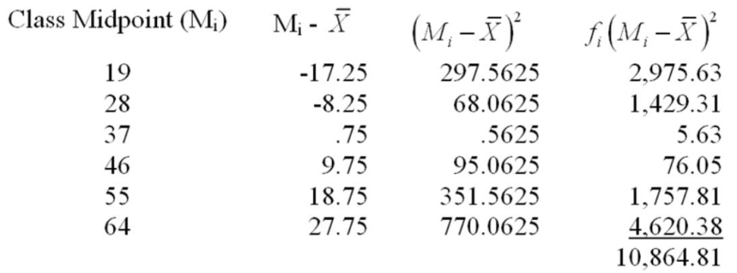  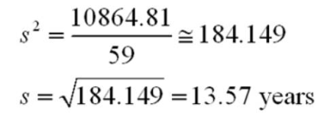

Bowerman - Chapter 02 #280
Difficulty: Medium
Learning Objective: N/A

A CFO is looking at the percentage of a company's resources are spent on computing. The CFO samples companies in the pharmaceutical industry and developed the following stem-and-leaf display.

Bowerman - Chapter 02

281. | What is the approximate shape of the distribution of the data?  Skewed to the right

Bowerman - Chapter 02 #281
Difficulty: Medium
Learning Objective: 02-04 Differentiate between a symmetrical distribution and a positively or negatively skewed distribution

282. | What is the smallest percent spent on computing?  5.2

Bowerman - Chapter 02 #282
Difficulty: Medium
Learning Objective: 02-03 Identify when a histogram should be used

283. | If a frequency histogram were to be created using these data, how many classes would you create?  6

Bowerman - Chapter 02 #283
Difficulty: Medium
Learning Objective: 02-02 Describe how a histogram is constructed

284. | Personnel managers usually want to know where a job applicant ranked in an entrance test for their company. With a score of 3.83, Michelle Robinson ranked above the 93rd percentile of the other applicants. What is the percentile rank of an applicant whose score was the median value?  50th

Bowerman - Chapter 02 #284
Difficulty: Easy
Learning Objective: 02-06 Distinguish between a mean; a median; and a mode

285. | The Rivertown city council is attempting to choose one of two sites (A or B) as the location for its new emergency facility. After the new emergency facility becomes available for service, the current emergency facility will be shut down. The project manager has estimated the following response times in minutes from each of the proposed sites to the four areas that must be served by the emergency facility.  The number of emergency runs from the current emergency facility to each of the four areas over the past year is as follows:  Compute the weighted mean response time from both proposed locations and determine which proposed site should be selected for the new emergency facility.  μ_{A} = 6.01, μ_{B} = 6.14, choose site A.  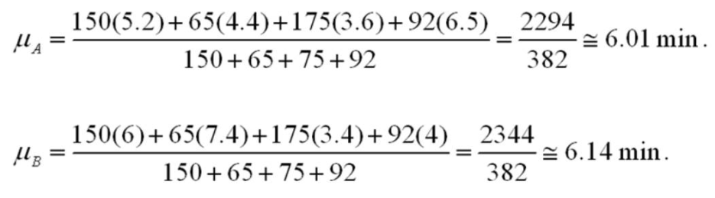

Bowerman - Chapter 02 #285
Difficulty: Hard
Learning Objective: N/A

286. | Consider the following data:  (a) Create a stem and leaf display for the sample.  (b) Describe the shape of the stem and leaf display.  (c) What is the mode?  (d) What is the media?  (a) Stem and leaf of C1, N = 20 Leaf Unit = 0.10  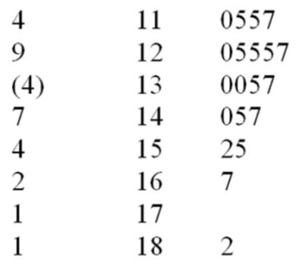  (b) Single peaked, skewed to the right.  (c) 12.5  (d) 13.0

Bowerman - Chapter 02 #286
Difficulty: Hard
Learning Objective: 02-01 Explain what is demonstrated by a stem-and-leaf display that you have constructed
Learning Objective: 02-04 Differentiate between a symmetrical distribution and a positively or negatively skewed distribution
Learning Objective: 02-06 Distinguish between a mean; a median; and a mode

Chapter 2 Summary
Category | # of Questions
Accessibility: Keyboard Navigation | 202
Bowerman - Chapter 02 | 327
Difficulty: Easy | 76
Difficulty: Hard | 38
Difficulty: Medium | 172
Learning Objective: 02-01 Explain what is demonstrated by a stem-and-leaf display that you have constructed | 11
Learning Objective: 02-02 Describe how a histogram is constructed | 19
Learning Objective: 02-03 Identify when a histogram should be used | 8
Learning Objective: 02-04 Differentiate between a symmetrical distribution and a positively or negatively skewed distribution | 11
Learning Objective: 02-05 Define the term outlier | 24
Learning Objective: 02-06 Distinguish between a mean; a median; and a mode | 51
Learning Objective: 02-07 Compute the variance and standard deviation from raw data | 75
Learning Objective: N/A | 96

