Multiple Choice

1. The first step of the scientific process is a(n):
 | a. | prediction.
 | b. | hypothesis.
 | c. | experiment.
 | d. | peer review.
 | e. | observation.

ANSWER: | e

2. A(n) _____ is a possible explanation for what is observed that is based on some previous knowledge.
 | a. | peer review
 | b. | prediction
 | c. | hypothesis
 | d. | theory
 | e. | anecdote

ANSWER: | c

3. Which sequence lists the steps of the scientific process in the CORRECT order?
 | a. | observe, create a testable prediction, form a hypothesis, experiment, support or refute the hypothesis
 | b. | observe, form a hypothesis, create a testable prediction, experiment, support or refute the hypothesis
 | c. | form a hypothesis, create a testable prediction, observe, experiment, support or refute the hypothesis
 | d. | create a testable prediction, form a hypothesis, observe, experiment, support or refute the hypothesis

ANSWER: | b

4. Which type of study manipulates a variable in a test group and compares the responses to a control group?
 | a. | anecdotal
 | b. | observational
 | c. | experimental
 | d. | inferential
 | e. | natural

ANSWER: | c

5. Which question can be solved with empirical evidence?
 | a. | Do ghosts exist?
 | b. | What is the meaning of life?
 | c. | What is my cat thinking?
 | d. | What causes the changing of the seasons?
 | e. | Is the death penalty wrong?

ANSWER: | d

6. What is TRUE regarding the following statements?
(1) "Higher levels of greenhouse gases cause increased warming of the troposphere."
(2) "People who are good go to heaven when they die."
 | a. | Both statements are obviously wrong.
 | b. | Both statements have been proven true by long-standing scientific theories.
 | c. | Only statement (1) is a scientific hypothesis testable by scientific methods.
 | d. | Only statement (2) can generate falsifiable predictions.
 | e. | Neither statement is suitable for science.

ANSWER: | c

7. Which statement is NOT falsifiable?
 | a. | Car exhaust contributes to ozone depletion.
 | b. | Iced wings of a plane contribute to some plane crashes.
 | c. | Dogs become tired when they are hungry.
 | d. | People should not litter because it is wrong to do so.
 | e. | All of these statements are falsifiable statements.

ANSWER: | d

8. Which hypothesis is NOT testable?
 | a. | The white fungus is causing death of bats.
 | b. | Bacterial water pollution increases risk of infectious disease.
 | c. | Increased salt intake leads to high blood pressure.
 | d. | Reincarnation exists.
 | e. | Increased UV exposure increases the risk of skin cancer.

ANSWER: | d

9. Peer review is:
 | a. | the process a scientist undergoes to analyze the results of the experiment.
 | b. | a measure of how well the report is received by the general public.
 | c. | a method for measuring the results of an experiment.
 | d. | a panel of editors who proofread the report after it is accepted for publication.
 | e. | a process by which a group of scientists in the field evaluate the report and determine if it is of high enough quality to publish in a journal.

ANSWER: | e

10. Which factor ensures that only quality scientific studies that have been well controlled and avoid bias appear in scientific journals?
 | a. | peer review
 | b. | funding agencies
 | c. | an independent variable
 | d. | anecdotal evidence
 | e. | the scientist responsible for the experiment

ANSWER: | a

11. How does a peer-reviewed article compare with an Internet blog?
 | a. | Both are equally analyzed and evaluated by scientists in the field prior to publication.
 | b. | Any person can easily create and publish a peer-reviewed article.
 | c. | A peer-reviewed article is likely to contain opinions that are not supported by data.
 | d. | A blog must be written by a researcher and not a reporter.
 | e. | The study design and results are evaluated in a peer-reviewed article.

ANSWER: | e

12. A(n) _____ is a widely accepted explanation of a natural phenomenon that has been extensively and rigorously tested scientifically.
 | a. | theory
 | b. | fact
 | c. | explanation
 | d. | definition
 | e. | proof

ANSWER: | a

13. Which statement is FALSE regarding a scientific theory?
 | a. | It can be modified over time as new information is discovered.
 | b. | It is the result of a hypothesis being repeatedly supported by many lines of inquiry.
 | c. | It has strong predictive powers that can explain observed phenomena.
 | d. | It is an idea based only on observations.
 | e. | It is a very well-supported hypothesis.

ANSWER: | d

14. Cell theory states that all living organisms are made up of one or more cells. Which statement is FALSE regarding this theory?
 | a. | All living organisms discovered so far have been made of one or more cells.
 | b. | A newly discovered organism is very likely to be made out of one or more cells.
 | c. | Cells are the basic units of structure for all known living organisms.
 | d. | No living organism will ever be discovered that is not made out of cells.
 | e. | All of these answers are true.

ANSWER: | d

15. Why can scientific opinions change over time?
 | a. | All conclusions in science are considered tentative and open to revision.
 | b. | Our understanding of a concept or process can change as scientists learn more.
 | c. | New evidence may be used to overturn a prevailing conclusion.
 | d. | All of these statements are true.
 | e. | None of these statements is true.

ANSWER: | d

16. The HIGHEST level of certainty a scientific explanation can attain is a(n):
 | a. | observation.
 | b. | inference.
 | c. | hypothesis.
 | d. | theory.
 | e. | study.

ANSWER: | d

17. Why do scientists use comparative studies?
 | a. | Most species are all the same, so a comparative study can be used instead of performing an experiment.
 | b. | Similar phenomena in other species or regions can provide clues to events being investigated.
 | c. | Comparative studies can replace an observational study, saving time and money.
 | d. | Scientists use comparative studies to prove a hypothesis.
 | e. | Scientists use comparative studies for research to publish peer-reviewed papers.

ANSWER: | b

18. Scientists looked at comparative studies to help their work with bats and a fungal infection. What organism was used in the comparative studies?
 | a. | birds
 | b. | fish
 | c. | rats
 | d. | frogs
 | e. | humans

ANSWER: | d

19. The disease caused by a novel fungus affecting some species of North American bats is called:
 | a. | white-nose syndrome.
 | b. | reduced torpor disease.
 | c. | chytridiomycosis.
 | d. | white-wing syndrome.
 | e. | bat hibernacula disease.

ANSWER: | a

20. What did the researchers suspect about the fungus that was affecting bats and its effect on the bats?
 | a. | Hibernating bats were more susceptible to the fungus, since their body temperature was lower than normal and their immune system was suppressed.
 | b. | Active bats were more susceptible to the fungus, since their body temperature was lower than normal and their immune system was suppressed.
 | c. | Hibernating bats were more susceptible to the fungus, since their body temperature was higher than normal and their immune system was suppressed.
 | d. | Active bats were more susceptible to the fungus, since their body temperature was higher than normal and their immune system was suppressed.
 | e. | None of these reflects what researchers thought about the fungus and the bats.

ANSWER: | a

21. Bats found with white-nose syndrome appeared to die because:
 | a. | the fungal infection affected their wings and they could not fly, making them easy prey for other animals.
 | b. | the fungal infection attacked the areas needed to maintain body temperature, so the bats froze to death.
 | c. | the fungal infection caused them to wake more often and use up their fat reserves, so they died of starvation.
 | d. | their immune system was suppressed, so they contracted other deadly infections.
 | e. | their torpor became so deep they could wake from their hibernation.

ANSWER: | c

22. What did the comparative study on chytridiomycosis teach scientists studying white-nose syndrome in bats?
 | a. | It was probably not a fungal infection affecting the bats and scientists needed to look elsewhere for a cause.
 | b. | Chytridiomycosis affected only certain amphibians, so the comparative study could not teach the scientists anything useful.
 | c. | A novel fungal infection could spread to colonies and cause dramatic population crashes, as seen in the comparative study.
 | d. | Humans were responsible for the spread of chytridiomycosis, but not white-nose syndrome.
 | e. | White-nose syndrome affects bats but does not cause death in organisms like chytridiomycosis does in amphibians.

ANSWER: | c

23. Which type of experiment collects data in the real world, without manipulating the subject of study?
 | a. | experimental
 | b. | anecdotal
 | c. | theoretical
 | d. | observational
 | e. | randomized

ANSWER: | d

24. In an experimental study, what is TRUE about the independent variable?
 | a. | It shows a response.
 | b. | It is charted on the y-axis (vertical axis).
 | c. | It is what you manipulate.
 | d. | It is what you measure.
 | e. | It is the same for both the control and experimental groups.

ANSWER: | c

25. In an experimental study, what is TRUE about the dependent variable?
 | a. | It is charted on the x-axis (horizontal axis).
 | b. | It pertains only to the experimental group.
 | c. | It is what you manipulate.
 | d. | It is a measured response.
 | e. | It is what can be changed to see if it produces an effect.

ANSWER: | d

26. When data are shown in a graph, the independent variable should be plotted on the:
 | a. | vertical axis.
 | b. | x-axis.
 | c. | response.
 | d. | ordinate.
 | e. | y-axis.

ANSWER: | b

27. Scientists generally require a level of certainty of at least _____% to be sure their conclusions are correct.
 | a. | 50
 | b. | 60
 | c. | 75
 | d. | 80
 | e. | 95

ANSWER: | e

28. In the following example, what is the independent variable?
Hypothesis: Mice on a restricted low-caloric diet will live longer than mice that can eat as much as they want.
Experiment: A large population of genetically identical mice is divided into two groups. Half receive as much food as they care to eat each day. The other half receive 20% less food than a typical mouse eats each day. The day of death (lifespan) is recorded for all mice. All mice live in the same room, in the same type of cage, with access to water.
 | a. | amount of food available
 | b. | volume of water available
 | c. | genetically identical mice
 | d. | happiness of each mouse
 | e. | lifespan of each mouse

ANSWER: | a

29. A researcher wants to know how effective a new suntan lotion is at preventing skin cancer caused by UV radiation. She uses mice as test subjects to model the effects on humans. Which statement describes the BEST control for this experiment?
 | a. | Only mice in the control group are shaded during the experiment.
 | b. | Mice in the test group receive twice as much UV radiation as those in the control group.
 | c. | No suntan lotion is applied to mice in the control group; lotion is applied only to the test group.
 | d. | Mice in the test group are from a genetic line that increases their susceptibility to UV radiation.
 | e. | Mice in the control group are provided lotion in their drinking water to maximize effectiveness.

ANSWER: | c

30. When conducting an experimental study, scientists manipulate the _____ variable and measure the _____ variable to see if it is affected.
 | a. | dependent; independent
 | b. | independent; dependent
 | c. | observational; dependent
 | d. | experimental; independent
 | e. | observational; experimental

ANSWER: | b

31. In an experiment examining the effect of the Pd fungus on the torpor of bats, the presence of Pd fungus would be the _____ variable.
 | a. | independent
 | b. | dependent
 | c. | non-independent
 | d. | control
 | e. | extraneous

ANSWER: | a

32. The group in an experimental study that is manipulated such that it differs from the control group in only one way is the _____ group.
 | a. | confirmation
 | b. | test
 | c. | validation
 | d. | placebo
 | e. | independent

ANSWER: | b

33. What type of studies can provide correlations?
 | a. | experimental
 | b. | variable
 | c. | correlational
 | d. | observational
 | e. | demonstrative

ANSWER: | d

34. What is a correlation?
 | a. | when changing one variable affects a change in another variable
 | b. | when two things occur together, but one does not necessarily cause the other to happen
 | c. | a study where a variable is manipulated in one group to compare the response to another group
 | d. | research that gathers data in a real-world setting without manipulating any variables
 | e. | the mathematical evaluation of experimental data to determine likely differences due to an observed variable

ANSWER: | b

35. What type of evidence shows that smoking causes lung cancer in humans?
 | a. | cause-and-effect
 | b. | experimental
 | c. | correlational
 | d. | statistical
 | e. | hypothetical

ANSWER: | c

36. In Warnecke's experimental study, fewer individual bats exposed to WNS fungus survived than did bats not exposed. This is an example of a(n):
 | a. | correlation.
 | b. | cause-and-effect relationship.
 | c. | observation.
 | d. | relationship.
 | e. | variable.

ANSWER: | b

37. A formalized plan that addresses a desired outcome of goal is a(n):
 | a. | policy.
 | b. | treaty.
 | c. | law.
 | d. | correlation.
 | e. | outcome.

ANSWER: | a

38. What is TRUE about establishing environmental policy?
 | a. | It is easy and straightforward to establish good environmental policy.
 | b. | Stakeholders all agree on the same way to deal with an environmental issue.
 | c. | Policies need to wait until we have all the data on an issue.
 | d. | Policies must be flexible and adapt to new scientific findings.
 | e. | Policies need to address only the environmental problem.

ANSWER: | d

39. Policies should address the triple bottom line—that is, they should:
 | a. | address environmental problems, fit scientific data, and not affect economics.
 | b. | address environmental problems, fit societal needs, and be economically viable.
 | c. | address environmental problems and fit scientific data regardless of economic considerations.
 | d. | focus on social and economic needs before environmental issues.
 | e. | use evidence that supports our beliefs no matter how compelling other evidence may be.

ANSWER: | b

40. What did scientists find that could help treat WNS in bats?
 | a. | a different fungus
 | b. | an antibiotic
 | c. | a bacterium
 | d. | a vaccine
 | e. | a virus

ANSWER: | c

41. When we are presented with evidence that supports our current beliefs, we strengthen our beliefs. If evidence contradicts our beliefs, we dismiss it. This is called a:
 | a. | belief bias.
 | b. | confirmation bias.
 | c. | validation belief.
 | d. | contradiction belief.
 | e. | scientific evidence.

ANSWER: | b

Use Infographic 5 below to answer the follwing question(s).
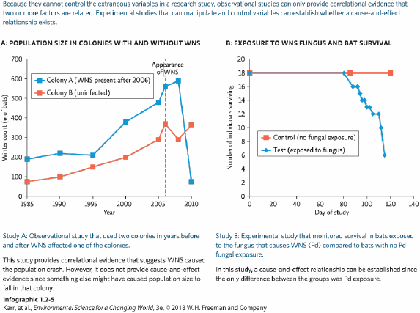

42. When bats were exposed to WNS fungus, how many were still alive on day 120?
 | a. | 18
 | b. | 16
 | c. | 8
 | d. | 6

ANSWER: | d

43. What did the observational study find?
 | a. | A cause-and-effect relationship was found between bats and exposure to WNS fungus.
 | b. | The winter count of bats in colonies where WNS was present declined after the appearance of WNS in the colony.
 | c. | Bats who were not exposed to WNS fungus survived longer than bats who were exposed to the fungus.

ANSWER: | b

44. How long did it take to see a decrease in survival of bats exposed to the WNS fungus?
 | a. | 80 days
 | b. | 120 days
 | c. | 4 years
 | d. | over 20 years

ANSWER: | a

45. In the experimental study, what was the independent variable?
 | a. | number of bats during the winter count
 | b. | number of individual bats surviving
 | c. | the day of study
 | d. | exposure to the WNS fungus

ANSWER: | d

46. The bat colony affected by the WNS fungus reached the LOWEST winter count in which year?
 | a. | 1985
 | b. | 1995
 | c. | 2005
 | d. | 2010

ANSWER: | d

Use the following scenario to answer the question(s) below.
You are a scientist doing research for U.S. Fish and Wildlife on the effect of fox predators on snowshoe hares. Park rangers have noticed fewer snowshoe hares in areas where foxes are more abundant. You set up two areas in the boreal forest with a fence that will allow the hares to get in but will keep out foxes, and two areas the same size that are marked but not fenced in. You count the number of snowshoe hares surviving after one year.

47. Which hypothesis is NOT testable in your experiment?
 | a. | Foxes are preying on the snowshoe hares and decreasing their survival.
 | b. | Something supernatural is decreasing the population of snowshoe hares.
 | c. | A predator other than foxes is preying on snowshoe hares and decreasing their survival.
 | d. | Something other than a predator is decreasing the survival of snowshoe hares.

ANSWER: | b

48. The type of study you are setting up is a(n) _____ study.
 | a. | experimental
 | b. | observational
 | c. | variable
 | d. | independent

ANSWER: | a

49. The dependent variable in your study is the:
 | a. | number of foxes.
 | b. | type of forest.
 | c. | size of the area.
 | d. | number of hares surviving.

ANSWER: | d

50. Your study will provide which type of results?
 | a. | correlation
 | b. | cause-and-effect
 | c. | control
 | d. | observational

ANSWER: | b

51. After you carry out your experiment and collect your data, what is the next step for you in the scientific process?
 | a. | make a new observation
 | b. | publish your conclusions
 | c. | analyze your data
 | d. | form a hypothesis

ANSWER: | c

Subjective Short Answer

Match each term to the statement that it best exemplifies.
A. an association between two variables that identifies one (the effect) occurring as a result of or in response to the other (the cause)
B. the group in an experimental study that the test group's results are compared to; ideally, the control group will differ from the test group in only one way
C. research that manipulates a variable in a test group and compares the response to that of a control group that was not exposed to the same variable
D. the mathematical evaluation of experimental data to determine how likely it is that any difference observed is due to the variable being tested
E. a formalized plan that addresses a desired outcome or goal
F. information detected with the senses or with equipment that extends our senses
G. researchers submit a report of their work to a group of outside experts who evaluate the study's design and results of the study to determine whether it is of high enough quality to publish
H. a body of knowledge (facts and explanations) about the natural world, and the process used to get that knowledge
I. a widely accepted explanation of a natural phenomenon that has been extensively and rigorously tested scientifically
J. the variable in an experiment that is evaluated to see if it changes due to the conditions of the experiment
K. conclusions we draw based on observations
L. the group in an experimental study that is manipulated such that it differs from the control group in only one way
M. procedure scientists use to empirically test a hypothesis
N. two things occur together, but it doesn't necessarily mean that one caused the other
O. information gathered via observation of physical phenomena
P. a possible explanation for what we have observed that is based on some previous knowledge
Q. research that gathers data in a real-world setting without intentionally manipulating any variable
R. the variable in an experiment that a researcher manipulates or changes to see if the change produces an effect.

52. observations
ANSWER: | F

53. inferences
ANSWER: | K

54. policy
ANSWER: | E

55. science
ANSWER: | H

56. empirical evidence
ANSWER: | O

57. correlation
ANSWER: | N

58. cause-and-effect relationship
ANSWER: | A

59. scientific method
ANSWER: | M

60. hypothesis
ANSWER: | P

61. observational study
ANSWER: | Q

62. experimental study
ANSWER: | C

63. control group
ANSWER: | B

64. test group
ANSWER: | L

65. independent variable
ANSWER: | R

66. dependent variable
ANSWER: | J

67. peer review
ANSWER: | G

68. theory
ANSWER: | I

69. statistics
ANSWER: | D

Essay

70. What criteria must be met for a hypothesis to be valid?
ANSWER: | A valid hypothesis must be testable. It must be possible to create predictions from the hypothesis that we can objectively observe if we run a test. Predictions based on a hypothesis also must be falsifiable. It must be possible to refute them by evidence.

71. Is the following a valid hypothesis? Cancer patients who are prayed for will have better outcomes compared with patients with similar prognoses (likely outcomes) who are not prayed for.
ANSWER: | Yes. Predictions from the hypothesis are testable and falsifiable.

72. Is the following a valid hypothesis? Natural disasters around the world are a result of a supernatural deity punishing humanity for our actions.
ANSWER: | No. Predictions from the hypothesis are not testable, nor are they falsifiable.

73. Scientists use the scientific method to investigate the natural world. The scientific method is based on gathering empirical evidence. What is empirical evidence, and why are empirical data a hallmark of good science?
ANSWER: | Empirical evidence is information gathered by means of observation of physical phenomena. The same data can be objectively observed by anyone in the same place (using the same equipment). Phenomena that are not objectively observable cannot be empirically studied and are therefore not under the purview of science.

74. Describe the importance of peer review to the scientific process.
ANSWER: | Prior to publication in a scientific journal, a study is rigorously analyzed by peers in that scientific area who can determine well if the study is of acceptable quality. This ensures only quality scientific reports (without bias, well-controlled studies, etc.) appear in the scientific literature.

75. Refer to Infographic 1. What are the possible outcomes after using the scientific method to analyze the data?
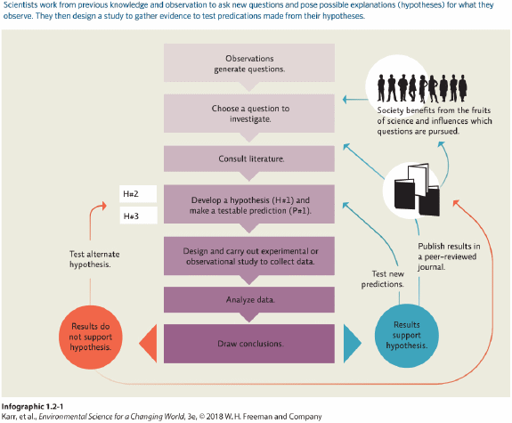
ANSWER: | The hypothesis is either rejected (develop and test alternate hypotheses), modified, or accepted (published in a peer-reviewed journal and used to test new predictions or hypotheses).

76. How would you respond to someone who says, "Evolution is just a theory"?
ANSWER: | The word "theory" in casual usage means "an idea." In contrast, a "scientific theory" is a very well-supported hypothesis with strong predictive powers. It is very likely not going to be refuted by additional studies.

77. In this chapter it has been made clear that the process used to obtain a body of knowledge (facts and explanations) is more important than the body of knowledge itself. Why is this?
ANSWER: | Facts may change as additional information is collected through the scientific process. Consequently, it is important that the entire process be open-ended and that the investigators be open-minded to change.

78. Refer to Infographic 2. Explain why in science absolute proof is not required.
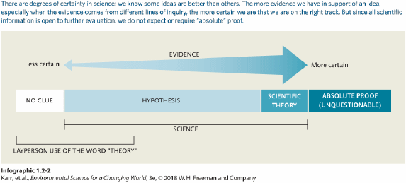
ANSWER: | Since all scientific information is open to further investigation, it is not expected or required that there will be absolute proof in science.

79. Describe the difference between a hypothesis and a scientific theory.
ANSWER: | A hypothesis is a possible explanation for what we have observed that is based on some previous knowledge. A scientific theory is a widely accepted explanation of a natural phenomenon that has been extensively and rigorously tested scientifically.

80. Why did scientists initially think bats with white-nose syndrome were dying?
ANSWER: | During hibernation, the bats are in a state of reduced metabolism called torpor. To wake up, the bats must use lots of energy. Scientists thought the fungal infection was causing the bats to wake up more often than usual, causing them to use more energy. This caused them to use their fat reserves up too soon, and since there were no insects to eat in the winter, the bats starved to death.

81. How did the comparative study on amphibians help scientists studying the white-nose syndrome in bats?
ANSWER: | The study on amphibians showed it was a fungal infection causing frogs to die in large numbers. The fungus spread quickly around the world, believed to be helped by human activity. This study taught scientists studying WNS that a novel fungal infection could cause large population crashes, which led them to look at the WNs fungus.

82. Refer to Infographic 4. Which study depicted in the infographic provides stronger support for the stated hypothesis? Briefly explain why.
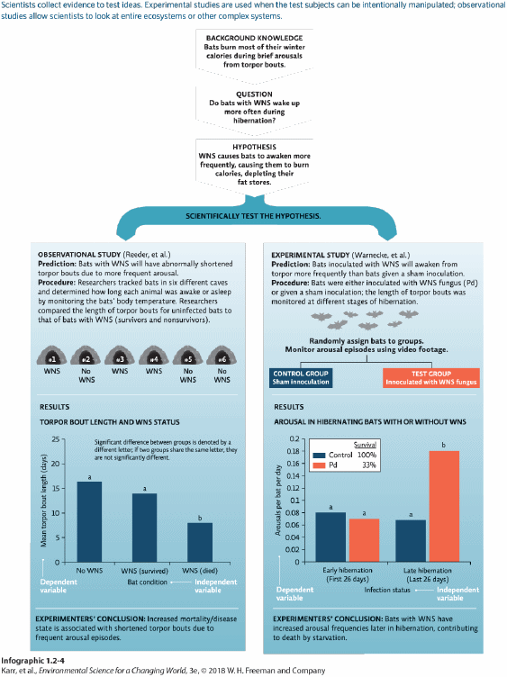
ANSWER: | By manipulating the independent variable (infection status), the experimental study (Warnecke et al.) provides stronger support because it allows researchers to compare the response in the test group to the control group that was not exposed.

83. The health and lifestyle of 10,000 nurses are tracked for a period of 30 years. It is discovered that of the nurses who smoked cigarettes for at least 10 years, 35% had lung cancer. Is this an observational or an experimental study? Does this study demonstrate that cigarettes cause lung cancer?
ANSWER: | This is an observational study which shows a correlation between smoking and lung cancer. It is not an experimental study, where variables can be directly manipulated. It would be unethical to directly test this cause-and-effect relationship using human subjects.

84. Explain the function of a control group in an experimental study.
ANSWER: | A control group validates the experiment. The control group should be identical to the test group except for the independent variable. This allows conclusions to be drawn about the outcome by comparing the experimental group with the control group. Any differences are due to the independent variable.

85. Tests of significance help to determine if an event was due to chance or something else. The probability value is expressed as a p-value. What does it mean to have a p-value equal to 0.05?
ANSWER: | The null hypothesis is that the result observed is due to chance. A p-value is the probability of obtaining a result at least as extreme as the one observed (assuming the null hypothesis is true). A p-value less than 0.05 means rejection of the null (by chance) hypothesis. This means the result is statistically significant. The smaller the p-value, the more strongly the test rejects the null hypothesis.

86. Explain how scientists use probability to apply a level of certainty to their conclusions.
ANSWER: | Scientists generally require a high level of certainty that their conclusions are correct. Normally scientists try to achieve 95% certainty that they are correct in their conclusions, meaning they accept no more than a 5% chance the wrong conclusion will be drawn.

87. Refer to Infographic 4. In Warnecke et al., what is the independent variable? What is the dependent variable? List as many qualities as possible that should be the same between bats in the two groups (control and test groups). Ideally, what should be the only difference between the two groups of bats?
ANSWER: | The independent variable is the infection status. The dependent variable is the arousals per bat per day. Bats in both groups should be handled the same way, and arousals should be measured the same way. The bats should be the same age and same sex, or there should at least be a balance across the groups, given the same diet, housed in the same conditions, and so on. The only difference between the groups should be the independent variable.

88. Refer to Infographic 4. In the observational study ( Reeder et al.), explain why the bat condition is the independent variable and the mean torpor length is the dependent variable.
ANSWER: | The bat condition is the independent variable because this is the variable in the experiment that is being compared by the investigator to see if it produces an effect. The mean torpor length is the dependent variable because this is what is measured to see if it changes due to the conditions of the experiment.

89. What is a correlation, and how does it differ from a cause-and-effect relationship? Give an example of each and note what type of study can provide that information.
ANSWER: | In an observational study, data can provide a correlation between, for example, a bat colony was exposed to WNS and most bats in the colony died shortly after. Both occur together, which suggests a cause-and-effect relationship. An experimental study, where variables can be directly manipulated and controlled, can be used to test a cause-and-effect relationship, for example, showing that exposure to WNS fungus decreased bat survival.

90. In terms of manipulating variables, what is the difference between an observational study and an experimental study? Which type of study can test cause-and-effect relationships?
ANSWER: | In an observational study, data are gathered in a real-world setting, without intentionally manipulating any variable. This can lead to correlative conclusions. In an experimental study, the independent variable is manipulated by the researcher to evaluate a cause-and-effect relationship.

91. When it rains, you often notice people outside holding open umbrellas. You hypothesize that opening an umbrella causes rain to fall. What type of experiment can be used to test this? Explain what is meant by the phrase "correlation is not causation."
ANSWER: | Although the appearance of rain and open umbrellas is correlated, it is not clear yet if one variable is causing the other to happen. We need an experimental study to test if rain is causing people to open umbrellas or if opening umbrellas causes rain to fall. "Correlation is not causation" means that just because two things happen at the same time does not mean that one is caused by the other.

92. Why is it difficult to establish policies to deal with environmental problems?
ANSWER: | There are often conflicts between protecting the environment and serving the short-term interests of one societal group or another. Stakeholders often have differing needs, and policy makers must balance all these considerations while still protecting human populations and the environment.

93. What are some approaches used to protect bats from WNS?
ANSWER: | The northern long-eared bat was listed as a threatened species, giving it federal protection. Hibernacula have been closed to the public to prevent humans from transmitting fungal spores from one cave to another. Cave visitors should decontaminate clothing after leaving caves. Education about the ecological role of bats can help dispel myths. A bacterium is being tested to see if it can reduce the amount of fungus growing on bats.

