1. The objective of most businesses is to maximize profits.
 | a. | True
 | b. | False

ANSWER: | True

2. A limited liability company combines attributes of a partnership and a corporation.
 | a. | True
 | b. | False

ANSWER: | True

3. A partnership is owned by two or more individuals.
 | a. | True
 | b. | False

ANSWER: | True

4. Manufacturing businesses change basic inputs into products that are sold to individual customers.
 | a. | True
 | b. | False

ANSWER: | True

5. Merchandising businesses produce products rather than provide services to customers.
 | a. | True
 | b. | False

ANSWER: | False

6. A corporation is a business that is legally separate and distinct from its owners.
 | a. | True
 | b. | False

ANSWER: | True

7. The popularity of the sole proprietorship is due to the ease and low cost of organizing.
 | a. | True
 | b. | False

ANSWER: | True

8. A primary disadvantage of corporations is that the financial resources available to them are limited.
 | a. | True
 | b. | False

ANSWER: | False

9. The ownership of a proprietorship is divided into shares of stock owned by its stockholders.
 | a. | True
 | b. | False

ANSWER: | False

10. All merchandising businesses are organized as corporations.
 | a. | True
 | b. | False

ANSWER: | False

11. Stockholders of a corporation are its internal stakeholders.
 | a. | True
 | b. | False

ANSWER: | False

12. John Deere is a leading manufacturer of agricultural machinery in the world, producing products that serve unique market needs. Therefore, John Deere is an example of a company that uses a premium-price emphasis to attract customers.
 | a. | True
 | b. | False

ANSWER: | True

13. A business stakeholder has an interest in the economic performance of a business.
 | a. | True
 | b. | False

ANSWER: | True

14. Companies using a low-cost emphasis provide products and services that compete on features other than price.
 | a. | True
 | b. | False

ANSWER: | False

15. The basic type of stock issued to owners is called common stock.
 | a. | True
 | b. | False

ANSWER: | True

16. Assets are acquired through investing activities when resources are purchased.
 | a. | True
 | b. | False

ANSWER: | True

17. Creditors have preference to assets behind stockholders if a business fails.
 | a. | True
 | b. | False

ANSWER: | False

18. A liability is a legal obligation to repay the amount borrowed according to the terms of the borrowing agreement.
 | a. | True
 | b. | False

ANSWER: | True

19. Accounting is thought to be the "language of business" because business information is communicated to stakeholders.
 | a. | True
 | b. | False

ANSWER: | True

20. The branch of accounting related to the management's financial decisions is known as financial accounting.
 | a. | True
 | b. | False

ANSWER: | False

21. The stockholders' equity of a company should equal the sum of its total assets and total liabilities.
 | a. | True
 | b. | False

ANSWER: | False

22. The balance sheet represents the accounting equation.
 | a. | True
 | b. | False

ANSWER: | True

23. What is the primary objective of most businesses?
 | a. | To maximize profits
 | b. | To pay dividends to stockholders
 | c. | To provide a benefit to society
 | d. | To manufacture a quality product

ANSWER: | a

24. Which of the following businesses buys products from other businesses wholesale to sell them to customers at a retail price?
 | a. | A merchandising business
 | b. | A manufacturing business
 | c. | A service business
 | d. | An investment business

ANSWER: | a

25. Which of the items below is not a business organization form?
 | a. | Multi-venture
 | b. | Proprietorship
 | c. | Partnership
 | d. | Corporation

ANSWER: | a

26. Which of the following types of organizational forms is popular for its ease of formation and low cost of organizing?
 | a. | Not-for-profit
 | b. | Corporation
 | c. | Partnership
 | d. | Proprietorship

ANSWER: | d

27. Which of the following statements is true about a limited liability company?
 | a. | It is organized under state or federal statutes as a separate legal entity.
 | b. | Many professional practices such as lawyers, doctors, and accountants are organized as limited liability companies.
 | c. | Its financial resources are limited to the individual owner's resources.
 | d. | The frequency of this form is due to the ease and low cost of organizing.

ANSWER: | b

28. Under a _____, a business design's products that possess unique attributes or characteristics for which customers are willing to pay more.
 | a. | premium-price emphasis
 | b. | outreach emphasis
 | c. | low-cost emphasis
 | d. | customer emphasis

ANSWER: | a

29. Which of the following is not a characteristic of a corporation?
 | a. | Corporations are organized as a separate legal taxable entity.
 | b. | Ownership is divided into shares of stock.
 | c. | Corporations experience an ease in obtaining large amounts of resources by issuing stock.
 | d. | A corporation can elect to be taxed as a partnership.

ANSWER: | d

30. A corporation is an entity _____.
 | a. | that is organized according to state or federal statutes and in which ownership is divided into shares of stock
 | b. | that is known for its ease of formation
 | c. | that terminates its existence with the death of the owner
 | d. | that pays tax on the owner's tax returns

ANSWER: | a

31. A low-cost emphasis strives to provide _____.
 | a. | no-frills, standardized products and services
 | b. | products and services that provide unique market needs
 | c. | products and services that provide prestige and image for customers
 | d. | products and services that compete on features other than price

ANSWER: | a

32. Which of the following businesses use a premium-price emphasis?
 | a. | Value City Furniture selling furniture at affordable prices
 | b. | Tommy Hilfiger selling products that have a unique image
 | c. | Wal-Mart reselling standardized products
 | d. | Southwest Airlines providing standardized services

ANSWER: | b

33. Motel 6, a company that helps customers find budget motels across the nation, is an example of a business using which of the following?
 | a. | Low-cost emphasis
 | b. | Outreach emphasis
 | c. | Customer emphasis
 | d. | Premium-price emphasis

ANSWER: | a

34. Which of the following is considered a business stakeholder?
 | a. | A bank
 | b. | An employee
 | c. | A federal government
 | d. | All of these

ANSWER: | d

35. _____ are an example of internal stakeholders.
 | a. | Managers
 | b. | Creditors
 | c. | Stockholders
 | d. | Suppliers

ANSWER: | a

36. Which of the following are not an example of a capital market stakeholder?
 | a. | Banks
 | b. | Owners
 | c. | Suppliers
 | d. | Stockholders

ANSWER: | c

37. Capital market stakeholders have an interest in a company because _____.
 | a. | they collect taxes from the company
 | b. | they depend upon the continued success of the company for keeping their jobs
 | c. | they purchase the company's products or services or sell their products or services to the company
 | d. | they provide major financing for the business

ANSWER: | d

38. In the case of a failing company, the right to the first claim of the company's assets belongs to _____.
 | a. | the state governments
 | b. | the creditors of the company
 | c. | the owners of the company
 | d. | the managers of the company

ANSWER: | b

39. The economic performance of a business is of importance to the government because _____.
 | a. | of potential tax collections
 | b. | the government sells its products to the business
 | c. | of the amount owed by the government to the business
 | d. | all of these

ANSWER: | a

40. The performance evaluation of the managers of a company is dependent on the company's _____.
 | a. | common stock
 | b. | volatility
 | c. | economic performance
 | d. | nonrecurring activities

ANSWER: | c

41. When a business borrows money, which of the following is incurred?
 | a. | An accumulated depletion
 | b. | A liability
 | c. | A loss
 | d. | An accrued expenditure

ANSWER: | b

42. Revenues received from providing services are referred to as _____.
 | a. | fees earned
 | b. | net income
 | c. | gross income
 | d. | retained earnings

ANSWER: | a

43. A note payable requires payment of the amount borrowed plus _____.
 | a. | interest
 | b. | tax
 | c. | overhead
 | d. | dividend

ANSWER: | a

44. Shares of ownership are evidenced by issuing _____.
 | a. | shares payable
 | b. | commercial paper
 | c. | shares of stock
 | d. | notes payable

ANSWER: | c

45. The resources a business owns are called _____.
 | a. | assets
 | b. | liabilities
 | c. | earnings
 | d. | stockholders' equity

ANSWER: | a

46. The purchase of factory equipment would be an example of which type of business activity?
 | a. | Financing
 | b. | Investing
 | c. | Operating
 | d. | All of these

ANSWER: | b

47. Which of the following is an intangible asset?
 | a. | Patent
 | b. | Cash
 | c. | Land
 | d. | Equipment

ANSWER: | a

48. Rights to payments from customers are _____.
 | a. | liabilities
 | b. | prepaid expenses
 | c. | accounts receivable
 | d. | accounts payable

ANSWER: | c

49. Which of the following is considered an asset until consumed?
 | a. | Accounts payable
 | b. | Prepaid expense
 | c. | Accounts receivable
 | d. | Stockholders' equity

ANSWER: | b

50. _____ is the increase in assets from selling products or providing services.
 | a. | Revenue
 | b. | Interest income
 | c. | Equity
 | d. | Cost of goods sold

ANSWER: | a

51. Cash collected from sales during the normal course of business would be an example of which type of business activity?
 | a. | Operating
 | b. | Investing
 | c. | Financing
 | d. | None of these

ANSWER: | a

52. Costs incurred to earn revenue are referred to as _____.
 | a. | common stock
 | b. | expenses
 | c. | liabilities
 | d. | retained earnings

ANSWER: | b

53. Debts owed by a business are referred to as _____.
 | a. | accounts receivable
 | b. | equities
 | c. | stockholders' equity
 | d. | liabilities

ANSWER: | d

54. Cash investments made by the stockholders of the business are reported on the statement of cash flows in the _____.
 | a. | financing activities section
 | b. | investing activities section
 | c. | operating activities section
 | d. | supplemental statement

ANSWER: | a

55. Financing activities_____ .
 | a. | involve obtaining funds to operate a business
 | b. | involve obtaining assets such as buildings and equipment
 | c. | help to earn revenues and profits
 | d. | help to make wise investments in other companies

ANSWER: | a

56. Reporting the financial condition of a business at a point in time and reporting the changes in the financial condition of a business over a period of time are the two major objectives of _____.
 | a. | fund accounting
 | b. | forensic accounting
 | c. | not-for-profit accounting
 | d. | financial accounting

ANSWER: | d

57. The role of accounting in business is best defined as _____.
 | a. | an information system that provides reports to stakeholders about the economic activities and financial condition of a business
 | b. | a method of forecasting the future profitability of a company
 | c. | the policies, procedures, and strategies used in a business
 | d. | the process of transaction analysis

ANSWER: | a

58. A list of assets, liabilities, and owners' equity as of a specific date is a(n) _____.
 | a. | income statement
 | b. | balance sheet
 | c. | statement of cash flows
 | d. | retained earnings statement

ANSWER: | b

59. Given the following list of accounts, calculate Total Assets.
Accounts Receivable | $ 10,000
Capital Stock | 20,000
Cash | 25,300
Equipment | 16,800
Fees Earned | 44,400
Miscellaneous Expense | 17,800
Rent Expense | 3,250
Retained Earnings | 7,850
Salaries Expense | 15,400
Wages Expense | 15,000

 | a. | $52,100
 | b. | $55,300
 | c. | $54,600
 | d. | $40,050

ANSWER: | a

60. Which of the following is an appropriate representation of the accounting equation?
 | a. | Assets + Liabilities = Stockholders' equity
 | b. | Assets = Liabilities + Stockholders' equity
 | c. | Assets = Liabilities + Capital stock
 | d. | Assets = Liabilities + Retained earnings

ANSWER: | b

61. Use the following information to determine Total Stockholders' Equity.
Total Assets | $ 85,000
Total Liabilities | 21,000
Total Stockholders' Equity | x
Total Retained Earnings | 9,000

 | a. | $58,000
 | b. | $64,000
 | c. | $55,000
 | d. | $40,000

ANSWER: | b

62. A summary of the cash receipts and cash payments for a specific period of time is a(n) _____.
 | a. | income statement
 | b. | balance sheet
 | c. | statement of cash flows
 | d. | retained earnings statement

ANSWER: | c

63. The portion of a corporation's net income reserved for future decisions in the business is called _____.
 | a. | interest earnings
 | b. | dividends
 | c. | tax expense
 | d. | retained earnings

ANSWER: | d

64. The debt created by a business when it borrows against credit from a vendor or supplier is called a(n) _____.
 | a. | account payable
 | b. | contingent liability
 | c. | intangible asset
 | d. | account receivable

ANSWER: | a

65. If there are no beginning retained earnings, net income of $30,300, and ending retained earnings of $8,000, how much are dividends?
 | a. | $38,300
 | b. | $22,300
 | c. | $6,000
 | d. | $8,000

ANSWER: | b

66. During the most recent year, Banigo Corporation experienced an increase in total assets of $72,600 and an increase in total liabilities of $40,900. Assuming that capital stock increased by $5,000 and no dividends were paid, calculate Banigo's net income or net loss for the end of the year.
 | a. | Net income of $26,700
 | b. | Net loss of $31,700
 | c. | Net income of $67,600
 | d. | Net loss of $45,900

ANSWER: | a

67. The financial statement that presents a summary of the revenues and expenses of a business for a specific period of time, such as a month or a year, is called a(n) _____.
 | a. | prior period statement
 | b. | statement of retained earnings
 | c. | income statement
 | d. | balance sheet

ANSWER: | c

68. Which of the following is the correct order for preparing financial statements?
 | a. | Income statement, Statement of cash flows, Retained earnings statement, Balance sheet
 | b. | Retained earnings statement, Income statement, Statement of cash flows, Balance sheet
 | c. | Statement of cash flows, Retained earnings statement, Balance sheet, Income statement
 | d. | Income statement, Retained earnings statement, Balance sheet, Statement of cash flows

ANSWER: | d

69. A financial statement that summarizes the cash receipts and cash payments of a company for a specific period of time is _____.
 | a. | the cash analysis statement.
 | b. | the bank reconciliation statement.
 | c. | the statement of cash flows.
 | d. | the statement of retained and nonretained cash earnings.

ANSWER: | c

70. Hofnim, Inc., had the following account balances on September 30, 20Y8. What is Hofnim's net income for the month of September?
Accounts Payable | $ 9,900
Capital Stock | 15,000
Cash | 19,600
Equipment | 19,100
Fees Earned | 64,000
Miscellaneous Expense | 19,700
Rent Expense | 5,100
Retained Earnings | 5,000
Wages Expense | 16,450

 | a. | $8,800
 | b. | $22,750
 | c. | $13,260
 | d. | $17,750

ANSWER: | b

71. Pelican, Inc., had revenues of $395,000, expenses of $155,000, and dividends of $54,000 during the current year. Based on the given information, which of the following statements is true?
 | a. | Net income for the current year totaled $240,000.
 | b. | Net income for the current year totaled $186,000.
 | c. | Total retained earnings increased by $240,000 during the current year.
 | d. | Total retained earnings decreased by $186,000 during the current year.

ANSWER: | a

72. The portion of a corporation's net income that is paid out to the stockholders, instead of being retained in the business, is referred to as _____.
 | a. | gross income
 | b. | earnings before interest and taxes
 | c. | interest expense
 | d. | dividends

ANSWER: | d

73. Which of the following accounting concepts requires that the financial statements, including related notes, contain all relevant data a stakeholder would need to understand the financial condition and performance of the company?
 | a. | The adequate disclosure concept
 | b. | The cost concept
 | c. | The objectivity concept
 | d. | The matching concept

ANSWER: | a

74. Heedy Company had the following account balances in 20Y7 and 20Y8, respectively. Assuming dividends of $20,000 were paid in 20Y8, how much was net income?
 | 20Y8 | 20Y7
Capital Stock | $ 42,000 | $ 40,000
Retained Earnings | x | 210,000
Total Stockholders' Equity | $ 314,000 | $ 250,000

 | a. | $62,000
 | b. | $82,000
 | c. | $272,000
 | d. | $252,000

ANSWER: | b

75. The "rules" of accounting are referred to as _____.
 | a. | income tax regulations
 | b. | SEC regulations
 | c. | Internet rules
 | d. | Generally Accepted Accounting Principles

ANSWER: | d

76. Which of the following is true about the cost principle?
 | a. | It limits the economic data recorded in an accounting system to data related to the activities of that company.
 | b. | It initially records assets in the accounting records at their purchase price.
 | c. | It assumes that a company will continue in business indefinitely.
 | d. | It reports the revenues earned by a company for a period with the expenses incurred in generating the revenues.

ANSWER: | b

77. According to which of the following concepts should the expenses incurred when generating revenue be reported in the same period as the related revenue?
 | a. | The cost concept
 | b. | The periodicity concept
 | c. | The matching concept
 | d. | The adequate disclosure concept

ANSWER: | c

78. Expressing financial data as if a business will continue operating for an indefinite period time refers to which concept?
 | a. | Business entity concept
 | b. | Going concern concept
 | c. | Objectivity concept
 | d. | Adequate disclosure concept

ANSWER: | b

79. Due to various fraudulent business practices and accounting scandals in the early 2000s, Congress enacted the Sarbanes-Oxley Act of 2002. The act was responsible for establishing a new oversight board for public accountants called the _____.
 | a. | Generally Accepted Accounting Practices for Public Accountants Board
 | b. | Public Company Accounting Oversight Board
 | c. | Congressional Accounting Oversight Board
 | d. | Financial Accounting Standards Board

ANSWER: | b

80. Which of the following is true of rate of return on assets?
 | a. | It is a measure of a company's profitability.
 | b. | It is used to evaluate a company's ability to pay off its short-term debts.
 | c. | It is used to determine the financial leverage of a company.
 | d. | It is a measure of the optimum capital structure.

ANSWER: | a

81. The return on assets is calculated by _____.
 | a. | dividing interest expense by average total asset and average current assets
 | b. | dividing net income before taxes and interest expense by average total asset
 | c. | dividing average total asset and interest expense by net income taxes
 | d. | dividing net income before taxes and interest expense by average current assets

ANSWER: | b

82. A return on assets of 5.15% means that a company is earning _____.
 | a. | a $5.15 return on every $100 of total assets.
 | b. | a $5.15 return on every $100 of assets minus liabilities.
 | c. | a $5.15 return on every $100 of current assets.
 | d. | a $5.15 return on every $100 invested in long-term assets.

ANSWER: | a

83. Profitability ratios such as _____ can be used to analyze and assess a company's financial performance.
 | a. | fixed assets turnover
 | b. | current ratios
 | c. | dividend payout ratios
 | d. | return on assets

ANSWER: | d

84. Name the three different types of businesses that operate for profit and their respective characteristics.
ANSWER: | (1) Manufacturing: These businesses change basic inputs into products to sell to individual customers.  (2) Merchandising: These businesses sell products to individual customers but do not make the products. The products are purchased from other businesses and resold to customers.  (3) Service: These businesses do not make or sell products. They provide services for fees.

85. Name and describe the three forms of businesses and their advantages and disadvantages (if any).
ANSWER: | (1) Proprietorship: These businesses are owned by one individual.  Advantages: There is ease and low cost of organizing proprietoships.  Disadvantages: the financial resources available to this type of business are limited to the owners' resources and to borrowing  (2) Corporation: These businesses are organized under state or federal statutes as a separate legal entity. Ownership is divided into shares of stock.  Advantages: Corporations have the ability to obtain large amounts of resources by issuing stock.  Disadvantages: Dividend distributions from corporations are taxed twice.  (3) Partnership: These businesses are owned by two or more individuals.  Advantages: Partnerships provide for pooling of talent.  Disadvantages: A partnership may outgrow its ability to finance operations.

86. For each of the following companies, identify whether it is a service, merchandising, or manufacturing business.
A. | Dillards
B. | Time Warner Cable
C. | Kohl's
D. | Ford Motor Co.
E. | Applebee's
F. | Sylvania
G. | Best Buy
H. | GAP
I. | H & R Block

ANSWER: | ​  A. Merchandising  B. Service  C. Merchandising  D. Manufacturing  E. Service  F. Manufacturing  G. Merchandising  H. Merchandising  I. Service

87. How do businesses make money? What strategies can they use to gain a competitive advantage?
ANSWER: | Businesses have the objective of making money by generating more revenues than costs. Businesses can seek competitive advantage by using a premium-price strategy or by using a low-cost strategy. A premium-price strategy tries to meet a unique market need based on quality, reliability, image, or design, allowing it to charge a higher price. A low-cost strategy focuses on efficiency in product design and production to offer a lower price due to lower costs.

88. Describe business stakeholders. State the classification of business stakeholders.
ANSWER: | Business stakeholders are persons or entities that have an interest in the economic performance of a company.  (1) Capital market stakeholder  (2) Product or service market stakeholder  (3) Government stakeholder  (4) Internal stakeholder

89. Indicate whether each of the following activities would be reported on the statement of cash flows as an operating activity, an investing activity, a financing activity, or does not appear on the statement of cash flows.
(a) | Cash paid for building
(b) | Cash paid to suppliers
(c) | Cash paid for dividends
(d) | Cash received from customers
(e) | Cash received from the sale of capital stock
(f) | Cash received from the sale of a building
(g) | Borrowed cash from a bank

ANSWER: | (a) Investing activity  (b) Operating activity  (c) Financing activity  (d) Operating activity  (e) Financing activity  (f) Investing activity  (g) Financing activity

90. Define accounting and its role in business.
ANSWER: | Accounting provides information for managers that can be used in operations of a business. Accounting provides information to external stakeholders to use in assessing the economic performance and condition of the business.

91. What is the basic accounting equation, and which financial statement is prepared from this equation?
ANSWER: | Assets = Liabilities + Stockholders' Equity; the balance sheet is prepared from this equation.

92. The following are the financial statement data for Degen Temporary Services at December 31, 20Y8. Prepare Degen's income statement.
Accounts Payable | $ 850
Accounts Receivable | 780
Cash | 425
Common Stock | 600
Dividends | 200
Insurance Expense | 75
Office Equipment | 1,500
Retained Earnings, January 1, 20Y8 | 370
Salaries Expense | 525
Notes Payable | 40
Service Revenue | 1,750
Inventory | 35
Supplies Expense | 50
​
Degen Temporary Services
Income Statement
For the Year Ended December 31, 20Y8

ANSWER: | ​  Degen Temporary Services  Income Statement  For the Year Ended December 31, 20Y8  Revenues:  Service Revenue $1,750  Expenses:  Salaries Expense $525  Insurance Expense 75  Supplies Expense 50  Total Expenses 650  Net income $1,100

93. Three different companies—A, B, and C—have the same balance sheet at the beginning and the end of a year. These are summarized as follows:
 | Total Assets | Total Liabilities
Beginning of the year | $500,000 | $250,000
End of the year | $1,200,000 | $350,000

Given the data above and the additional information for each of the following companies, determine the net income (loss) for each company.
Company A | No additional investment was made by stockholders, and no dividends were paid.
Company B | Stockholders invested an additional $200,000, and no dividends were paid.
Company C | Stockholders invested $450,000, and dividends of $50,000 were paid.

ANSWER: | Company A Net income $600,000  Company B Net income $400,000  Company C Net income $200,000

94. Fill in the missing amounts of the following balance sheet.
Prova Company
Balance Sheet
December 31, 20Y8
Assets
Cash |  | $ 3,300
Accounts Receivable |  | 2,400
Supplies |  | (a)
Inventory |  | 5,700
Equipment |  | 7,400
Land |  | 9,250
Total Assets |  | $32,550
Liabilities
Accounts Payable | $ 850
Notes Payable | (b)
Total Liabilities |  | $ (c)
Stockholders' Equity
Common Stock | $18,500
Retained Earnings | 4,200
Total Stockholders' Equity |  | 22,700
Total Liabilities and Stockholders' Equity |  | $ (d)

ANSWER: | (a) $4,500  (b) $9,000  (c) $9,850  (d) $32,550

95. Classify the following as an asset, liability, revenue, or expense.
(1) | Unearned revenue
(2) | Office equipment
(3) | Wages payable
(4) | Salary expense
(5) | Dividends payable
(6) | Art fees earned
(7) | Prepaid rent
(8) | Accounts receivable
(9) | Income tax expense
(10) | Office supplies

ANSWER: | (1) Liability  (2) Asset  (3) Liability  (4) Expense  (5) Liability  (6) Revenue  (7) Asset  (8) Asset  (9) Expense  (10) Asset

96. Match the following items with the appropriate financial statement.
a. | Income statement
b. | Balance sheet
c. | Retained earnings statement
d. | Statement of cash flows
​
(1) | Cash
(2) | Salary expense
(3) | Unearned revenue
(4) | Depreciation expense
(5) | Capital stock
(6) | Cash flows from operating activities
(7) | Accounts receivable
(8) | Beginning balance of retained earnings
(9) | Notes payable
(10) | Accounts payable
(11) | Changes in current assets and current liabilities
(12) | Total expenses

ANSWER: | (1) Balance sheet  (2) Income statement  (3) Balance sheet  (4) Income statement  (5) Balance sheet  (6) Statement of cash flows  (7) Balance sheet  (8) Retained earnings statement  (9) Balance sheet  (10) Balance sheet  (11) Statement of cash flows  (12) Income statement

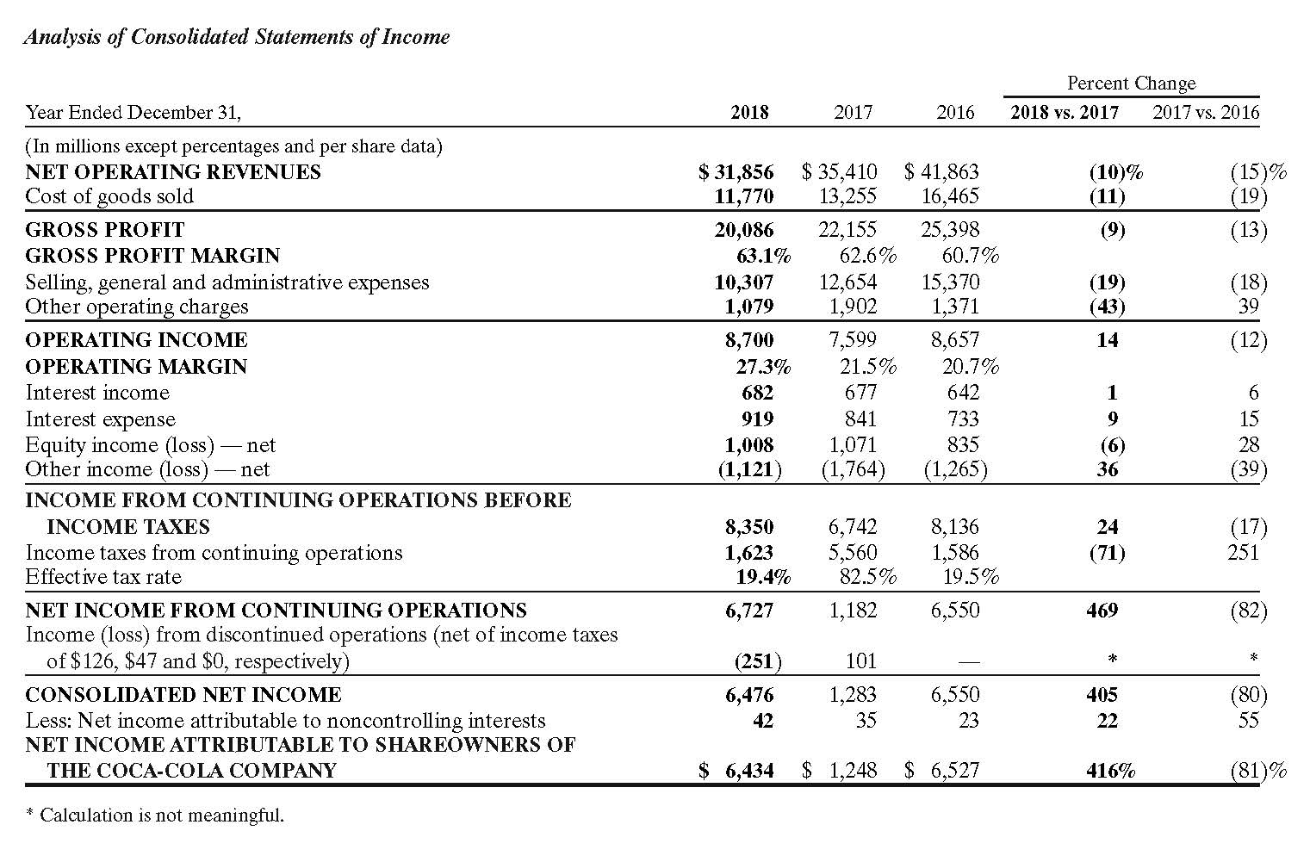

97. Review Coca-Cola's financial statements and answer the following questions:
(1) | How are Coke's numbers reported (in what denomination)?
(2) | What is Coke's net operating revenue for 2018?
(3) | What is Coke's cost of goods sold for 2018?
(4) | What is Coke's net income for 2018?
(5) | What is Coke's percent of interest expense to net operating revenue on its 2018 income statement?
(6) | What is Coke's percent of increase in net operating revenue from 2017 to 2018?

ANSWER: | (1) In millions of dollars  (2) $31,856  (3) $11,770  (4) $6,727  (5) 919/31,856 = 2.88%  (6) (31,856 - 35,410)/35,410 = -10.0%

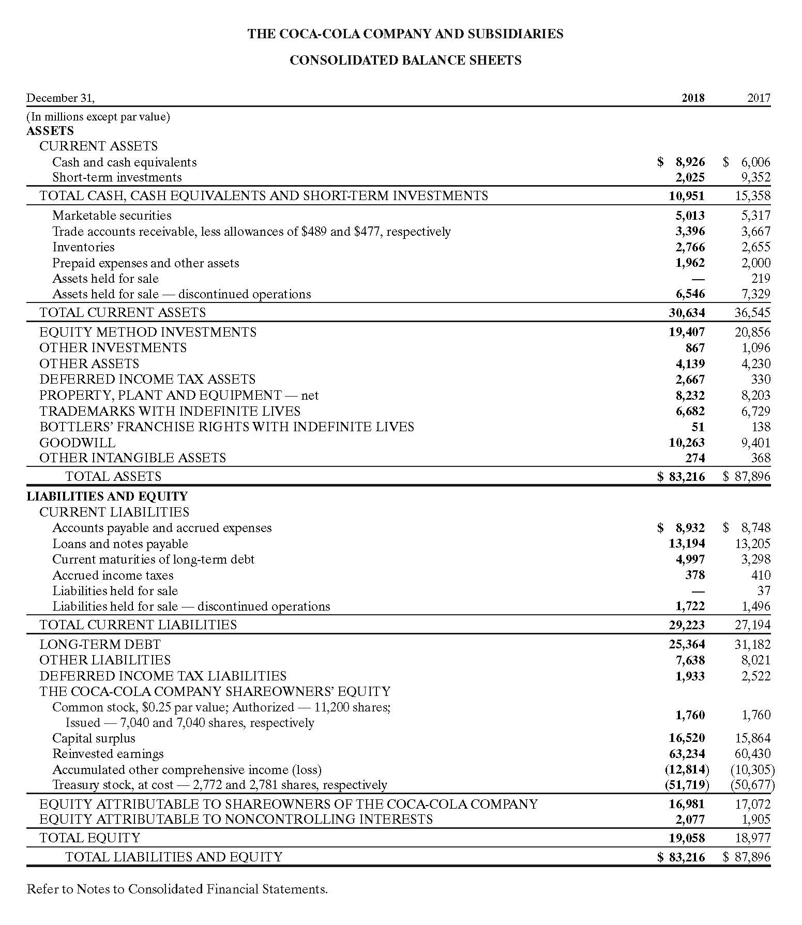

98. Review Coca-Cola's financial statements and answer the following questions:
(1) | What is Coke's percent of current assets to total assets on its December 31, 2018 balance sheet?
(2) | What is Coke's percentage of current liabilities to total stockholders' equity on its December 31, 2018, balance sheet?
(3) | What is the percentage increase in cash and cash equivalents from 2017 to 2018?
(4) | What percentage did total assets decrease from 2017 to 2018?

ANSWER: | (1) 30,634/83,216 = 36.81%  (2) 29,233/19,058 = 153.39%  (3) (8,926 – 6,006)/6,006 = 48.62%  (4) (83,216 – 87,896)/87,896 = (5.32%)

99. On May 31, 20X8, Deana's Services Company had account balances as follows:
Accounts payable | $ 9,900
Accounts receivable | 26,950
Cash | 11,390
Fees earned | 70,800
Insurance expense | 1,475
Land | 74,400
Miscellaneous expense | 1,510
Prepaid insurance | 2,000
Rent expense | 8,000
Salary expense | 35,300
Dividends | 15,100
Supplies | 950
Supplies expense | 825
Utilities expense | 3,800
Capital stock | 81,000
Retained earnings (beginning balance on May 1, 20Y8) | 20,000
Present, in good form, (a) an income statement for May, (b) a statement of shareholders' equity for May, and (c) a balance sheet as of May 31.
ANSWER: | (a)  Deana's Services Company  Income Statement  For the Month Ended May 31, 20Y8  Fees earned $70,800  Operating expenses:  Salary expense $35,300  Rent expense 8,000  Utilities expense 3,800  Supplies expense 825  Insurance expense 1,475  Miscellaneous expense 1,510  Total operating expenses 50,910  Net income $19,890  ​  (b)  Deana's Services Company  Statement of Retained Earnings  For the Month Ended May 31, 20Y8  Retained earnings, May 1, 20Y8 $20,000  Net income for the month 19,890  Subtotal 39,890  Less dividends 15,100  Retained earnings, May 31, 20Y8 $24,790  (c)  Deana's Services Company  Balance Sheet  May 31, 20Y8  Assets Liabilities  Cash $ 11,390 Accounts payable $ 9,900  Accounts receivable 26,950  Prepaid insurance 2,000 Stockholders' Equity  Supplies 950 Capital stock $81,000  Land 74,400 Retained earnings 24,790  Total stockholders' equity 105,790  Total liabilities and  Total assets $115,690 stockholders' equity $115,690

100. Match each statement with the appropriate accounting concept. (Some items may not be used. Others may be used more than once.)
a. | Accounting period concept
b. | Adequate disclosure concept
c. | Business entity concept
d. | Cost concept
e. | Going concern concept
f. | Matching concept
g. | Objectivity concept
h. | Unit of measure concept
​
(1) | Owners' transactions are separate from business transactions.
(2) | Financial statements are prepared at the end of each year.
(3) | Land purchased for $50,000, 10 years ago, is reported on the Balance Sheet at $50,000.
(4) | December rent expense paid in January is reported with the December revenues.
(5) | All transactions are recorded and reported in dollars.
(6) | This provides a summary of significant accounting policies.
(7) | This assumes that IBM will continue as a corporation forever.
(8) | The length of time left on debt obligations is shown.

ANSWER: | (1) c  (2) a  (3) d  (4) f  (5) h  (6) b  (7) e  (8) b

101. From the following information for BlueInks Corporation, compute the rate on return of assets.
Net income after tax | $30,548
Taxes | $6,785
Interest expense | $3,545
Total assets at beginning of year | $150,500
Total assets at end of year | $175,684

 | a. | 20.90%
 | b. | 25.06%
 | c. | 22.89%
 | d. | 18.73%

ANSWER: | b

