Instructor’s Manual and Test Bank

For

Foundations of Addictions Counseling

Fourth Edition

David Capuzzi, Walden University, Professor Emeritus,

Portland State University

Mark D. Stauffer, Walden University

Prepared by
Melinda Haley, Walden University

Boston Columbus Indianapolis New York San Francisco Hoboken
Amsterdam Cape Town Dubai London Madrid Milan Munich Paris Montreal Toronto
Delhi Mexico City Sao Paolo Sydney Hong Kong Seoul Singapore Taipei Tokyo
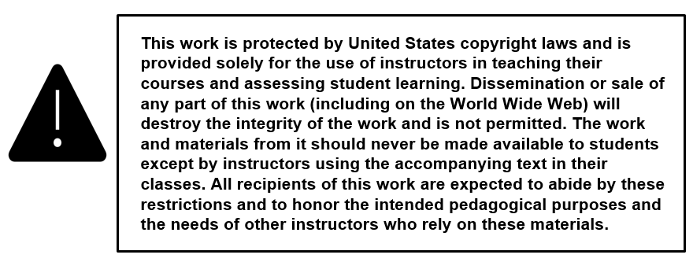

____________________________________________________________________________

Copyright © 2020, 2016, 2012 by Pearson Education, Inc. or its affiliates. All Rights Reserved. Printed in the United States of America. This publication is protected by copyright, and permission should be obtained from the publisher prior to any prohibited reproduction, storage in a retrieval system, or transmission in any form or by any means, electronic, mechanical, photocopying, recording, or otherwise. For information regarding permissions, request forms and the appropriate contacts within the Pearson Education Global Rights & Permissions Department, please visit www.pearsoned.com/permissions/.

Instructors of classes using Foundations of Addictions Counseling, 4th edition, by David Capuzzi and Mark D. Stauffer, may reproduce material from the Instructor’s Resource Manual for classroom use.

10 9 8 7 6 5 4 3 2 1 ISBN-10: 013516978X
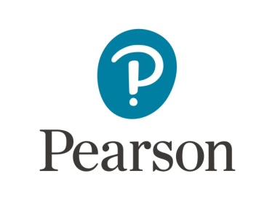
ISBN-13: 9780135169780

www.pearsonhighered.com
NOTES TO INSTRUCTORS

The Instructors Manual to accompany Foundations of Addictions Counseling encourages journaling, group exercises, and class experiential exercises.

There is also a test bank for creating mid-term and final exams. These exercises and test items were generated from the context of each chapter. There are fifteen test items for each chapter. Please note that the answer keys for all chapters are on pages 72 to 81 of this booklet.

It is the intent and hope of the authors that these exercises and test items will be helpful to those utilizing this text. The authors appreciate the contributions made by the writers of individual chapters.

Table of Contents

PART 1 INTRODUCTION TO ADDICTIONS COUNSELING
Chapter 1 History and Etiological Models of Addiction 1
Chapter 2 Substance Addictions 5
Chapter 3 Process Addictions 8
Chapter 4 Professional Issues in Addictions Counseling 11
Chapter 5 Introduction to Assessment 16
Chapter 6 Assessment and Diagnosis of Substance-Related and Addictive Disorders 19

PART 2 THE TREATMENT OF ADDICTIONS
Chapter 7 Motivational Interviewing 22
Chapter 8 Psychotherapeutic Approaches 26
Chapter 9 Treatment of Comorbid Disorders 31
Chapter 10 Group Counseling for Treatment of Addictions 35
Chapter 11 Addiction Pharmacotherapy 39
Chapter 12 12-Step Facilitation of Treatment 42
Chapter 13 Maintenance and Relapse Prevention 46

PART 3 ADDICTIONS AND FAMILY THERAPY, REHABILITATION, AND SCHOOL SETTINGS
Chapter 14 Substance Addiction and Families 50
Chapter 15 Persons with Disabilities and Substance-Related and Addictive Disorders 53
Chapter 16 Substance Addiction Prevention Programs Across the Lifespan 56

PART 4 CROSS-CULTURAL COUNSELING IN ADDICTIONS
Chapter 17 Cross-Cultural Counseling: Engaging Ethnic Diversity 59
Chapter 18 Gender, Sex, and Addictions 62
Chapter 19 Lesbian, Gay, Bisexual, Transgender, and Queer Affirmative Addictions Treatment 65

EPILOGUE SOME ADDITIONAL PERSPECTIVES
Chapter 20 Inpatient and Outpatient Addiction Treatment 68

ANSWER KEYS
Chapters 1 & 2 72
Chapters 3 & 4 73
Chapters 5 & 6 74
Chapters 7 & 8 75
Chapters 9 & 10 76
Chapters 11 & 12 77
Chapters 13 & 14 78
Chapters 15 & 16 79
Chapters 17 & 18 80
Chapters 19 & 20 81

CHAPTER 1
History and Etiological Models of Addiction

Journaling Exercises:

- As you read about the history of drugs in this country, you will note that attitudes about use changed as time passed and that attitudes and biases changed over the decades. Take some time to do a short life review and describe time periods in your life that impacted your attitudes about the use of illicit drugs. What was happening in your personal life that impacted how you felt?
- Describe how attitudes in your family of origin have affected your current attitudes about the consumption of alcohol.
- Is the philosophy of Alcoholics Anonymous congruent or incongruent with your values and beliefs? Why or why not?

Discussion Exercises:

- Interview some professional counselors and ask them what they believe to be the causes of addictive behavior. Share your findings with members of the class.
- Ask five or six individuals who are not members of this class or connected in any way with the profession of counseling what they think about the possibility of legalizing the use of marijuana. Report the results of your interviews with members of the class.
- Do you think enough time, effort, and money is being spent on the prevention of addictive behavior? What are your best guesses about the most effective approaches to prevention?

Group Exercises:

- Divide the class into several groups and assign each group one of the models used to explain the etiology of addiction. Ask each group to outline a tentative treatment plan that would be congruent with the model under consideration.
- Divide the class into several groups and assign each group one or more of the web sites listed at the end of chapter one. Have each group explain to the rest of the class what they learned from exploration of each web site.
- Organize a panel composed of students who represent different cultural, ethnic, and racial groups. Ask them to share their thoughts and feelings about the applicability of the models used to explain the etiology of addiction in cross and multi-cultural situations. Encourage class interaction with panelists as the presentations of panel members are made.

Quiz Items
True/False:

- In 1926, the United States Congress passed the Purity in Food and Drug Act designed to control addiction by requiring labels on drugs contained in products including opium, morphine, and heroin.

  - True
  - False

- A small minority of juvenile offenders (2 out of every 1000) will be offered Juvenile Drug Court (JDC) diversionary programs as an option to prison sentences.

  - True
  - False

- Cognitive-behavioral models suggest a variety of motivations and reinforcers for taking drugs. One explanation suggests that people take drugs to experience variety.

  - True
  - False

- The disease model of etiology, addiction is viewed as a primary disease rather than being secondary to another condition.

  - True
  - False

- According to the moral model, addiction is incurable.

  - True
  - False

Multiple Choice:

- Which U.S. Act required drugs to be classified according to their medical use, potential for abuse, and possibility of creating dependence:

  - Anti-Drug Abuse Prevention Act.
  - Harrison Act.
  - Controlled Substance Act.
  - None of the above.

- Which etiological theory of addictions assumes that addicts are constitutionally predisposed to develop dependence on drugs:

  - Disease theory.
  - Family systems theory.
  - Biophysiological theory.
  - Supracultural theory.

- Which etiology model explains addiction as a consequence of personal choice and, individuals, who are engaging in addictive behaviors, are viewed as being capable of making alternative choices:

  - Learning theory model.
  - Disease model.
  - Cognitive behavioral model.
  - None of the above.

- According to this chapter, which of the following is NOT a psychological model of addiction etiology:

  - Psychodynamic.
  - Learning theory.
  - Personality theory.
  - Family Disease.

- According to the syndrome model of Addictions, there are multiple and interacting antecedents of addiction that can be organized in at least three primary areas. Which of the following is NOT a primary area:

  - Shared neuro-biological antecedents.
  - Shared psychosocial antecedents.
  - Shared spiritual antecedents.
  - Shared experiences and consequences.

Matching:

1. _____Integral model
2. _____Learning model
3. _____Supracultural model
4. _____Disease model
5. _____Biological model

- Influenced by B. F. Bales
- Addiction is caused by genetics.

- Influenced by E. M. Jellinek’s work.
- Posits that children and adolescents may internalize the values and expectations of their parents.
- A multi-causal model of addiction.

ANSWER KEY TO TEST QUESTIONS

CHAPTER 1
True/False
1) b
2) a
3) a
4) a
5) b

Multiple Choice
1) c
2) c
3) d
4) d
5) c

Matching
1) e
2) d
3) a
4) c
5) b

