1
Introduction to Anatomy and Physiology
Pedagogical Tips
1. Establishing an active, engaging learning environment from the beginning of the course is critical. Therefore,
encourage student interaction during the first lab. Ideas to help create such an environment include:
a. Have students draw numbers as they enter the lab to determine where they sit for that lab period. Do this for each lab period, and students will have the opportunity to interact with many, if not all, of their classmates.
b. Have students introduce themselves on the first day of class. They can share their names, major, career goals, and something unique about themselves. Such introductions are a great way to encourage students to get to know each other.
2. Keep students busy for the entire lab period. Set up an expectation that students are required to attend the entire lab.
Activity 1: Identifying Body Regions and Exploring Surface Anatomy (Estimated time: 20–30 minutes)
Materials and Advance Preparation
Laminated body regions poster (Figure 1-3)
Water-soluble markers
Muscle models
Labeling tape
Print one poster for each lab group using Figure 1-3 found on the IRDVD and laminate.
Active Learning Tips, Modifications, and Extensions
1. Reduce time requirement for this activity by assigning instruction #1 as part of the pre-lab assignment and starting lab with #2.
2. Add additional muscles to extend instruction #2. Suggested muscles include: zygomaticus m., triceps brachii m., tibialis anterior m., orbicularis oculi m., and extensor digitorum m.
Activity 2: Identifying Body Cavities and Abdominopelvic Regions (Estimated time: 20–30 minutes)
Materials and Advance Preparation
Torso model
Quart-sized plastic resealable bag
Food coloring
Miscellaneous anatomical models

Activity 3: Demonstrating and Identifying Body Planes of Section
(Estimated time: 10–15 minutes)
Materials and Advance Preparation
Modeling clay
Scalpel
Anatomical models: (Suggested models include cross-section of spinal cord, midsagittal section of the brain,
coronal section of the kidney, and midsagittal section of the pelvis).
Active Learning Tips, Modifications, and Extensions
1. Pieces of fruit can be used instead of modeling clay to demonstrate body planes.
Activity 4: Assisting the Coroner (Estimated time: 15–20 minutes)
Materials and Advance Preparation
Torso model with three “wounds”
ANSWERS TO Pre-Lab Assignments
Lab 1: Introduction to Anatomy and Physiology
Pre-Lab Activity 1:
1. b  2. a. 3  b. 7  c. 5  d. 6  e. 1  f. 4  g. 8  h. 2  i. 10  j. 9  3. a. frontal  b. cervical  c. antecubital | d. pelvic  e. femoral  f. patellar  Pre-Lab Activity 2:  1. cranial, vertebral  2. thoracic, abdominopelvic  3. a. hypogastric  b. right and left hypochondriac  c. right lumbar  d. left lumbar  e. right and left iliac  4. visceral  5. parietal
Pre-Lab Activity 3:  1. Coronal/Frontal  2. Transverse  3. Sagittal | Pre-Lab Activity 4:  1. c  2. a  3. c  4. deep

ANSWERS TO ACTIVITY QUESTIONS
Activity 1
2. rectus abdominis m. abdominal
brachialis m. brachial
biceps femoris m. femoral
epicranius m. frontal/occipital
mentalis m. mental
gluteus maximus m. gluteal
Activity 2
A. Body Cavities and Abdominopelvic Regions
Dorsal Body Cavity
Subdivision | Organ(s)
Cranial cavity | Brain
Vertebral cavity | Spinal cord
Ventral Body Cavity
Subdivision | Organ(s)
Thoracic cavity | Heart, lungs, esophagus
Abdominopelvic cavity
- Right hypochondriac region | Liver
- Epigastric region | Liver, stomach
- Left hypochondriac region | Spleen, stomach
- Right lumbar region | Right kidney
- Umbilical region | Small intestine, large intestine, stomach
- Left lumbar region | Left kidney
- Right iliac region | Small intestine, large intestine
- Hypogastric region | Urinary bladder, uterus, large intestine
- Left iliac region | Small intestine, large intestine

B. Serous Membranes
1. Place the plastic bag on top of a heart model.
The portion of the bag adjacent to the heart represents the visceral pericardium , the water-filled space represents the pericardial cavity , and the outermost portion of the bag represents the parietal pericardium .
2. Next, place the plastic bag on top of a lung model.
The portion of the bag adjacent to the lung represents the visceral pleura , the water-filled space represents the pleural cavity , and the outermost portion of the bag represents the parietal pleura .
3. Finally, place the plastic bag on top of the model of the small intestine.
The portion of the bag adjacent to the intestines represents the visceral peritoneum , the water-filled space represents the peritoneal cavity , and the outermost portion of the bag represents the parietal peritoneum .
4. What are the functions of the serous membranes and serous fluid?
They reduce friction as organs move within the ventral body cavity.
Activity 3
B. Answers will vary.
Activity 4
1. Answers will vary.
2. Answers will vary.
3. Answers will vary.

ANSWERS TO POST-Lab ASSIGNMENTS
Name: ___________________________ Date: _______________ Lab Section: __________
PART I. Check Your Understanding
Activity 1: Identifying Body Regions and Exploring Surface Anatomy
1. Which of the following terms is correctly matched to its description?
a. Manual, pertaining to the palm d. Mental, pertaining to the chin
b. Crural, pertaining to the calf e. Femoral, pertaining to the leg
c. Acromial, pertaining to the chest
2. Another term for the wrist is the:
a. crural region. d. sural region.
b. femoral region. e. carpal region.
c. popliteal region.
Activity 2: Identifying Body Cavities and Abdominopelvic Regions
1. Identify the three ventral body cavities and the two dorsal body cavities in the following diagram. Then, name one organ found in each cavity.  a. Cranial Brain  b. Vertebral Spinal cord  c. Thoracic Heart  d. Abdominal Stomach  e. Pelvic Bladder  2. In which specific body cavity is each of the following organs located?  a. Abdominopelvic e. Abdominopelvic  b. Thoracic f. Vertebral  c. Cranial g. Thoracic  d. Abdominopelvic h. Abdominopelvic | 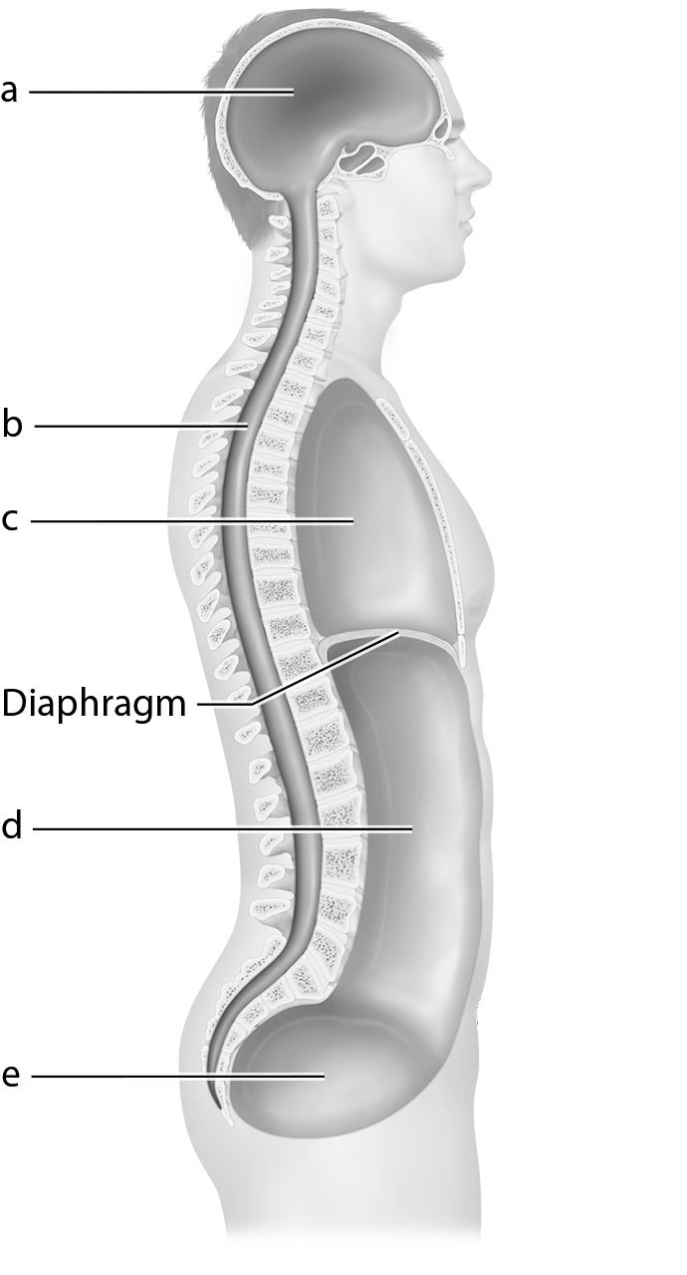
3. The spleen is located in the ______________ abdominopelvic region.
a. left hypochondriac d. right hypochondriac
b. umbilical e. epigastric
c. hypogastric

4. A bullet that lodges in the heart would:
a. be located in the ventral body cavity. d. penetrate the parietal pleura.
b. penetrate the visceral peritoneum. e. be located laterally to a bullet that lodges in the lung.
c. be located in the vertebral cavity.
Activity 3: Demonstrating and Identifying Body Planes of Section
1. Identify the planes of section shown in the following diagrams:
a. transverse  b. frontal | 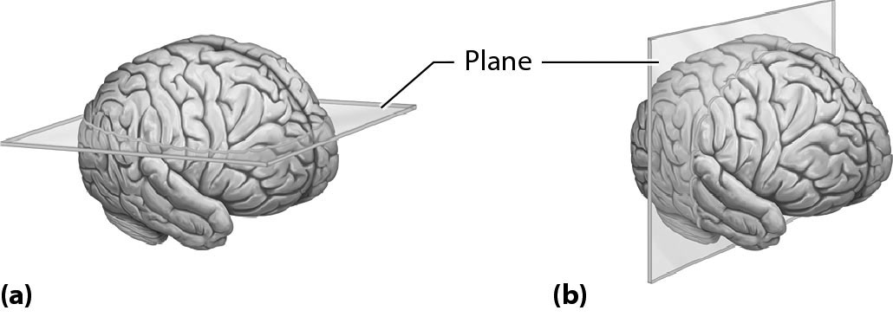
2. Which of the following organs could not be viewed in a midsagittal section through the body?
a. Brain d. Diaphragm
b. Heart e. Pancreas
c. Lung
Activity 4: Assisting the Coroner
1. For each of the wound descriptions, mark the diagram with an “a,” “b,” and “c” to represent the location of each wound.
a. A cut in the medial part of the right femoral region
b. A wound in the left iliac region
c. Bruising in the left thoracic region, midway between the sternal and
axillary regions
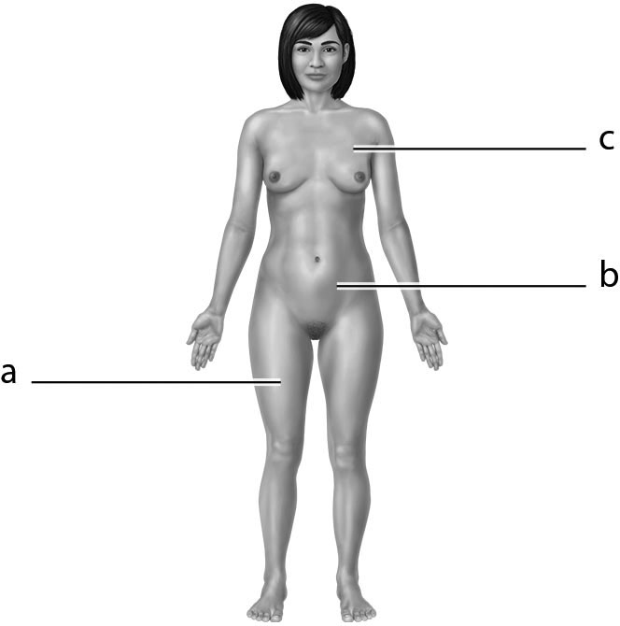
2. Which phrase correctly describes a stab wound that penetrates the anterior liver?
a. Medial to the sternum c. Superior to the left inguinal region
b. Inferior to the rib cage d. In the right lower quadrant

PART II. Putting It All Together
A. Review Questions
Answer the following questions using your lecture notes, your textbook, and your lab notes.
1. Indicate whether each of the following statements is true or false. If the statement is false,
correct it so that it is true.
a. The small intestine is to the kidneys. F; ventral
b. The trachea is to the lungs. F; medial
c. The urinary bladder is to the uterus. F; inferior
d. The brain is to the skull. F; deep
2. Assume anatomical position. Is the radius medial or lateral to the ulna? lateral
Explain the importance of using anatomical position as a standard reference point. So that
scientists/clinicians can communicate effectively.
3. Use as many directional terms as possible to describe the relationship between:
a. the antecubital region and the popliteal region. Antecubital region is superior to the
popliteal region. Popliteal region is posterior to the antecubital region.
b. the acromial region and the mental region. Acromial region is inferior to the mental
region. Acromial region is lateral to the mental region.
c. the gluteal region and the sternal region. Gluteal region is inferior to the sternal region.
Gluteal region is posterior to the sternal region. Sternal region is medial to the gluteal
region.
4. Identify the body cavities entered during each of the following medical procedures. Begin with the largest cavity and end with the most specific body cavity. The answer for the first procedure is provided as an example.
a. Spinal tap Dorsal, vertebral cavity
b. Removal of appendix Ventral, abdominopelvic cavity
c. Removal of gallbladder Ventral, abdominopelvic cavity
d. Coronary bypass surgery Ventral, thoracic, pericardial cavity
5. Which body plane(s) could provide a view of both:
a. the spinal cord and the right lung? Transverse
b. the trachea and the bladder? Sagittal
c. the right and left kidneys? Coronal and transverse
d. the brain and the thyroid gland? Sagittal

B. Concept Mapping
1. Fill in the blanks to complete this concept map outlining the anatomy of the ventral cavity.
abdominopelvic cavity diaphragm mediastinum thoracic cavity ventral cavity

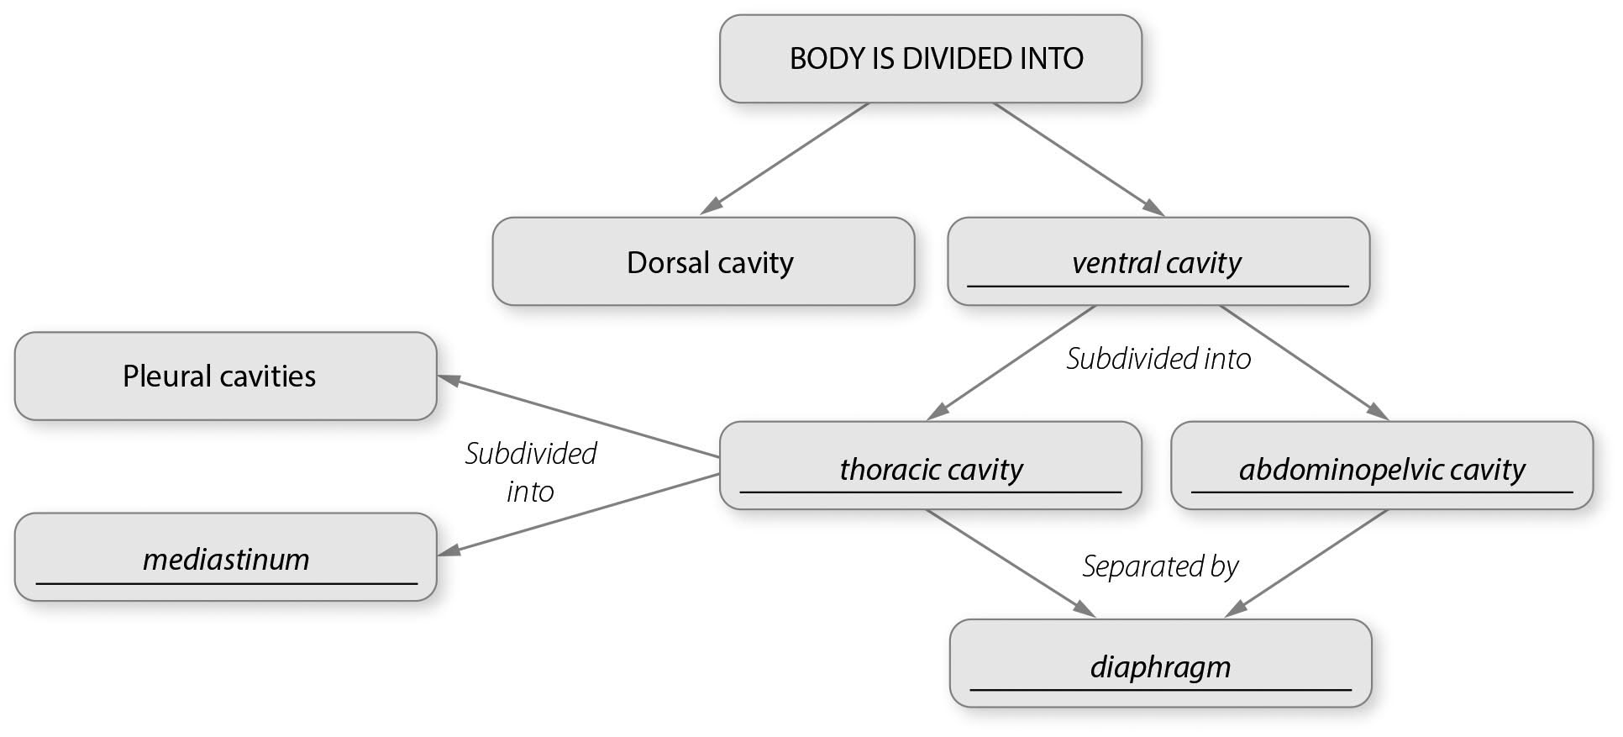

2. Construct a unit concept map to show the relationships among the following set of terms.
Include all of the terms in your diagram. Your instructor may choose to assign additional terms.
dorsal cavity |  | heart | hypogastric
lung | medial | pericardial cavity | peritoneum
pleural cavity |  | stomach | transverse
Answers will vary.

